|  |  |
| --- | --- |
|  | **European Commission**  **DIRECTORATE GENERAL**  **GROWTH** |

ESPD Exchange Data Model

Version 2.0.0

XML Implementation Guide

Abstract

This document describes the new Exchange Data Model, Version 2.0.0, of the European Single Procurement Document (ESPD-EDM) and provides rules and examples for its implementation as XML document instances.

Where needed it also mentions the differences from the previous version (version 1.0.2).

Table of Contents

1 Introduction 7

1.1 Context 7

1.2 The ESPD Service and e-Certis 7

1.3 Objectives of the Document 7

2 Main differences with the previous version 8

2.1 Regulated and Self-contained eESPD 8

2.2 EU and national criteria 8

2.3 XSD Schemas, use of OASIS UBL-2.2 8

2.4 Technical notes 9

3 The Qualification Application Request document 10

3.1 Global view 10

3.2 ESPD-EDM constraints related to the Request 11

3.3 Minimum set of elements for the Request used in the ESPD-EDM 12

3.3.1 XML instantiation of the basic components of the Qualification Application Request, example 13

3.4 The main elements of the Request document 13

3.4.1 Reference to OJEU and other publications 14

3.4.2 Identity of the procurer 16

3.4.3 Information about the Procurement Procedure 17

4 The ESPD-EDM Criteria 20

4.1 ESPD-EDM constraints related to the criteria 20

4.2 The ESPD-EDM Criteria Taxonomy 20

4.3 Rules to build an ESPD Criterion 21

4.4 The ESPD Criterion component 22

4.4.1 Criterion sub-elements 24

4.4.2 Groups of Properties and Properties of a Criterion 24

4.4.3 Example: Information about the Lots 26

4.5 Exclusion criteria 30

4.5.1 Exclusion criteria XML implementation 31

4.5.2 Example 1: A Conviction Exclusion Criterion with national sub-criteria 32

4.5.3 Example 2: EU Payment of Taxes Criterion with a national specific requirement 37

4.5.4 Example 3: Purely national Exclusion grounds 43

4.6 Selection criteria 46

4.6.1 Example 1: Suitability 47

4.6.2 Example 2: Turnovers 51

4.6.3 Example 3: Financial Ratios 61

4.6.4 Example 4: Weighting a selection Criterion 66

4.6.5 Example 5: References on similar works, deliveries or services 69

5 The Qualification Application Response document 77

5.1 Global view 77

5.2 ESPD-EDM constraints related to the Response document 77

5.3 Minimum set of elements for the Response document used in the ESPD-EDM 78

5.3.1 XML instantiation of the basic components of the Qualification Application Request, example 79

5.3.2 How to respond a Criterion 79

5.3.3 Evidences 80

5.4 The main elements of the Response document 82

5.4.1 Information common to the Request 82

5.5 Information about the Economic Operator 82

5.5.1 The Economic Operator role 83

5.5.2 The Party-related information 85

5.5.3 Additional information about the Economic Operator 87

5.5.4 Participation in Consortia 90

5.5.5 Reliance on other entities 91

5.5.6 Not reliance on other entities 93

5.6 Answering the criteria and attaching evidences 94

5.6.1 Example 1: EO specifies the lots to which it tenders 94

5.6.2 Example 2: Payment of taxes 95

5.6.3 Example 3: Turnovers 101

5.6.4 Example 4: Financial Ratios 104

5.6.5 Example 5: References and confidentiality 109

5.6.6 Example 6: Purely national exclusion grounds 112

6 Annex I: Mapping Version 1.0.2 and Version 2.0.0 114

6.1 Code Lists 114

6.1.1 New Code Lists 115

6.2 New criteria 118

6.3 Updated criteria 119

6.4 Main differences between the “Regulated” and the “Self-contained” documents 120

8 Cited works 121

Conventions

* Tables with the caption NEW! contain details about one component of the model that is totally new, has changed or has introduced new elements that did not exist in the previous model;
* XML components and files are written using the font Courier New to differentiate them from usual concepts with similar or identical names;
* Essential business Concepts, such as Procurement Procedure, Economic Operator, Contracting Authority, Criterion, Criterion Property, etc. are capitalised;

# Introduction

## Context

Article 59 of the new Public Procurement Directive 2014/24/EC (henceforth ''the Directive'') introduced a new concept, the European Single Procurement Document (ESPD) which is a self-declaration document intended for preliminary evidence in a public procurement procedure. By mapping out equivalent certificates between MS, the ESPD replaces certificates issued by public authorities or a third party involved in a procedure. It is thus a valuable facilitator for cross-border participation of a greater number of potential operators in public procurement procedures and a valuable tool for integrating the European Single Market.

## The ESPD Service and e-Certis

In order to make use of the ESPD concept, the European Commission has established an on-line service available for both suppliers and buyers.

The ESPD Service tool allows Contracting Authorities and Economic Operators to create, edit, export and import electronic documents in XML format (eESPD) for the exchange of criteria, requirements, statements and references to evidences.

The main objective of the ESPD is to reduce the administrative burden and lead to considerable simplification of participation in public procurement procedures for buyers and suppliers. The service, the ESPD Service[1], will reduce that burden by removing the need to produce a substantial number of certificates and documentation related to exclusion and selection criteria. This will answer to obstacles reported by many suppliers and especially SMEs.

The ESPD service is also integrated with e-Certis[2] - a mapping tool used to identify and compare certificates requested in public procurement procedures across the EU. The full potential of the eESPD will be reached when tenderers will provide links to repositories, which hold data proving their compliance with the exclusion and selection criteria.

Both, ESPD-EDM and e-Certis are currently being evolved to become a “Qualification Information System” where:

* e-Certis will provide the Member States the possibility of define Criteria, including Exclusion and Selection Criteria and particular MS requirements and associate them to online evidences kept in the official national databases and base registries. In time, e-Certis will become a “source or trust” for the exchange of information between Economic Operators, Contracting Authorities, Service Providers and Authorities;
* The eESPD will act as a “business passport” for companies bidding for tenders anywhere in the EU.

## Objectives of the Document

The objective of this document is to introduce the new ESPD Exchange Data Model (ESP-EDM-2.0.0), namely the schemas, data structures, rules and examples necessary for the implementation of two eESPD documents: the Request and the Response documents.

The **Request document** is used by the Contracting Authorities (CA) to express the Exclusion and Selection criteria, as well as particular requirements, that the Economic Operators will need to fulfil in the context of a tender.

The **Response document** is used by the Economic Operators (EO) to answer the questions and provide references to evidences in response to the criteria and requirements expressed by the CA in the Request document.

This document is part of a “distribution” package (abbreviated as “dist”) containing:

1. The W3C XSD Schemas based on which the XML eESPD documents are implemented;
2. The XML fragments of code used in the examples;
3. The Code Lists used for the implementation of this version of the eESPD documents;
4. The conceptual model and logic design
5. Resources for the validation of the XML instances of the eESPD;
6. Other resources.

# Main differences with the previous version

## Regulated and Self-contained eESPD

This new version of the eESPD makes the difference between “Regulated” and “Self-contained” eESPD.

Regulated eESPDs are those XML document instances the structure and content of which are strictily adjusted to the terms expressed in the Annex 2 of the Commission Implementing Regulation (EU) 2016/7 (1): Standard form for the European Single Procurement document (ESPD). Hence a Regulated eESPD will refer to documents and information that is external, e.g. mentioned in the Contract Notice published or the Contract Documents.

In a Self-contained eESPD the definition of the criteria, its properties and requirements that are particular to the MS or to the Contracting Authority, and both generic to all Procurement Procedures or particular of the Procurement Procedure, are explicitly mentioned or defined in the eESPD document. Self-contained eESPDs confer the Contracting Authorities a greater flexibility when preparing their eESPD Request documents.

## EU and national criteria

This new version of the ESPD-EDM 2.0.0 allows the specification of criteria defined by the MS in e-Certis. In the case of Exclusion criteria, each national Criterion is linked to a EU Criterion. The XML implementation of this situation is solved nesting the national Criterion inside the EU Criterion, i.e. as a sub-Criterion. XML examples are provided in sections “4.5.2 Example 1: A Conviction Exclusion Criterion with national sub-criteria” and “4.5.4 Example 3: Purely national Exclusion grounds”.

## XSD Schemas, use of OASIS UBL-2.2

One important difference of this new version in respect of the previous versions of the ESPD-EDM is that the XSD Schemas used for the XML implementation of the Request and Response documents have been developed by the OASIS UBL Technical Committee in close collaboration with the European Commission (EC).

The results of such collaboration have been included in the version 2.2 of UBL which is actually under revision and is to be formally adopted by the end of 2017.

UBL, developed by the Organization for the Advancement of Structured Information Standards, is a royalty-free library of standard electronic Extensible Markup Language (XML) business documents. It is designed to plug directly into existing business, legal, auditing, and records management practices, and to operate within a standard business framework such as ISO 15000 (ebXML) to provide a complete, standards-based infrastructure that can extend the benefits of existing Electronic Data Interchange (EDI) systems to businesses of all sizes.

UBL is also included in the European Catalogue[3] (EUcat): the rules on European standardisation allow the European Commission to identify information and communication technology (ICT) technical specifications - that are not national, European or international standards - to be eligible for referencing in public procurement.

UBL is a specific used in some Member States and by the EU institutions, namely the European Commision. UBL is also refered to in the Commission implementing decision of 31 October 2014 on the identification of Universal Business Language version 2.1 for referencing in public procurement[4] (2014/771/EU).

Technical resources and tools are freely available for its use and repurpose by the Member States, Service Providers, EC and any other stakeholders. Especially interesting and largely used are the open source tools and artefacts referred by the OASIS UBL-TC, such as Genericode[5], ISO Schematron[6] and Crane Softwright[7].

## Technical notes

For the migration towards the new ESDP-EDM 2.0.0, the software developers need to take into considerations these technical aspects:

* The data architecture model used in previous versions is not used anymore. UBL-2.2 uses its own. Therefore:
  + The ccv: and cev: prefixes (and corresponding namespaces) are not used in ESPD-2.0.0. Instead, UBL-2.2 compiles all the Common Basic Components in one single library and uses the prefix “cbc:”;
  + UBL-2.2 distributes two sets of XSD schema: see folders “xsd” and “xsdrt” of the UBL distribution package. The “xsd” folder contains the schemata fully documented (with dictionary entry names, definitions, examples, etc.); whilst the “xsdrt” schemata are not likewise documented and are frequently used in production environments (“rt” stands for “run-time”);
* UBL-2.2 defines thousands of different information components and dozens of documents. The ESPD-EDM reuses only a small set of those components and only 2 documents. This document describes and illustrates only those elements from UBL-2.2 that are actually used by the eESPD. For details on the rest of unused UBL-2.2 elements see the spread-sheet /dist/mod/UBL-Entities-2.2-Pre-award.xls.xlsx.
* The documents ESDPRequest and ESPDResponse, from the previous versions of the ESPD-EDM, are named in UBL-2.2: **QualificationApplicationRequest** and **QualificationApplicationResponse**. The new ESPD-EDM-2.0.0 uses these documents as they are offered and named by UBL-2.2.
* The elements Criterion, Response and Evidence from the previous version 1.0.2 of the ESPD-EDM behave are differently named and designed in UBL-2.0.0.;
* The responses to a particular question and the evidences are now directly associated to the root element of the Response document.
* In order to align all the semantic artefacts that accompany the new ESPD-EDM version 2.0.0, all the lists maintained by EU-COM-GROW have been versioned also as “2.0.0”. This includes the new Code Lists and Criteria Taxonomy as well as the previous ones even if the content of the list has not suffered any change. See “6.1 Code Lists” for more details on the Code Lists.

# The Qualification Application Request document

## Global view

The figure below shows the XSD Schema defined by UBL-2.2 for the document “Qualification Application Request”. This schema replaces the Schema for the “ESPD Request” document used in the previous versions of the ESPD-EDM.

Beware that not all the elements of the “Qualification Application Request” document defined by UBL-2.2 are necessary in the context of the ESPD-EDM.



Figure 1: QualificationApplicationRequest Schema, global view

## ESPD-EDM constraints related to the Request

For the time being, this version 2.0.0 of the EPSD-EDM uses the UBL-2.2 schemata as they are provided by UBL. Therefore the ESPD-EDM will not use a customised version of the UBL-2.2 XSD Schemata. The rationale for this is to provide the maximum flexibility to the MS and Service Providers when adapting or evolving their systems to meet the needs of their e-Tendering, Pre-Qualification, Evaluation or other systems.

Nonetheless the ESPD-EDM imposes certain constraints upon the original UBL-2.2 schema, namely regarding the cardinality of some elements. In order to control these constraints the ESPD-EDM uses ISO Schematron (2) assertions[8].

In the context of the ESPD-EDM the following requirements need to be satisfied:

Always specify whether this is a “Regulated” or a “Self-contained” document. Use the QualificationApplicationTypeCode component and the Code List “ESPDTypes”;

Always identify the Request document with an internal identifier (use the cbc:ID element). It is also a good practice to identify each specific XML instance issued with a Unique Universal ID (UUID);

Specify only one Contracting Authority: provide only one instance of the UBL-2.2 cac:ContractingParty. If in the procurement procedure more than one Contracting Authority participates specify only the leading one;

Always identify the procurement procedure (use the cac:ProcurementProject component);

If the procurement procedure is not divided into lots do not provide any instance of the component cac:ProcurementProjectLot. If the Request document contains one instance of a lot (and only one) the assumption will be that the procurement procedure is not split into lots;

All exclusion criteria specified in the Commission Implementing Regulation (EU) 2016/7 (1) MUST be specified in the Request document;

At least one selection Criterion MUST be specified in the Request document;

A reference to the Contract Notice MUST be included in the Request. Use the component AdditionalDocumentReference for this purpose.

## Minimum set of elements for the Request used in the ESPD-EDM

|  |  |  |  |  |
| --- | --- | --- | --- | --- |
| Document Name | QualificationApplicationRequest | | | |
| Definition | A document issued by a procurement organization to specify the criteria for an Economic Operator to be admitted to or excluded from the tendering process. | | | |
| File | dist/main/xsdrt/UBL-QualificationApplicationRequest-2.2-Pre-award.xsd | | | |
| Components | **Type** | **UBL**  **Cardinality** | **ESPD**  **Cardinality** | **Description** |
| cbc:UBLVersionID | Identifier | 0..1 | 1 | Identifies the earliest version of the UBL 2 schema for this document type that defines all of the elements that might be encountered in the current instance. |
| cbc:CustomizationID | Identifier | 0..1 | 1 | Identifies a user-defined customization of UBL for a specific use. ESPD: use the current version of the ESP-EDM “2.0.0”. See XML example below. |
| cbc:ID | Identifier | 0..1 | 1 | An identifier for this document, assigned by the sender. |
| cbc:UUID | Identifier | 0..1 | 1 | A universally unique identifier for an instance of this document. |
| cbc:ContractFolderID | Identifier | 1 | 1 | An identifier, assigned by the sender, for the process file (i.e., record) to which this document belongs. |
| cbc:IssueDate | Date | 1 | 1 | The date, assigned by the sender, on which this document was issued. |
| cbc:IssueTime | Time | 0..1 | 0..1 | The time, assigned by the sender, at which this document was issued. |
| cbc:QualificationApplicationTypeCode | Code | 0..1 | 1 | A code specifying the type of the Qualification Application. |
| cac:ContractingParty | Complex | 1..n | 1 | The Contracting Authority or entity in charge of the procurement procedure. |
| cac:ProcurementProject | Complex | 0..1 | 1 | An overall definition of this procurement procedure. |
| cac:ProcurementProjectLot | Complex | 0..n | 0..n | One of the procurement project lots into which this contract can be split. |
| cac:TenderingCriterion | Complex | 0..n | 1..n | Exclusion and selection criteria. |
| cac:AdditionalDocumentReference | Complex | 0..n | 1..n | A reference to an additional document associated with this document. |

### XML instantiation of the basic components of the Qualification Application Request, example

|  |
| --- |
| <?xml version="1.0" encoding="UTF-8"?>  <QualificationApplicationRequest  xsi:schemaLocation="urn:X-test:UBL:Pre-award:QualificationApplicationRequest UBL-QualificationApplicationRequest-2.2-Pre-award.xsd"  xmlns="urn:X-test:UBL:Pre-award:QualificationApplicationRequest"  xmlns:xsi="http://www.w3.org/2001/XMLSchema-instance"  xmlns:cac="urn:X-test:UBL:Pre-award:CommonAggregate" xmlns:cbc="urn:X-test:UBL:Pre-award:CommonBasic">  <cbc:UBLVersionID schemeAgencyID="OASIS-UBL-TC">2.2</cbc:UBLVersionID>  <cbc:CustomizationID schemeAgencyID="EU-COM-GROW"> ESPD-EDM-2.0.0</cbc:CustomizationID>  <cbc:ID schemeAgencyID="DGPE" schemeVersionID="1.1"> PP.20170419.1024.EO</cbc:ID>  <cbc:UUID schemeID="ISO/IEC 9834-8:2008 - 4UUID" schemeAgencyID="EU-COM-GROW" schemeVersionID="2.0.0">f01c214f-2fe6-4664-83ff-353f118b8d6f</cbc:UUID>  <cbc:ContractFolderID schemeAgencyID="DGPE">PP.20170419.1024-9</cbc:ContractFolderID>  <cbc:IssueDate>2017-04-13</cbc:IssueDate>  <cbc:IssueTime>19:09:11</cbc:IssueTime>  <cbc:QualificationApplicationTypeCode listID="QualificationApplicationType" listAgencyName="EU-COM-GROW" listVersionID="2.0.0"> SELFCONTAINED </cbc:QualificationApplicationTypeCode>  ...  </QualificationApplicationRequest> |
| **COMMENTS**   * The Common Basis Components (CBC) are defined in the file dist/xsdrt/common/UBL-CommonBasicComponents-Pre-award.xsd; * UBL-2.2 is under public review, hence the temporary urn:X-test namespaces. Final version is foreseen by the end of 2017. |

## The main elements of the Request document

This section describes the XSD schema elements used instantiate an ESP Request document. It also provides snippets of XML illustrate how to implement those elements in conformance to the ESPD-EDM expectations.

### Reference to OJEU and other publications

For contracts above the threshold the procurer SHALL publish the contract documents, namely the Contract Notice, on the Official Journal of the European Union (OJEU). The Qualification Application Request document MUST specify a minimum set of data ensuring the access to that information.

Additionally to the reference to the OJEU, the Contracting Authority MAY also refer to other official publications where the documents were published.

The Figure below is a mock-up representation of how to collect the data expected to reference publications on official gazettes or journals[9].

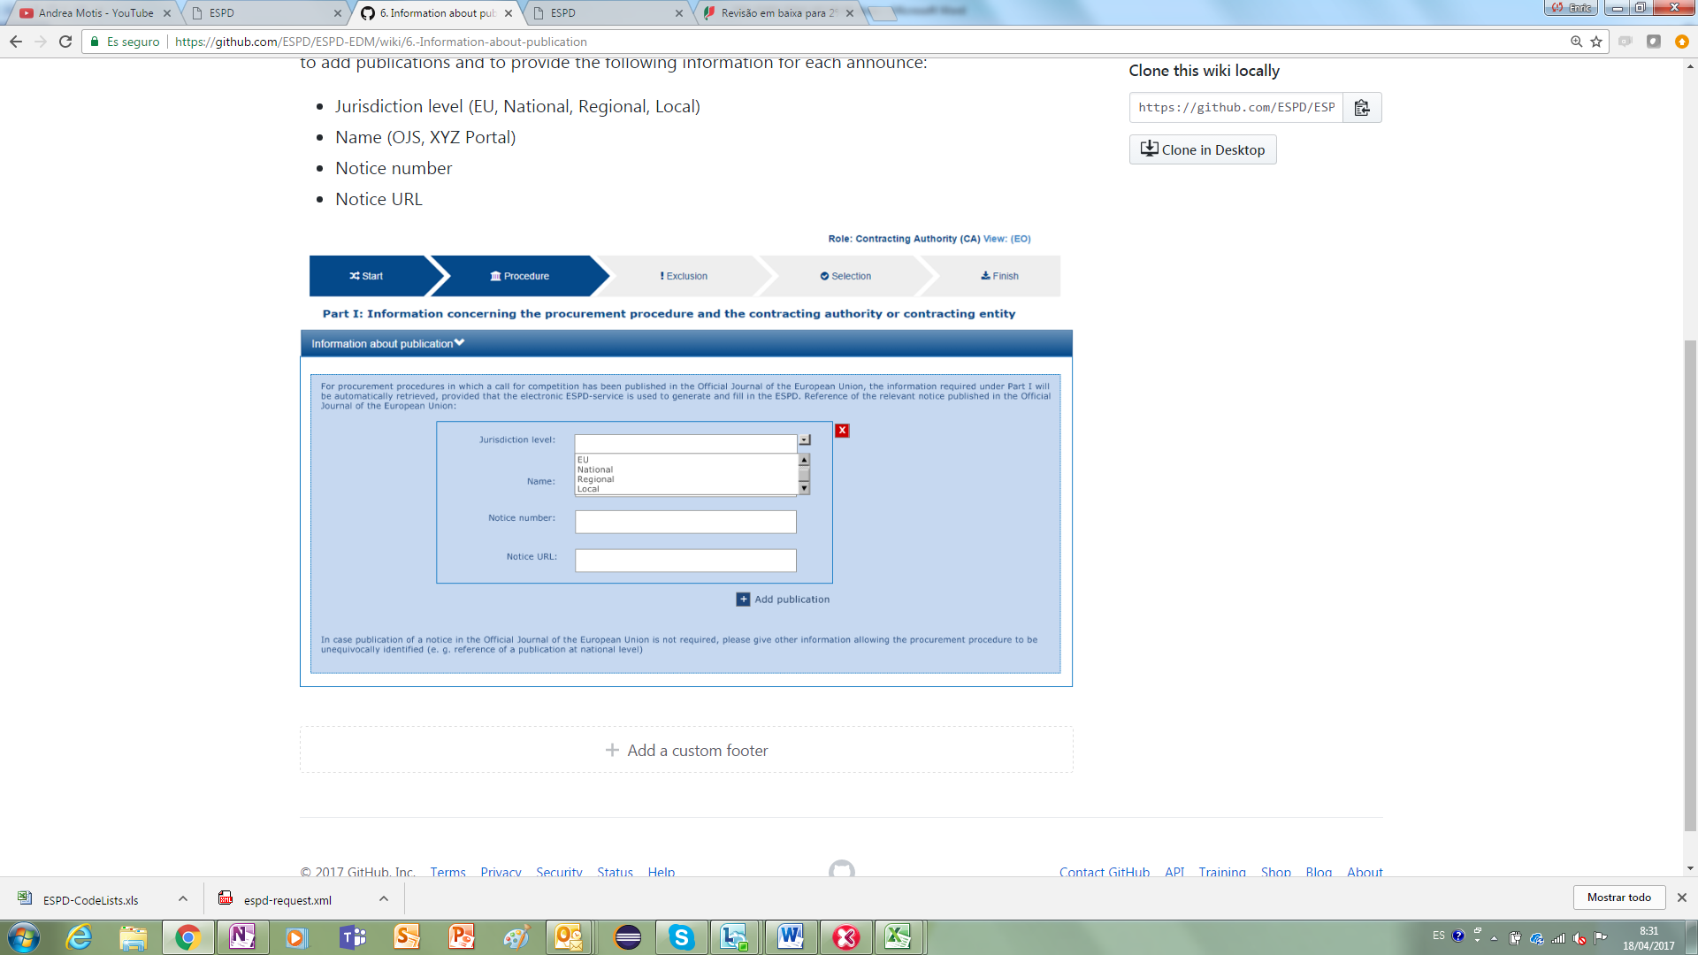

Figure 2: Information about the publication of the Contract Notice

The information required is thus limited to these four data: the jurisdiction level of the journal, the name of the publication, the number assigned by the publication to the contract notice and the URL to access the contract notice (Notice that more than one publication can be added, button “Add publication”).

The UBL-2.2 common aggregate component used to hold these data is AdditionalReferenceDocument.

|  |  |  |  |  |
| --- | --- | --- | --- | --- |
| Element Name | cac:AdditionalReferenceDocument | | | |
| ESPD Use | The ESPD-EDM uses this component to refer to official gazettes or journals as well as to external documents. Although the component allows both the reference (via a URL) and the embedding of the content (e.g. as Base64 code), the ESPD-EDM always never embeds the content but uses the attachment URL field to refer to those documents. | | | |
| File | dist/common/xsdrt/UBL-CommonAggregateComponents-Pre-award.xsd | | | |
| Absolute Path | /QualificationApplicationRequest/cac:AdditionalReferenceDocument | | | |
| Diagram |  | | | |
|  | | | |
| UBL Definition | A reference to an additional document associated with this document. | | | |
| Child Name | **Type** | **UBL Cardinality** | **ESPD Cardinality** | **Description** |
| cbc:ID | Identifier | 1 | 1 | An identifier for the referenced document. The ESPD-EDM uses it to hold the Contract Notice number. See example below. |
| cbc:DocumentTypeCode | Code | 0..1 | 1 | The type of document being referenced, expressed as a code. For the ESDP-EDM it is compulsory use of the Code List “DocRefContentType”. See example below on how to specify the OJEU CN. If the type of document is not available in this list, provide the code “Other” and describe the content in the element “DocumentType”. |
| cbc:DocumentType | Code | 0..1 | 0..1 | The type of document being referenced, expressed as text. |
| cac:Attachment/cac:ExternalReference/cbc:FileName | Text | 0..1 | 0..1 | The file name of the external object. The ESPD-EDMs uses this field to hold a self-descriptive title of the reference |
| cac:Attachment/cac:ExternalReference/cbc:DocumentDescription | Text | 0..1 | 0..1 | Text describing the referenced document. |
| cac:Attachment/cac:ExternalReference/cbc:URI | URI | 0..1 | 0..1 | The Uniform Resource Identifier (URI) that identifies the external object as an Internet resource. |

#### Example

|  |
| --- |
| <cac:AdditionalDocumentReference>  <cbc:ID schemeID="ISO/IEC 9834-8:2008 - 4UUID" schemeAgencyID="EU-COM-GROW" schemeAgencyName="DG GROW (European Commission)" schemeVersionID="1.1">2015/S 252-461137</cbc:ID>  <cbc:DocumentTypeCode listID="DocRefContentType" listAgencyID="EU-COM-GROW" listVersionID="1.0">TED_CN</cbc:DocumentTypeCode>  <cbc:DocumentType>Contract Notice published in TeD (Official Journal of the European Publications Office)</cbc:DocumentType>  <cac:Attachment>  <cac:ExternalReference>  <cbc:URI>http://ted.europa.eu/udl?uri=TED:NOTICE:127658-2017:TEXT:EN:HTML</cbc:URI>  <cbc:FileName>Belgium-Brussels: European Resource Efficiency Excellence Centre</cbc:FileName>  <cbc:Description>The objective of this contract is to set up a virtual European Resource Efficiency Excellence Centre. The Centre will provide information and support to European SMEs, business intermediaries, resource efficiencypractitioners and other interested parties such as regional authorities.</cbc:Description>  </cac:ExternalReference>  </cac:Attachment>  </cac:AdditionalDocumentReference> |
| **COMMENTS**   * In the context of the ESPD-EDM all the Request documents XML instances MUST always include an Additional Document Reference indicating the OJEU reference number of the Contract Notice. * This OJEU reference number MUST be specified in the field cbc:ID of the element cac:AdditionalDocumentReference component, and MUST follow the scheme defined by the European Publications Office: [][][][]/S [][][]-[][][][][][] (e.g. 2015/S 252-461137). |

### Identity of the procurer

The ESPD-EDM asks for a few data about the procurer (i.e. the Contracting Authority, body or entity). As a matter of fact it only requests two data to identify the procurer, its official name and the country. The figure below represents a GUI interface with the data required by the ESPD-EDM:

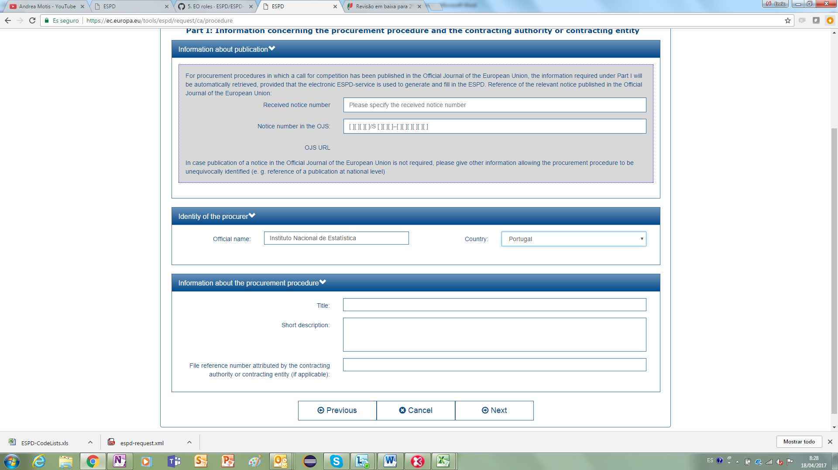

Figure 3: Information about the contracting entity, mock-up

The UBL-2.2 model provides a component that fits that purpose, the common aggregate component ContractingParty.

|  |  |  |  |  |
| --- | --- | --- | --- | --- |
| Element Name | cac:ContractingParty | | | |
| ESPD Use | Used to hold the data about the contracting body, authority or entity | | | |
| File | dist/common/xsdrt/UBL-CommonAggregateComponents-Pre-award.xsd | | | |
| Absolute Path | /QualificationApplicationRequest/cac:ContractingParty | | | |
| Diagram |  | | | |
|  | | | |
| UBL Definition | The contracting party. In the case of the ESPD the contracting entity, body or authority. | | | |
| File | dist/common/xsdrt/UBL-CommonAggregateComponents-Pre-award.xsd | | | |
| Child Name | **Type** | **UBL Cardinality** | **ESPD Cardinality** | **Description** |
| cac:/Party/cac:PartyName/cbc:Name | Text | 0..1 | 1 | The official name of the Contracting Authority. |
| cac:/Party/cac:PostalAddress/cac:Country/cbc:IdentificationCode | Code | 0..1 | 1 | A code signifying the country of the Contracting Authority. |
| cac:/Party/cac:PostalAddress/cac:Country/cbc:Name | Text | 0..1 | 0..1 | The name of the country. |

#### Example

|  |
| --- |
| <cac:ContractingParty>  <cac:Party>  <cac:PartyName>  <cbc:Name>Instituto Nacional de Estatística</cbc:Name>  </cac:PartyName>  <cac:PostalAddress>  <cac:Country>  <cbc:IdentificationCode listID="CountryCodeIdentifier" listAgencyID="ISO" listVersionID="1.0">PT</cbc:IdentificationCode>  </cac:Country>  </cac:PostalAddress>  <cac:Contact/>  </cac:Party>  </cac:ContractingParty> |
| **COMMENTS**   * The ESPD-EDM requires the use the ISO 3166-1 alpha 2 country code identifier Code List (See Code List “CountryCodeIdentifier”); * Beware that the ESPD-EDM requires the specification of the attributes listID, listAgencyID and listVersionID for all the codes. |

### Information about the Procurement Procedure

Three basic data are required by the ESPD-EDM to identify the procurement procedure to which the ESPD belongs: the title, a short description and the file (i.e. case) reference number attributed by the Contracting Authority to the procurement procedure:

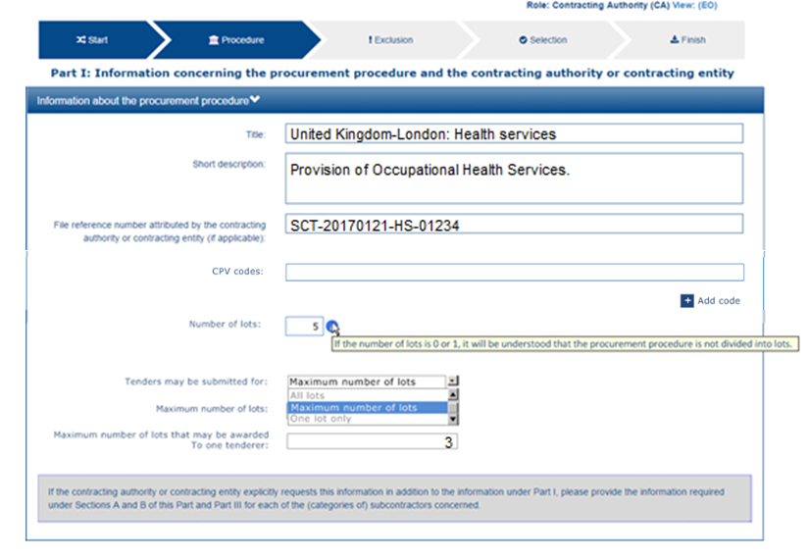

Figure 4: information about the procurement procedure, mock-up

To represent the information about a procurement procedure UBL-2.2 uses the common aggregate component cac:ProcurementProject. For the file (case) reference number, use the component /QualificationApplicationRequest/cbc:ContractFolderId.

Beware that differently to the previous version a cac:ProcurementProject component has been added directly under the root element of the document.

The additional information about is collected in a cac:TenderingCriterion component. Please see section “5.4.3 Example: Information about the Lots” for details and examples.

|  |  |  |  |  |  |
| --- | --- | --- | --- | --- | --- |
| Element Name | cac:ProcurementProject | | | | NEW! |
| ESPD Use | Used to identify the procurement procedure. | | | | |
| File | dist/common/xsdrt/UBL-CommonAggregateComponents-Pre-award.xsd | | | | |
| Absolute Path | /QualificationApplicationRequest/cac:ProcurementProject | | | | |
| Diagram |  | | | | |
| UBL Definition | An overall definition of the procurement procedure. | | | | |
| File | dist/common/xsdrt/UBL-CommonAggregateComponents-Pre-award.xsd | | | | |
| Child Name | **Type** | **UBL Cardinality** | **ESPD Cardinality** | **Description** | |
| cbc:Name | Text | 0..n | 1 | The name of the procurement procedure. | |
| cbc:Description | Text | 0..n | 0..1 | Text describing the procurement procedure. | |

#### Example 1: instantiation of the file reference number

|  |
| --- |
| <?xml version="1.0" encoding="UTF-8"?>  <QualificationApplicationRequest  xmlns="urn:oasis:names:specification:ubl:schema:xsd:QualificationApplicationRequest-2"  xmlns:cac="urn:oasis:names:specification:ubl:schema:xsd:CommonAggregateComponents-2"  xmlns:cbc="urn:oasis:names:specification:ubl:schema:xsd:CommonBasicComponents-2"  xmlns:ext="urn:oasis:names:specification:ubl:schema:xsd:CommonExtensionComponents-2"  xsi:schemaLocation="urn:oasis:names:specification:ubl:schema:xsd:QualificationApplicationRequest-2 ../xsdrt/main/UBL-QualificationApplicationRequest-2.2-Pre-award.xsd">  ...  <cbc:ContractFolderID schemeAgencyID=" UK-SCT">SCT-20170121-HS-01234</cbc:ContractFolderID>  ...  </QualificationApplicationRequest> |

#### Example 2: instantiation of the name and description of the procurement procedure

|  |
| --- |
| <cac:ProcurementProject>  <cbc:Name>United Kingdom-London: Health services</cbc:Name>  <cbc:Description>Provision of Occupational Health Services.</cbc:Description>  </cac:ProcurementProject> |

#### Example 3: instantiation of the CPVs

|  |  |
| --- | --- |
| SELF-CONTAINED ESPD FEATURE | In order for the CA to be able to assess the classification of the EO, the CA may need to provide one or several CPV codes for the procurement procedure in the Request document. Later on, the CA will access the pre-qualification system and verify that that EO is classified for the CPV codes that apply to the procurement procedure. |

The ESPD-EDM Criterion (UBL-2.2 component TenderingCriterion) is at the very core of the ESPD Exchange Data Model. It defines a flexible data structure allowing for the expression of any of the Exclusion and Selection criteria specified in the ESPD Implementing Regulation (1) (the “Regulated” ESPD) and beyond (i.e. all the requirements and information that may be specified by the Contracting Authority in a “Self-contained” ESPD).

In the case of the ESPD this component can be used by the CA to inform the Economic Operators about conditions and requirements that are either specific to the MS or the procurement procedure.

In this version of the ESPD-EDM this resource is used to express the Common Procurement Vocabulary (CPV) codes that describe the services or works of a procurement procedure. See also subsection about the lots, below, for a similar situation and example.

The XML example below shows how to implement this Criterion in the Request document:

|  |
| --- |
| <cac:TenderingCriterion>  <cbc:ID schemeID="CriteriaTaxonomy" schemeAgencyID="EU-COM-GROW" schemeVersionID="2.0.0">fab9ab25-9b2a-43c0-ab46-c3b2bd4859a1</cbc:ID>  <cbc:CriterionTypeCode listID="CriteriaTypeCode" listAgencyID="EU-COM-GROW" listVersionID="2.0.0">CRITERION.OTHER.PROCUREMENT_PROCEDURE_CPV</cbc:CriterionTypeCode>  <cbc:Name> CPVs</cbc:Name>  <cbc:Description>Set of CPVs describing the activities or goods for this procurement procedure.</cbc:Description>  <cac:TenderingCriterionPropertyGroup>  <cbc:ID schemeID="CriteriaID" schemeAgencyID="EU-COM-GROW" schemeVersionID="2.0.0"> 74639b31-c397-4b96-ad77-9ebc4d05d460</cbc:ID>  <cac:TenderingCriterionProperty>  <cbc:ID schemeID="CriteriaID" schemeAgencyID="EU-COM-GROW" schemeVersionID="2.0.0">026e5c77-4a82-4a8a-a986-91966fed6ad8</cbc:ID>  <cbc:Description>CPV</cbc:Description>  <cbc:ValueDataTypeCode listID="ResponseDataType" listAgencyName="EU-COM-GROW" listVersionID="2.0.0">NONE</cbc:ValueDataTypeCode>  <cac:ExpectedCode>13.45</cac:ExpectedCode>  </cac:TenderingCriterionProperty>  <cac:TenderingCriterionProperty>  <cbc:ID schemeID="CriteriaID" schemeAgencyID="EU-COM-GROW" schemeVersionID="2.0.0">026e5c77-4a82-4a8a-a986-91966fed6ad8</cbc:ID>  <cbc:Description>CPV</cbc:Description>  <cbc:ValueDataTypeCode listID="ResponseDataType" listAgencyName="EU-COM-GROW" listVersionID="2.0.0">NONE</cbc:ValueDataTypeCode>  <cac:ExpectedCode>13.46</cac:ExpectedCode>  </cac:TenderingCriterionProperty>  </cac:TenderingCriterionPropertyGroup>  </cac:TenderingCriterion> |

# The ESPD-EDM Criteria

The central element of the ESPD is the concept “Criterion”. In general, criteria are used to ask questions and require data that will be used at evaluation time to exclude or select candidate persons, organisations, products, etc.

The ESPD Exchange Data Model (ESPD-EDM) uses XML data structures to express the questions and ask for (or express) information on the legal exclusion grounds and the capacities (technical, economic and financial, etc.) to exclude or select Economic Operators as candidates to win a Procurement Procedure.

## ESPD-EDM constraints related to the criteria

* The ESPD-EDM requires that the Request document MUST specify ALL the Exclusion criteria and one or more (generally more than one, obviously) Selection criteria;
* **One important aspect of the ESPD-EDM is that all the criteria defined in the Request document MUST also be part of the Response document, both for the Regulated and (especially) the Self-contained modes of the ESPD documents.**
* There are data that that is generic, i.e. not specific of the procurement procedure. The IDs and descriptions are “constant”, .e.g. cannot be modified by the Contracting Authority. **These constant data are defined in e-Certis** (the values for the Criterion IDs and descriptions can be consulted in the list “CriteriaTaxonomy” (file /dist/cl/xls/CriteriaTaxonomy-V2.0.0.xlsx).
* In the ESPD-EDM each Criterion contains always specific properties that MUST be grouped using the UBL-2.2 component TenderingCriterionPropertyGroup. A group of properties MAY contain (and usually contains) sub-groups of properties. The taxonomy of criteria (mentioned in the previous point) is also used in this document to illustrate the predefined data structure for each ESPD Criterion.

## The ESPD-EDM Criteria Taxonomy

As said, the ESPDEDM defines different types of criteria, namely exclusion and selection criteria. It also defines criteria to capture and evaluate other general information about the Economic Operators (e.g. number of employees of the company, for statistical purposes).

The whole set of ESPD-EDM criteria is collected in a spread-sheet and is organised as a taxonomy. This ESPD-EDM Criteria Taxonomy file is distributed jointly with this documentation and is also online and publicly accessible[10].

For the purposes of the ESPD the two main branches of this taxonomy are the Exclusion grounds and the selection criteria. Developers in charge of the implementation of the exchange of ESPD documents should use the Criteria Taxonomy spread-sheet mentioned above (file /dist/cl/xls/CriteriaTaxonomy-2.0.0.xlsx). This file specifies the data structure of each Criterion, as well as the identifiers, types and descriptions of the Criterion elements (a.k.a. “Criterion Properties”).

## Rules to build an ESPD Criterion

In the ESPD-EDM each Criterion is expected in a predefined structure. The implementation of an ESP-EDM the data structure of a Criterion follows always a regular pattern. It is important for the developers to understand and follow the rules applied to build this pattern and implement the corresponding XML code. The figure below shows a fragment of one Criterion (extracted from the Criteria Taxonomy spread-sheet):



Figure 5: The pattern of an ESPD-EDM Criterion

|  |
| --- |
| Legend:   * Cn represent the Criterion; * Gn represent a group of properties; * Gn.n, Gn.n.n, Gn.n.n.n represents sub-groups of Properties. The maximum nesting of sub-groups in ESPD is 4; * Pn represents one Property. |

The regular rules to build this pattern are:

One Criterion expresses a general condition or question. The description of the Criterion may be as long as needed and MUST describe unambiguously what needs to be evaluated. It might also refer to supporting documentation or additional information. Example:

“Has the Economic Operator itself or any person who is a member of its administrative, management or supervisory body or has powers of representation, decision or control therein been the subject of a conviction by final judgment for participation in a criminal organisation, by a conviction rendered at the most five years ago or in which an exclusion period set out directly in the conviction continues to be applicable? As defined in Article 2 of Council Framework Decision 2008/841/JHA of 24 October 2008 on the fight against organised crime (OJ L 300, 11.11.2008, p. 42).","EXCLUSION.CRIMINAL_CONVICTIONS","57(1)”;

In general the Criterion description contains a question that is answered with a “yes” or “not” answer. For the exclusion criteria, the ESPD approach is to draft the question from a “negative perspective”:

*“Has the Economic Operator … been the subject of a conviction …?”*

If the Economic Operator answers ''no'' then it has nothing to justify or motivate. On the contrary if it answers ''yes'' it will have to provide additional data and evidences to prove that the Criterion is satisfied.

This rule is systematically applied to all the exclusion criteria of the ESPD.

If additional data has to be provided by the Economic Operator then the particular questions (or “Criterion Properties”) need to be organised as follows:

* + A Criterion Property MUST always be included in a group; e.g.: “your answer?” in the example above belongs to the group G1 (in other words, Criterion Properties can never been implemented as an isolated element attached directly to the Criterion. See XML examples in this document to check this principle);
  + If the property implies several data, the set of data MUST be grouped; e.g. “date of conviction, reason, who has been convicted, length of the period of exclusion”;
  + If the answer to the property implies one or multiple forking scenarios, the data required in each scenario must be grouped in sub-groups of properties; e.g. “have you taken measures to demonstrate your reliability (Self-cleaning)”.

This document provides multiple examples of XML fragments containing criteria where you can study and verify these rules.

## The ESPD Criterion component

This version 2.0.0 of the ESPD-EDM uses the UBL-2.2 component cac:TenderingCriterion to represent any Exclusion and Selection criteria. The global structure of the UBL-2.2 component is identical to the one in the previous version of the ESPD-EDM. Notice however that the naming of some elements have changed (e.g. “RequirementGroup” and “Requirement” are named as “TenderingCriterionPropertyGroup” and “TenderingCriterionProperty”).

See also section “5.6.3 Example 3: Weighting a selection Criterion” for an example of how to weight a Criterion.

|  |  |  |  |  |  |
| --- | --- | --- | --- | --- | --- |
| Element Name | cac:TenderingCriterion | | | | NEW! |
| ESPD Use | Used to specify any type of criteria (e.g. Exclusion, Selection Criteria or other). In the case of the Self-contained ESPD, the Criterion component is also used by the Contracting Authority to specify concrete requirements of the procurement procedure. | | | | |
| File | dist/common/xsdrt/UBL-CommonAggregateComponents-Pre-award.xsd | | | | |
| Absolute Path | /QualificationApplicationRequest/cac:TenderingCriterion | | | | |
| Diagram |  | | | | |
| UBL Definition | An exclusion or selection Criterion. | | | | |
| File | dist/common/xsdrt/UBL-CommonAggregateComponents-Pre-award.xsd | | | | |
| Child Name | **Type** | **UBL Cardinality** | **ESPD Cardinality** | **Description** | |
| cbc:ID | Identifier | 0..1 | 1 | An identifier to refer to the Criterion requirement. ESPD constraint: Compulsory use of the list “CriteriaTaxonomy”. | |
| cbc:CriterionTypeCode | Code | 0..1 | 1 | A code signifying the type of Criterion. ESPD: Compulsory use of the Code List “CriteriaType”. | |
| cbc:Name | Text | 0..1 | 1 | The name of the Criterion. | |
| cbc:Description | Text | 0..1 | 1 | The textual description for this Criterion. | |
| cbc:WeightNumeric | Numeric | 0..1 | 0..1 | A weighting to provide for automatic scoring of the Criterion. | |
| cbc: EvaluationMethodTypeCode | Code | 0..1 | 0..1 | A code signifying the type of Evaluation. ESPD: Compulsory use of the Code List “EvaluationMethodType” | |
| cbc:weightingConsiderationDescription | Text | 0..1 | 0..1 | The textual description of the Weighting Description | |
| cac: SubTenderingCriterion | Complex | 0..n | 0..n | One or more tendering subcriteria. | |
| cac: Legislation | Complex | 0..n | 0..n | The legislation reference for the Criterion. | |
| cac: TenderingCriterionPropertyGroup | Complex | 0..n | 1..n | The sets of properties that can be used to fulfil the tendering Criterion. In previous versions of the ESPD-EDM this was termed “RequirementGroup”. | |

### Criterion sub-elements

#### Legislation

Beware that:

the previous ESPD-EDM versions named this component LegislationReference.

UBL-2.2 defines an additional element that is not currently used in the ESPD-EDM (JurisdictionRegionAddress) but that could be found useful by the MS.

The table below lists the minimum set of data used in the ESPD-EDM to inform about the legislation related to a Criterion. For details on the rest of unused UBL-2.2 elements see the spread-sheet /dist/mod/UBL-Entities-2.2-Pre-award.xls.xlsx.

|  |  |  |  |  |
| --- | --- | --- | --- | --- |
| Element Name | cac:Legislation | | | |
| ESPD Use | Used to specify the Legislation(s) where the Criterion is defined or mentioned. | | | |
| File | dist/common/xsdrt/UBL-CommonAggregateComponents-Pre-award.xsd | | | |
| Absolute Path | /QualificationApplicationRequest/cac:TenderingCriterion/cac:Legislation | | | |
| Diagram |  | | | |
| UBL Definition | The legislation reference for the Criterion. | | | |
| File | dist/common/xsdrt/UBL-CommonAggregateComponents-Pre-award.xsd | | | |
| Child Name | **Type** | **UBL Cardinality** | **ESPD Cardinality** | **Description** |
| cbc:ID | Identifier | 0..1 | 0..1 | An identifier to refer to the legislation. ESPD: If a DOI (Digital Object Identifier) exists for this legislation please use it here. |
| cbc:Title | Text | 0..n | 1..n | The title of the legislation. |
| cbc:Description | Text | 0..n | 1..n | The textual description of the legislation. |
| cbc:JurisdictionLevel | Text | 0..n | 1 | The jurisdiction level for the legislation. |
| cbc:Article | Text | 0..n | 0..n | The article of the legislation. |
| cbc:URI | URI | 0..n | 0..1 | A URI to the legislation. |

### Groups of Properties and Properties of a Criterion

What really defines the Criterion are its “properties”, i.e. all the specific elements that the Contracting Authority defines inside a Criterion that will help determine whether the Criterion is fulfilled or not. The Criterion can thus be seen as a generic question that the Contracting Authority asks, and the properties are a set of concrete requests (optional or mandatory) and data (in the response) that, altogether, will be assessed to, namely, decide the exclusion or selection of the Economic Operator.

In the ESP these properties are always defined in groups of properties. A group of properties MAY contain (and usually contains) subgroups of properties that will need to be answered by the Economic Operator possibly depending on the answer given to the parent group (see subsections below for examples).

This way the ESPD-EDM predefines specific structures of data per each Exclusion and Selection Criterion.

The table below shows all the elements of the UBL-2.2 component and lists the ones used in the ESPD-EDM.

|  |  |  |  |  |
| --- | --- | --- | --- | --- |
| Element Name | cac:TenderingCriterionPropertyGroup | | | |
| ESPD Use | A group of specific requests (optional or mandatory) that defines a specific data structure for a given Criterion. In the ESPD-EDM these data structures are predefined. See file /dist/cl/xls/CriteriaTaxonomy-V2.0.0.xlsx. | | | |
| File | dist/common/xsdrt/UBL-CommonAggregateComponents-Pre-award.xsd | | | |
| Absolute Path | /QualificationApplicationRequest/cac:TenderingCriterion/cac:TenderingCriterionPropertyGroup | | | |
| Diagram |  | | | |
| UBL Definition |  | | | |
| File | dist/common/xsdrt/UBL-CommonAggregateComponents-Pre-award.xsd | | | |
| Child Name | **Type** | **UBL Cardinality** | **ESPD Cardinality** | **Description** |
| cbc:ID | Identifier | 0..1 | 1 | An identifier to refer to the Criterion property group. |
| cbc:CriteriaGroupTypeCode | Code | 0..1 | 1 | A code signifying the type of group. ESPD: Compulsory use of the Code List “CriteriaType”. |
| cac:TenderingCriterionProperty | Complex | 0..n | 0..n | All the criteria properties comprising the tendering Criterion. |
| cac:SubsidiaryTenderingCriterionPropertyGroup | Complex | 0..n | 0..n | Subsidiary tendering criteria groups comprising this tendering Criterion. ESPD: Subcriteria. |

The next table describes the elements of one Property. Beware that it defines different types of possible data the Contracting Authority may request (and for which it expects an answer from the Economic Operator, e.g. ExpectedID, ExpectedValueNumeric, etc.). See examples of XML snippets below to further understand how this is implemented for the ESPD.

|  |  |  |  |  |
| --- | --- | --- | --- | --- |
| Element Name | cac:TenderingCriterionProperty | | | |
| ESPD Use | Concrete request for (or expression of) one datum specified by the Contracting Authority. The request for data is answered by the Economic Operator in the Qualification Application Response document. | | | |
| File | dist/common/xsdrt/UBL-CommonAggregateComponents-Pre-award.xsd | | | |
| Absolute Path | /QualificationApplicationRequest/cac:TenderingCriterion/cac:TenderingCriterionPropertyGroup/cac:TenderingCriterionProperty | | | |
| Diagram |  | | | |
| UBL Definition | All the criteria properties comprising the tendering Criterion. | | | |
| File | dist/common/xsdrt/UBL-CommonAggregateComponents-Pre-award.xsd | | | |
| Child Name | **Type** | **UBL Cardinality** | **ESPD Cardinality** | **Description** |
| cbc:ID | Identifier | 0..1 | 1 | An identifier to refer to the Criterion property. |
| cbc:Name | Text | 0..1 | 0..1 | The name of the Criterion requirement |
| cbc:Description | Text | 0..n | 1 | A description of the Criterion requirement |
| cbc:ValueDataTypeCode | Code | 0..1 | 1 | The data type of the numeric value and any constraints on the data type metadata. ESPD: The expected type of the data. Compulsory use of the Code List “ResponseDataType”. |
| cbc:ValueUnitCode | Code | 0..1 | 0..1 | The unit of measure of the numeric value as a quantity or measure. |
| cbc:ValueCurrencyCode | Code | 0..1 | 0..1 | The currency of the numeric value as an amount. |
| cbc:ExpectedID | Identifier | 0..1 | 0..1 | The expected identifier that the responder has to provide in the Criterion response. |
| cbc:ExpectedCode | Code | 0..1 | 0..1 | The expected code that the responder has to provide in the Criterion response. |
| cbc:ExpectedValueNumeric | Numeric | 0..1 | 0..1 | The expected value that the responder has to provide in the Criterion response. |
| cbc:MaximumValueNumeric | Numeric | 0..1 | 0..1 | The maximum value the response must have. |
| cbc:MinimumValueNumeric | Numeric | 0..1 | 0..1 | The minimum value the response must have. |
| cbc:CertificationLevelDescription | Text | 0..1 | 0..1 | The description of the level of the expected certification. |
| cac:ApplicablePeriod |  | 0..1 | 0..1 | The period to which this Criterion requirement shall apply. |

### Example: Information about the Lots

|  |  |
| --- | --- |
| SELF-CONTAINED ESPD FEATURE | Lots management:  The Contracting Authority (CA) needs to be able to provide the number of lots into which the procurement procedure is divided in the Request document.  The CA provides, for each criteria in Part IV of the ESPD Request document, the specific requirements and the set of lots these requirements apply to. By default, all specific requirements will apply to all lots, so the CA must only select the lots for requirements that apply only to particular lots;  The EO provides the lots for which the economic operator wishes to tender in Part II of the ESPD Response document;  When the EO relies on the capacities of other entities in order to meet the selection criteria, the EO must provide the lots for each entity in Part II of the ESPD Response document;  In Part IV of the ESPD Response document, the system will display the specific requirements that apply to each lot, and the EO will be able to provide information for specific lots. |

If the procurement procedure is divided into lots, the CA shall provide the number of lots. By doing this, the ESPD-EDM will also allow the Contracting Authority to –per each Criterion—link specific requirements to the set of lots these requirements apply to. See the sections regarding the component “Criterion”, further on in this document.

**The UBL-2.2 component used to specify the lots is** cac:ProcurementProjectLot**. Notice that this UBL-2.2. element does in turn contain a** cac:ProcurementProject **component, which is used by UBL to further describe the lot.** The ESPD-EDM does not use the component cac:ProcurementProject inside the ProcurementProjectLot)**.**

**The number of lots specified by the Contracting Authority (CA) ends up in the instantiation of as many ProcurementProjectLot objects as specified by the CA.**

|  |  |  |  |  |
| --- | --- | --- | --- | --- |
| Element Name | cac:ProcurementProjectLot | | | |
| ESPD Use | Used to identify the lots into which a procurement procedure is divided into. The ESPD-EDM only uses the Identifier of the Lot from this UBL-2.2. component. Typical examples of lot identifiers are Lot1, Lot2, Lot3, etc. | | | |
| File | dist/common/xsdrt/UBL-CommonAggregateComponents-Pre-award.xsd | | | |
| Absolute Path | /QualificationApplicationRequest/cac:ProcurementProjectLot | | | |
| Diagram |  | | | |
| UBL Definition | One of the procurement project lots into which this contract can be split. | | | |
| File | dist/common/xsdrt/UBL-CommonAggregateComponents-Pre-award.xsd | | | |
| Child Name | **Type** | **UBL Cardinality** | **ESPD Cardinality** | **Description** |
| cbc:ID | Identifier | 1 | 1 | An identifier for this procurement project lot. |

#### CA view

The mock-up below shows a possible mock-up where the Contracting Authority specifies the information about the lots:

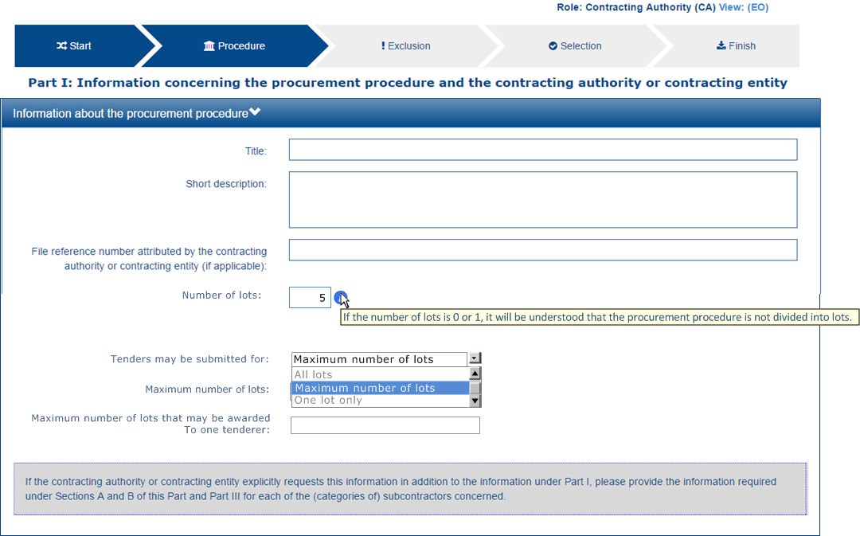

Figure 6: Information about lots, mock-up

#### EO view

The Economic Operator, in turn MUST specify to which lots it will tender:

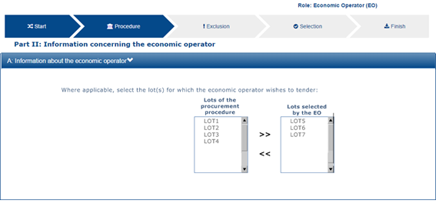

Figure 7: Lots to which the Economic Operator whishes to tender

#### Data structure

The data structure to present this information, pre-defined in the Criteria Taxonomy, looks as follows:



#### XML example

Aligned with the mock-up presented above, if the Contracting Authority specifies 5 lots, the ESPD-EDM instantiates five ProcurementProjectLot components. Although the ESPD-EDM does only uses the ID field, National systems MAY use this component to further describe the lots, if so they desire.

|  |
| --- |
| ...  <cac:ProcurementProjectLot>  <cbc:ID>Lot1</cbc:ID>  </cac:ProcurementProjectLot>  <cac:ProcurementProjectLot>  <cbc:ID>Lot2</cbc:ID>  </cac:ProcurementProjectLot>  <cac:ProcurementProjectLot>  <cbc:ID>Lot3</cbc:ID>  </cac:ProcurementProjectLot>  <cac:ProcurementProjectLot>  <cbc:ID>Lot4</cbc:ID>  </cac:ProcurementProjectLot>  <cac:ProcurementProjectLot>  <cbc:ID>Lot5</cbc:ID>  </cac:ProcurementProjectLot>  ... |

The rest of information about the lots (“tenders must be submitted for…”, “maximum number of lots”, “maximum number of lots that may be awarded”) is treated as the elements (or properties) of a “Criterion” named “Additional information about the Lots”.

The example bellows shows how to capture this additional information in a Criterion. For the details on the schema and the different data structures of the different criteria please see the section “Exclusion and Selection Criteria in the Request document”, below. Notice that the last Property asks to specify the lots to which the economic operator (or the group it leads) wishes to tender. See section “6.6.1 XXXX” for an example on how to respond this request.

|  |
| --- |
| <cac:TenderingCriterionPropertyGroup>  <cbc:ID schemeID="CriteriaID" schemeAgencyID="EU-COM-GROW" schemeVersionID="2.0.0">69c1de17-3256-4920-9d46-1e7da839b279</cbc:ID>  <cac:TenderingCriterionProperty>  <cbc:ID schemeID="CriteriaID" schemeAgencyID="EU-COM-GROW" schemeVersionID="2.0.0">e0036f1c-8129-430b-ab8a-4e1d8703ddeb</cbc:ID>  <cbc:Description>Please take into account the following requirements regarding the lots of this procurement procedure:</cbc:Description>  <cbc:ValueDataTypeCode listID="ResponseDataType" listAgencyName="EU-COM-GROW" listVersionID="2.0.0">NONE</cbc:ValueDataTypeCode>  </cac:TenderingCriterionProperty>  <cac:SubsidiaryTenderingCriterionPropertyGroup>  <cbc:ID schemeID="CriteriaID" schemeAgencyID="EU-COM-GROW" schemeVersionID="2.0.0">eabd66bb-6899-469b-bb17-80177a2d7f7a</cbc:ID>  <cac:TenderingCriterionProperty>  <cbc:ID schemeID="CriteriaID" schemeAgencyID="EU-COM-GROW" schemeVersionID="2.0.0">f0a38925-a8ee-4753-942d-deca0262ed94</cbc:ID>  <cbc:Description>Tenders may be submitted for:</cbc:Description>  <cbc:ValueDataTypeCode listID="ResponseDataType" listAgencyID="EU-COM-GROW" listVersionID="2.0.0">NONE</cbc:ValueDataTypeCode>  <cbc:ExpectedCode listID="NumberOfLotsCode" listAgencyName="EU-COM-GROW" listVersionID="2.0.0">MAX</cbc:ExpectedCode>  </cac:TenderingCriterionProperty>  <cac:TenderingCriterionProperty>  <cbc:ID schemeID="CriteriaID" schemeAgencyID="EU-COM-GROW" schemeVersionID="2.0.0">8d899045-1031-467f-a2b4-58ef9b1f719d</cbc:ID>  <cbc:Description>Maximum number of lots</cbc:Description>  <cbc:ValueDataTypeCode listID="ResponseDataType" listAgencyID="EU-COM-GROW" listVersionID="2.0.0">NONE</cbc:ValueDataTypeCode>  <cbc:ExpectedValueNumeric>5</cbc:ExpectedValueNumeric>  </cac:TenderingCriterionProperty>  <cac:TenderingCriterionProperty>  <cbc:ID schemeID="CriteriaID" schemeAgencyID="EU-OM-GROW" schemeVersionID="2.0.0">8d899045-1031-467f-a2b4-58ef9b1f719d</cbc:ID>  <cbc:Description>Maximum number of lots that may be awarded to one tenderer</cbc:Description>  <cbc:ValueDataTypeCode listID="ResponseDataType" listAgencyID="EU-COM-GROW" listVersionID="2.0.0">NONE</cbc:ValueDataTypeCode>  <cbc:ExpectedValueNumeric>1</cbc:ExpectedValueNumeric>  </cac:TenderingCriterionProperty>  </cac:SubsidiaryTenderingCriterionPropertyGroup>  </cac:TenderingCriterionPropertyGroup>  <cac:TenderingCriterionPropertyGroup>  <cbc:ID schemeID="CriteriaID" schemeAgencyID="EU-COM-GROW" schemeVersionID="2.0.0">7ad7f4b0-98eb-4d7e-8fd5-e1350de20cc2</cbc:ID>  <cac:TenderingCriterionProperty>  <cbc:ID schemeID="CriteriaID" schemeAgencyID="EU-COM-GROW" schemeVersionID="2.0.0">13441726-e488-40ff-8202-758a325c1a38</cbc:ID>  <cbc:Description>Please provide the lots to which you are tendering</cbc:Description>  <cbc:ValueDataTypeCode listID="ResponseDataType" listAgencyID="EU-COM-GROW" listVersionID="2.0.0">IDENTIFIER</cbc:ValueDataTypeCode>  </cac:TenderingCriterionProperty>  </cac:TenderingCriterionPropertyGroup>  </cac:TenderingCriterion> |
| **COMMENTS:**  Observe that this Criterion has one group of properties containing a sub-group (component cac:SubsidiaryTenderingCriterionPropertyGroup) where the three requirements about the lots are actually specified:   * + The tenderers may submit tenders for the maximum number of lots;   + The Contracting Authority specifies a maximum number of 5 lots;   + One tenderer can only win 1 lot.   Notice also the code NONE used in the ValueDataTypeCode element. This code indicates that for this Criterion the Contracting Authority does not expect any answer from the Economic Operator (in the QualificationApplicationResponse document);  Only the last Criterion Property is intended to be answered by the EO. |

## Exclusion criteria

Exclusion criteria may be grouped in several different categories. The figure below is intended to identify and list these categories for the Exclusion criteria (branches in text boxes), and specific subgroups within each category (leaves in text without boxes):

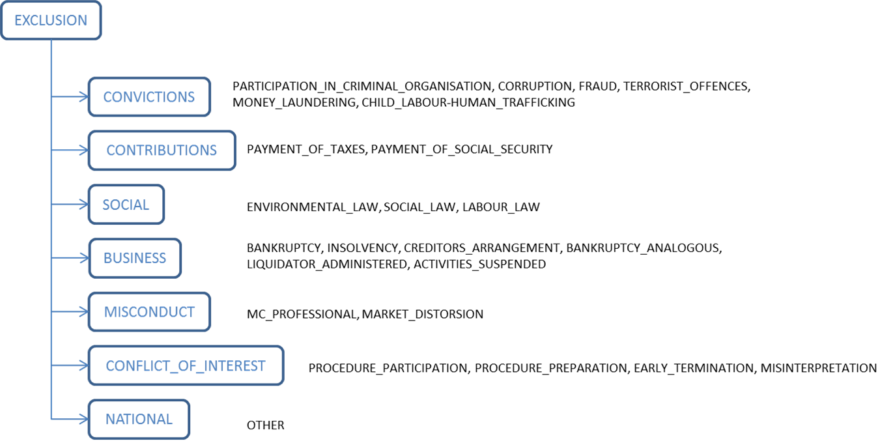

Figure 8: Exclusion criteria taxonomy

The following subsection, below, illustrates how to implement these exclusion criteria.

### Exclusion criteria XML implementation

All the exclusion criteria in the ESPD-EDM follow the same rules for its implemention as XML:

1. Any element in the Criterion is compulsorily identified with a UUID generated by e-Certis;
2. Each exclusion criteria has a root EU Criterion and may have national or subnational sub-criteria. National and sub-national criteria are always nested under its parent EU exclusion Criterion;
3. For self-contained ESPDs, the Contracting Authority may add specific MS or procurement procedure requirements for a concrete exclusion criteria (see example for “Payment of Taxes” where the CA may specify a minimum threshold of unpaid taxes for certain countries where small debts with the MS Tax Agency do not exclude the Economic Operator).

### Example 1: A Conviction Exclusion Criterion with national sub-criteria

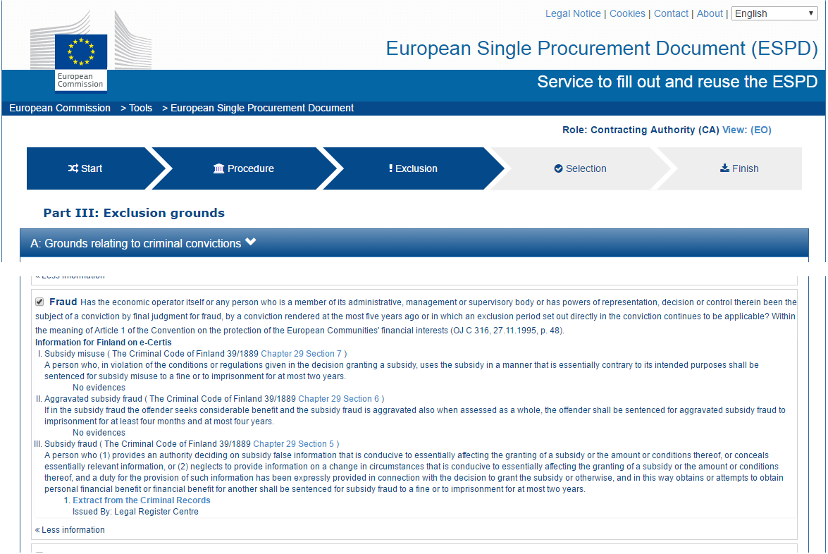

Figure 9: EU Criterion Conviction (fraud) and national fraud-related criteria (CA mock-up)

In the example mock-up above the EU “fraud” Criterion is followed by specific national fraud-related criteria. The data structure for both the EU and the national criteria is the same (see the figure below). In the XML implementation the national criteria are “nested” inside the EU criteria (see also the XML example below).

In a software application managing the response (e.g. the ESPD Service) the Economic Operator view would vary depending on whether it answers “yes” or “no”. If yes the presumption is that the Economic Operator is in breach of the Criterion and therefore it is required to provide additional data (Criterion “properties”). The mock-up below shows the data that is required by the Contracting Authority, in case of an affirmative response, for the EU Criterion. The same structure would be repeated per each national criteria (see section “4.7 Purely national criteria” for an example of mock-up with a similar behaviour).

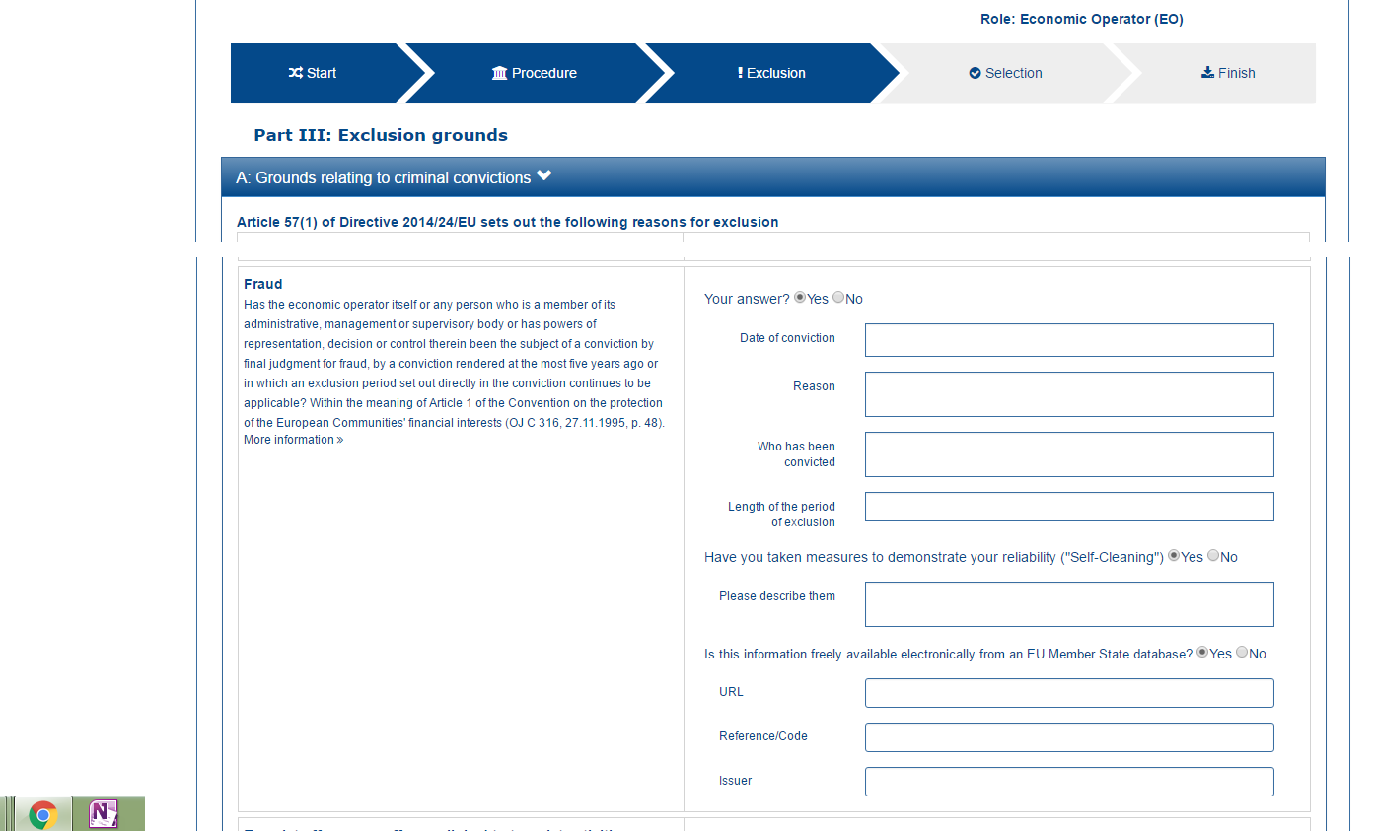

Figure 10: EU Criterion Conviction (fraud) Criterion (EO mock-up)

#### Data structure

The regular structure for a EU and national Conviction Criterion is as follows (this figure is a screen-capture of the list “CriteriaTaxonomy”, file /dist/cl/xls/CriteriaTaxonomy-V2.0.0.xlsx:



Figure 11: Regular structure for a EU or national Conviction Criterion

#### XML examples

The example below defines an EU “Fraud” Criterion. It also includes national groups of requirements (collapsed for the sake of clarity) and national sub-criteria (also collapsed). Other examples following this one show the groups of requirements and the national sub-criteria in detail.

Details on the EU Criterion and the EU Legislation:

|  |
| --- |
| <cac:TenderingCriterion>  <cbc:ID schemeID="CriteriaTaxonomy" schemeAgencyID="EU-COM-GROW" schemeVersionID="2.0..0">297d2323-3ede-424e-94bc-a91561e6f320</cbc:ID>  <cbc:CriterionTypeCode listID="CriteriaTypeCode" listAgencyID="EU-COM-GROW" listVersionID="2.0.0">CRITERION.EXCLUSION.CONVICTIONS.FRAUD</cbc:CriterionTypeCode>  <cbc:Name>Fraud</cbc:Name>  <cbc:Description>Has the Economic Operator itself or any person who is a member of its administrative, management or supervisory body or has powers of representation, decision or control therein been the subject of a conviction by final judgment for fraud, by a conviction rendered at the most five years ago or in which an exclusion period set out directly in the conviction continues to be applicable? Within the meaning of Article 1 of the Convention on the protection of the European Communities' financial interests (OJ C 316, 27.11.1995, p. 48).</cbc:Description>  <!-- National criteria follow -->  <cac:SubTenderingCriterion> .. </cac:SubTenderingCriterion>  <cac:SubTenderingCriterion> .. </cac:SubTenderingCriterion>  <cac:SubTenderingCriterion> .. </cac:SubTenderingCriterion>  <!-- EU Criterion Legislation-->  <cac:Legislation>  <cbc:Title>DIRECTIVE 2014/24/EU OF THE EUROPEAN PARLIAMENT AND OF THE COUNCIL of 26 February 2014 on public procurement and repealing Directive 2004/18/EC</cbc:Title>  <cbc:Description>Directive 2014/24/EU</cbc:Description>  <cbc:JurisdictionLevel>EU DIRECTIVE></cbc:JurisdictionLevel>  <cbc:Article>57(1)</cbc:Article>  <cbc:URI>http://eur-lex.europa.eu/legal-content/EN/TXT/?uri=celex:32014L0024</cbc:URI>  </cac:Legislation>  <!-- EU Criterion properties -->  <cac:TenderingCriterionPropertyGroup>  <cac:TenderingCriterionProperty/>  </cac:TenderingCriterionPropertyGroup>  </cac:TenderingCriterion> |
| **COMMENTS**:   * For the EU and national criteria identifiers use the ones generated by e-Certis. In the case of the EU criteria they are the same as in the Criteria Taxonomy spread-sheet; * Notice that for the EU Legislation the expected title is in fact the long description of the legislation and the description is a short text (Directive 2014/24/EU). |

Details on the properties of the EU Criterion follow (see structure in “Figure 7: Regular structure for a EU or national Conviction Criterion”):

|  |
| --- |
| <cac:TenderingCriterion>  ...  <cbc:Name>Fraud</cbc:Name>  <cbc:Description>Has the Economic Operator itself or any person who is ... </cbc:Description>  <!-- National criteria follow -->  <cac:SubTenderingCriterion> ... </cac:SubTenderingCriterion>  <cac:SubTenderingCriterion> ... </cac:SubTenderingCriterion>  ...  <!-- EU Criterion Legislation-->  <cac:Legislation> ... </cac:Legislation>  <!-- EU Criterion properties -->  <cac:TenderingCriterionPropertyGroup>  <cbc:ID schemeAgencyID="EU-COM-GROW" schemeVersionID="2.0.0">7c637c0c-7703-4389-ba52-02997a055bd7</cbc:ID>  <cac:TenderingCriterionProperty>  <cbc:ID schemeAgencyID="EU-COM-GROW" schemeVersionID="2.0.0">974c8196-9d1c-419c-9ca9-45bb9f5fd59a</cbc:ID>  <cbc:Description>Your answer?</cbc:Description>  <cbc:ValueDataTypeCode listID="ResponseDataType" listAgencyID="EU-COM-GROW" listVersionID="2.0.0">INDICATOR</cbc:ValueDataTypeCode>  </cac:TenderingCriterionProperty>  <cac:SubsidiaryTenderingCriterionPropertyGroup>  <cbc:ID schemeAgencyID="EU-COM-GROW" schemeVersionID="2.0.0">41dd2e9b-1bfd-44c7-93ee-56bd74a4334b</cbc:ID>  <cac:TenderingCriterionProperty>  <cbc:ID schemeAgencyID="EU-COM-GROW" schemeVersionID="2.0.0">ecf40999-7b64-4e10-b960-7f8ff8674cf6</cbc:ID>  <cbc:Description>Date of conviction</cbc:Description>  <cbc:ValueDataTypeCode listID="ResponseDataType" listAgencyID="EU-COM-GROW" listVersionID="2.0.0">DATE</cbc:ValueDataTypeCode>  </cac:TenderingCriterionProperty>  <cac:TenderingCriterionProperty>  <cbc:ID schemeAgencyID="EU-COM-GROW" schemeVersionID="2.0.0">7d35fb7c-da5b-4830-b598-4f347a04dceb</cbc:ID>  <cbc:Description>Reason</cbc:Description>  <cbc:ValueDataTypeCode listID="ResponseDataType" listAgencyID="EU-COM-GROW" listVersionID="2.0.0">DESCRIPTION</cbc:ValueDataTypeCode>  </cac:TenderingCriterionProperty>  <cac:TenderingCriterionProperty>  <cbc:ID schemeAgencyID="EU-COM-GROW" schemeVersionID="2.0.0">c5012430-14da-454c-9d01-34cedc6a7ded</cbc:ID>  <cbc:Description>Who has been convicted</cbc:Description>  <cbc:ValueDataTypeCode listID="ResponseDataType" listAgencyID="EU-COM-GROW" listVersionID="2.0.0">DESCRIPTION</cbc:ValueDataTypeCode>  </cac:TenderingCriterionProperty>  <cac:TenderingCriterionProperty>  <cbc:ID schemeAgencyID="EU-COM-GROW" schemeVersionID="2.0.0">9ca9096f-edd2-4f19-b6b1-b55c83a2d5c8</cbc:ID>  <cbc:Description>Length of the period of exclusion</cbc:Description>  <cbc:ValueDataTypeCode listID="ResponseDataType" listAgencyID="EU-COM-GROW" listVersionID="2.0.0">PERIOD</cbc:ValueDataTypeCode>  </cac:TenderingCriterionProperty>  <cac:SubsidiaryTenderingCriterionPropertyGroup>  <cbc:ID schemeAgencyID="EU-COM-GROW" schemeVersionID="2.0.0">5f9f09f7-f701-432c-9fdc-c22c124a74c9</cbc:ID>  <cac:TenderingCriterionProperty>  <cbc:ID schemeAgencyID="EU-COM-GROW" schemeVersionID="2.0.0">20c5361b-7599-4ee6-b030-7f8323174d1e</cbc:ID>  <cbc:Description>Have you taken measures to demonstrate your reliability (Self-Cleaning)?</cbc:Description>  <cbc:ValueDataTypeCode listID="ResponseDataType" listAgencyID="EU-COM-GROW" listVersionID="2.0.0">INDICATOR</cbc:ValueDataTypeCode>  </cac:TenderingCriterionProperty>  <cac:SubsidiaryTenderingCriterionPropertyGroup>  <cbc:ID schemeAgencyID="EU-COM-GROW" schemeVersionID="2.0.0">74e6c7b4-757b-4b40-ada6-fad6a997c310</cbc:ID> <cac:TenderingCriterionProperty>  <cbc:ID schemeAgencyID="EU-COM-GROW" schemeVersionID="2.0.0">7b07904f-e080-401a-a3a1-9a3efeeda54b</cbc:ID>  <cbc:Description>Please describe them</cbc:Description> <cbc:ValueDataTypeCode listID="ResponseDataType" listAgencyID="EU-COM-GROW" listVersionID="2.0.0">DESCRIPTION</cbc:ValueDataTypeCode>  </cac:TenderingCriterionProperty>  </cac:SubsidiaryTenderingCriterionPropertyGroup>  </cac:SubsidiaryTenderingCriterionPropertyGroup>  </cac:SubsidiaryTenderingCriterionPropertyGroup>  </cac:TenderingCriterionPropertyGroup>  <cac:TenderingCriterionPropertyGroup>  <cbc:ID schemeAgencyID="EU-COM-GROW" schemeVersionID="2.0.0">7458d42a-e581-4640-9283-34ceb3ad4345</cbc:ID>  <cac:TenderingCriterionProperty>  <cbc:ID schemeAgencyID="EU-COM-GROW" schemeVersionID="2.0.0">c1347b74-1872-4060-a6db-f4044edcd7c4</cbc:ID>  <cbc:Description>Is this information available electronically?</cbc:Description>  <cbc:ValueDataTypeCode listID="ResponseDataType" listAgencyID="EU-COM-GROW" listVersionID="2.0.0">INDICATOR</cbc:ValueDataTypeCode>  </cac:TenderingCriterionProperty>  <cac:SubsidiaryTenderingCriterionPropertyGroup>  <cbc:ID schemeAgencyID="EU-COM-GROW" schemeVersionID="2.0.0">41dd2e9b-1bfd-44c7-93ee-56bd74a4334b</cbc:ID>  <cac:TenderingCriterionProperty>  <cbc:ID schemeAgencyID="EU-COM-GROW" schemeVersionID="2.0.0">f4313bb6-21b6-499e-bdff-debe10e11d2c</cbc:ID>  <cbc:Description>URL</cbc:Description>  <cbc:ValueDataTypeCode listID="ResponseDataType" listAgencyID="EU-COM-GROW" listVersionID="2.0.0">EVIDENCE_URL</cbc:ValueDataTypeCode>  </cac:TenderingCriterionProperty>  <cac:SubsidiaryTenderingCriterionPropertyGroup>  <cbc:ID schemeAgencyID="EU-COM-GROW" schemeVersionID="2.0.0">1f1cd18e-3e01-4ca2-af4c-e2981924ba8d</cbc:ID>  <cac:TenderingCriterionProperty>  <cbc:ID schemeAgencyID="EU-COM-GROW" schemeVersionID="2.0.0">Verification Code</cbc:ID>  <cbc:Description>Please describe them</cbc:Description>  <cbc:ValueDataTypeCode listID="ResponseDataType" listAgencyID="EU-COM-GROW" listVersionID="2.0.0">CODE</cbc:ValueDataTypeCode>  </cac:TenderingCriterionProperty>  </cac:SubsidiaryTenderingCriterionPropertyGroup>  </cac:SubsidiaryTenderingCriterionPropertyGroup>  </cac:TenderingCriterionPropertyGroup>  </cac:TenderingCriterion> |

Nesting of a national criteria inside the EU Criterion. The groups of properties have been collapsed for the sake of brevity.

|  |
| --- |
| <cac:TenderingCriterion>  ...  <cbc:Name>Fraud</cbc:Name>  <cbc:Description>Has the Economic Operator itself or any person who is ...</cbc:Description>  <!-- National criteria follow -->  <cac:SubTenderingCriterion>  <cbc:ID schemeAgencyID="EU-COM-GROW" schemeVersionID="2.0.0">719585f3-4b46-45ca-97bd-ad389c6a85bc</cbc:ID>  <cbc:Name>Subsidy misuse ( The Criminal Code of Finland 39/1889 Chapter 29 Section 7 )</cbc:Name>  <cbc:Description>A person who, in violation of the conditions or regulations given in the decision granting a subsidy, uses the subsidy in a manner that is essentially contrary to its intended purposes shall be sentenced for subsidy misuse to a fine or to imprisonment for at most two years.</cbc:Description>  <cac:Legislation>  <cbc:Title>The Criminal Code of Finland 39/1889 </cbc:Title>  <cbc:JurisdictionLevel>National - Finland</cbc:JurisdictionLevel>  <cbc:Article>9 Chapter 29 Section 7</cbc:Article>  <cbc:URI>http://www.finlex.fi/en/laki/kaannokset/1889/en18890039.pdf</cbc:URI>  </cac:Legislation>  <!— Beware that the groups of properties, i.e. the data structure, is identical to the one in the parent EU Criterion -->  <cac:TenderingCriterionPropertyGroup> ... </cac:TenderingCriterionPropertyGroup>  <cac:TenderingCriterionPro**p**ertyGroup> ... </cac:TenderingCriterionPropertyGroup>  </cac:SubTenderingCriterion>  <cac:SubTenderingCriterion>  <cbc:ID schemeAgencyID="EU-COM-GROW" schemeVersionID="2.0.0">37e9d9b8-4888-496f-80e2-0297bc2458c2</cbc:ID>  <cbc:Name>Aggravated subsidy fraud</cbc:Name>  <cbc:Description>If in the subsidy fraud the offender seeks considerable benefit and the subsidy fraud is aggravated also when assessed as a whole, the offender shall be sentenced for aggravated subsidy fraud to imprisonment for at least four months and at most four years.</cbc:Description>  <cac:Legislation>  <cbc:Title>The Criminal Code of Finland 39/1889 </cbc:Title>  <cbc:JurisdictionLevel>National - Finland</cbc:JurisdictionLevel>  <cbc:Article>9 Chapter 29 Section 6</cbc:Article>  <cbc:URI>http://www.finlex.fi/en/laki/kaannokset/1889/en18890039.pdf</cbc:URI>  </cac:Legislation>  <!— Beware that the groups of properties, i.e. the data structure, is identical to the one in the parent EU Criterion -->  <cac:TenderingCriterionPropertyGroup> .. </cac:TenderingCriterionPropertyGroup>  <cac:TenderingCriterionPropertyGroup> .. </cac:TenderingCriterionPropertyGroup>  </cac:SubTenderingCriterion>  <cac:SubTenderingCriterion>  <cbc:ID schemeAgencyID="EU-COM-GROW" schemeVersionID="2.0.0">da817378-3871-4ece-b5ab-2d7b45d06e36</cbc:ID>  <cbc:Name>Subsidy fraud</cbc:Name>  <cbc:Description>A person who (1) provides an authority deciding on subsidy false information that is conducive to essentially affecting the granting of a subsidy or the amount or conditions thereof, or conceals essentially relevant information, or (2) neglects to provide information on a change in circumstances that is conducive to essentially affecting the granting of a subsidy or the amount or conditions thereof, and a duty for the provision of such information has been expressly provided in connection with the decision to grant the subsidy or otherwise, and in this way obtains or attempts to obtain personal financial benefit or financial benefit for another shall be sentenced for subsidy fraud to a fine or to imprisonment for at most two years.</cbc:Description>  <cac:Legislation>  <cbc:Title>The Criminal Code of Finland 39/1889 </cbc:Title>  <cbc:JurisdictionLevel>National - Finland</cbc:JurisdictionLevel>  <cbc:Article>9 Chapter 29 Section 5</cbc:Article>  <cbc:URI>http://www.finlex.fi/en/laki/kaannokset/1889/en18890039.pdf</cbc:URI>  </cac:Legislation>  <!— Beware that the groups of properties, i.e. the data structure, is identical to the one in the parent EU Criterion -->  <cac:TenderingCriterionPropertyGroup> ... </cac:TenderingCriterionPropertyGroup>  <cac:TenderingCriterionPropertyGroup> ... </cac:TenderingCriterionPropertyGroup> ...  </cac:SubTenderingCriterion>  ...  </cac:TenderingCriterion> |

### Example 2: EU Payment of Taxes Criterion with a national specific requirement

|  |  |
| --- | --- |
| SELF-CONTAINED ESPD FEATURE | Payment of taxes and social contributions:  Member States should be able to provide in e-Certis their required thresholds for unpaid taxes or social security contributions, or to indicate that it is up to the CA to indicate the threshold in each particular procurement procedure.  Grounds relating to the payment of taxes or social security contributions should retrieve the information available from e-Certis and provide the CA the possibility to indicate the threshold and currency (when this information is not available in e-Certis), as well as additional information in a free text field. |

The Payment of Taxes Criterion, and the one on Social Security contribution, are possibly the ones with a more complex data structure in the ESPD-EDM. Hence the interest in showing how to implement its XML instance. The rest of criteria are simpler and their implementation can be inferred from the pattern rules established in section “4.1 The ESPD-EDM Criteria Taxonomy”, the data structures in the Criteria Taxonomy spread-sheet and the rest of examples in this document.

The mock-up below simulates the view from where the Contracting Authority could introduce these Criterion Properties that do not require an answer from the Economic Operator.

#### Contracting Authority view

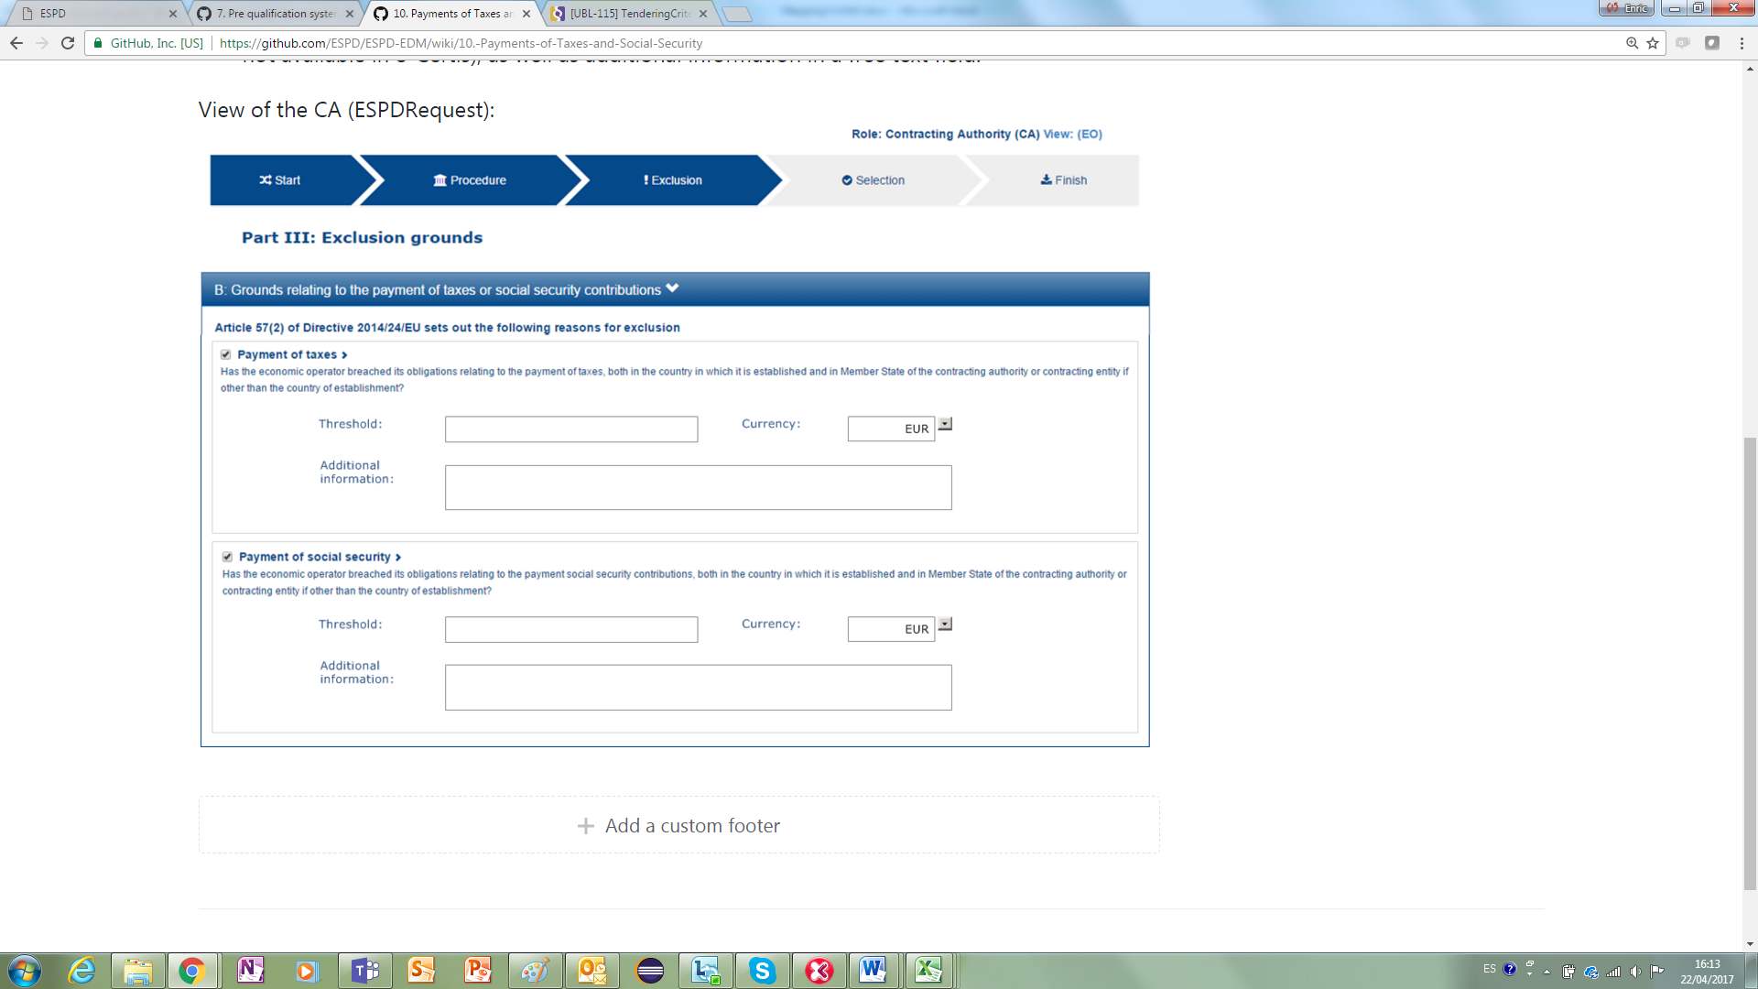

Figure 12: Establishment of MS-specific requirements for the Payment of Taxes

The figure below shows the data structure of the Payment of Taxes Criterion. Notice that the Criterion defines Properties for which an answer is not required, but aim at informing the economic operator specific MS information (in this case it informs of the minimum amount or threshold of debt that is legally permitted in the country where the economic operator is tendering: fields “Threshold”, “Currency” and “Additional Information").



In this case the EO needs to know the threshold of the buyer regarding unpaid taxes or social security obligations. In order to provide this information to the EO:

* The Member State can indicate in e-Certis that this requirement makes no sense for its country (most EU MS do not allow any debt related to taxes or social security). In this case neither a user GUI nor the XML instance should reflect this aspect;
* Otherwise the Member States either maintain in e-Certis their required thresholds or indicate that it is up to the CA to specify the threshold in each particular procurement procedure.
* If the threshold is kept in e-Certis, this information would be retrieved from e-Certis; otherwise the CA would have the possibility of indicating the threshold and currency, as well as additional information in a free text field.

The mock-up below illustrates how this would look like from the CA point of view when it is up to the CA to indicate the threshold:

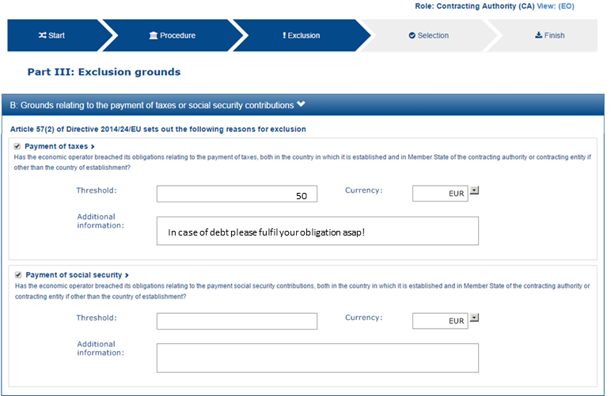

Figure 13: Payment of taxes and social security and specific national requirement (thresholds) CA view

#### Economic Operator view

The mock-up below illustrates the EO view from a software application managing the Response (e.g. the ESPD Service):

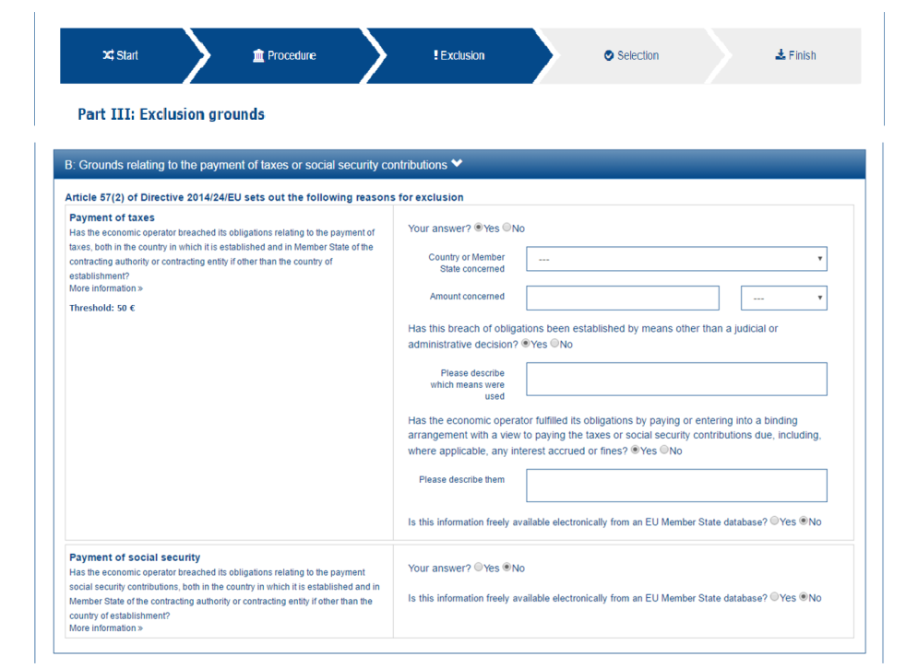

Figure 14: Payment of taxes and social security and specific national requirement (thresholds) EO view

#### XML implementation

Details on how to specify the Criterion and the Contracting Authority’s specific threshold information (details on the properties to be answered by the EO follow in a subsequent example below):

|  |
| --- |
| <cac:TenderingCriterion>  <cbc:ID schemeID="CriteriaTaxonomy" schemeAgencyID="EU-COM-GROW" schemeVersionID="2.0..0">b61bbeb7-690e-4a40-bc68-d6d4ecfaa3d4</cbc:ID>  <cbc:CriterionTypeCode listID="CriteriaTypeCode" listAgencyID="EU-COM-GROW" listVersionID="2.0.0">CRITERION.EXCLUSION.CONTRIBUTIONS.PAYMENT_OF_TAXES</cbc:CriterionTypeCode>  <cbc:Name>Payment of Taxes</cbc:Name>  <cbc:Description>Has the Economic Operator breached its obligations relating to the payment of taxes, both in the country in which it is established and in Member State of the Contracting Authority or contracting entity if other than the country of establishment?</cbc:Description>  <!-- EU Criterion Legislation-->  <cac:Legislation>  <cbc:Title>DIRECTIVE 2014/24/EU OF THE EUROPEAN PARLIAMENT AND OF THE COUNCIL of 26 February 2014 on public procurement and repealing Directive 2004/18/EC</cbc:Title>  <cbc:Description>Directive 2014/24/EU</cbc:Description>  <cbc:JurisdictionLevel>EU DIRECTIVE></cbc:JurisdictionLevel>  <cbc:Article>57(2))</cbc:Article>  <cbc:URI>[http://eur-lex.europa.eu/legal-content/EN/TXT/?uri=celex:32014L0024</cbc:URI](http://eur-lex.europa.eu/legal-content/EN/TXT/?uri=celex:32014L0024%3c/cbc:URI)>  </cac:Legislation>  <!—CA specified information-->  <cac:TenderingCriterionPropertyGroup>  <cbc:ID schemeAgencyID="EU-COM-GROW" schemeVersionID="2.0.0">e9e9dcfc-89f9-4109-abe9-0621364f059e</cbc:ID>  <cac:TenderingCriterionProperty>  <cbc:ID schemeAgencyID="EU-COM-GROW" schemeVersionID="2.0.0">7fb0c853-bf04-4be8-ad46-44d5245bec38</cbc:ID>  <cbc:Description>Threshold</cbc:Description>  <cbc:ValueDataTypeCode listID="ResponseDataType" listAgencyID="EU-COM-GROW" listVersionID="2.0.0">NONE</cbc:ValueDataTypeCode>  <cbc:ExpectedValueNumeric>50</cbc:ExpectedValueNumeric>  </cac:TenderingCriterionProperty>  <cac:TenderingCriterionProperty>  <cbc:ID schemeAgencyID="EU-COM-GROW" schemeVersionID="2.0.0">1b776e06-96d7-4472-b5f9-a6714a8999bc</cbc:ID>  <cbc:Description>Currency</cbc:Description>  <cbc:ValueDataTypeCode listID="ResponseDataType" listAgencyID="EU-COM-GROW" listVersionID="2.0.0">NONE</cbc:ValueDataTypeCode>  <cbc:ValueCurrencyCode listID="CurrencyCode" listAgencyID="EU-COM-GROW" listVersionID="2.0.0">EUR</cbc:ValueCurrencyCode>  </cac:TenderingCriterionProperty>  <cac:TenderingCriterionProperty>  <cbc:ID schemeAgencyID="EU-COM-GROW" schemeVersionID="2.0.0">Additional information</cbc:ID>  <cbc:Description>Additional information</cbc:Description>  <cbc:ValueDataTypeCode listID="ResponseDataType" listAgencyID="EU-COM-GROW" listVersionID="2.0.0">NONE</cbc:ValueDataTypeCode>  <cbc:ExpectedDescription>In case of debt please fulfil your obligation asap!</cbc:ExpectedDescription>  </cac:TenderingCriterionProperty>  </cac:TenderingCriterionPropertyGroup>  <!—Properties that need to be responsed by the EO-->  </cac:TenderingCriterionPropertyGroup> ... </cac:TenderingCriterionPropertyGroup>  </cac:TenderingCriterionPropertyGroup> ... </cac:TenderingCriterionPropertyGroup>  </cac:TenderingCriterionPropertyGroup> ... </cac:TenderingCriterionPropertyGroup>  </cac:TenderingCriterion> |

Details on the properties to be answered by the EO:

|  |
| --- |
| <cac:TenderingCriterionPropertyGroup>  <cbc:ID schemeAgencyID="EU-COM-GROW" schemeVersionID="2.0.0">098fd3cc-466e-4233-af1a-affe09471bce</cbc:ID>  <cac:TenderingCriterionProperty>  <cbc:ID schemeAgencyID="EU-COM-GROW" schemeVersionID="2.0.0">974c8196-9d1c-419c-9ca9-45bb9f5fd59a</cbc:ID>  <cbc:Description>Your answer?</cbc:Description>  <cbc:ValueDataTypeCode listID="ResponseDataType" listAgencyID="EU-COM-GROW" listVersionID="2.0.0">INDICATOR</cbc:ValueDataTypeCode>  </cac:TenderingCriterionProperty>  <cac:SubsidiaryTenderingCriterionPropertyGroup>  <cbc:ID schemeAgencyID="EU-COM-GROW" schemeVersionID="2.0.0">f8499787-f9f8-4355-95e2-9784426f4d7b</cbc:ID>  <cac:TenderingCriterionProperty>  <cbc:ID schemeAgencyID="EU-COM-GROW" schemeVersionID="2.0.0">6c87d3d4-e8eb-4253-b385-6373020ab886</cbc:ID>  <cbc:Description>Country or member state concerned</cbc:Description>  <cbc:ValueDataTypeCode listID="ResponseDataType" listAgencyID="EU-COM-GROW" listVersionID="2.0.0">CODE</cbc:ValueDataTypeCode>  </cac:TenderingCriterionProperty>  <cac:TenderingCriterionProperty>  <cbc:ID schemeAgencyID="EU-COM-GROW" schemeVersionID="2.0.0">9052cc59-cfe5-41c6-a314-02a7f378ffe8</cbc:ID>  <cbc:Description>Amount concerned</cbc:Description>  <cbc:ValueDataTypeCode listID="ResponseDataType" listAgencyID="EU-COM-GROW" listVersionID="2.0.0">AMOUNT</cbc:ValueDataTypeCode>  </cac:TenderingCriterionProperty>  <cac:SubsidiaryTenderingCriterionPropertyGroup>  <cbc:ID schemeAgencyID="EU-COM-GROW" schemeVersionID="2.0.0">7c2aec9f-4876-4c33-89e6-2ab6d6cf5d02</cbc:ID>  <cac:TenderingCriterionProperty>  <cbc:ID schemeAgencyID="EU-COM-GROW" schemeVersionID="2.0.0">9b4497e6-a166-46f9-8581-7fc39ff975c4</cbc:ID>  <cbc:Description>Has this breach of obligations been established by means other than a judicial or administrative decision?</cbc:Description>  <cbc:ValueDataTypeCode listID="ResponseDataType" listAgencyID="EU-COM-GROW" listVersionID="2.0.0">INDICATOR</cbc:ValueDataTypeCode>  </cac:TenderingCriterionProperty>  <cac:SubsidiaryTenderingCriterionPropertyGroup>  <cbc:ID schemeAgencyID="EU-COM-GROW" schemeVersionID="2.0.0">3cb7abf1-662a-4756-b61c-7bc716c1fafc</cbc:ID>  <cac:TenderingCriterionProperty>  <cbc:ID schemeAgencyID="EU-COM-GROW" schemeVersionID="2.0.0">201f11c3-1fa2-4464-acc0-f021266fd881</cbc:ID>  <cbc:Description>Please describe which means were used</cbc:Description>  <cbc:ValueDataTypeCode listID="ResponseDataType" listAgencyID="EU-COM-GROW" listVersionID="2.0.0">DESCRIPTION</cbc:ValueDataTypeCode>  </cac:TenderingCriterionProperty>  </cac:SubsidiaryTenderingCriterionPropertyGroup>  <cac:SubsidiaryTenderingCriterionPropertyGroup>  <cbc:ID schemeAgencyID="EU-COM-GROW" schemeVersionID="2.0.0">c882afa4-6971-4b00-8970-0c283eb122cc</cbc:ID>  <cac:TenderingCriterionProperty>  <cbc:ID schemeAgencyID="EU-COM-GROW" schemeVersionID="2.0.0">08b0c984-c5e6-4143-8493-868c39745637</cbc:ID>  <cbc:Description>If this breach of obligations was established through a judicial or administrative decision, was this decision final and binding?</cbc:Description>  <cbc:ValueDataTypeCode listID="ResponseDataType" listAgencyID="EU-COM-GROW" listVersionID="2.0.0">INDICATOR</cbc:ValueDataTypeCode>  </cac:TenderingCriterionProperty>  <cac:SubsidiaryTenderingCriterionPropertyGroup>  <cbc:ID schemeAgencyID="EU-COM-GROW" schemeVersionID="2.0.0">815422d6-f8a1-418a-8bf0-3524f7c8f721</cbc:ID>  <cac:TenderingCriterionProperty>  <cbc:ID schemeAgencyID="EU-COM-GROW" schemeVersionID="2.0.0">ecf40999-7b64-4e10-b960-7f8ff8674cf6</cbc:ID>  <cbc:Description>Date of conviction</cbc:Description>  <cbc:ValueDataTypeCode listID="ResponseDataType" listAgencyID="EU-COM-GROW" listVersionID="2.0.0">DATE</cbc:ValueDataTypeCode>  </cac:TenderingCriterionProperty>  <cac:TenderingCriterionProperty>  <cbc:ID schemeAgencyID="EU-COM-GROW" schemeVersionID="2.0.0">9ca9096f-edd2-4f19-b6b1-b55c83a2d5c8</cbc:ID>  <cbc:Description>Length of the period of exclusion</cbc:Description>  <cbc:ValueDataTypeCode listID="ResponseDataType" listAgencyID="EU-COM-GROW" listVersionID="2.0.0">PERIOD</cbc:ValueDataTypeCode>  </cac:TenderingCriterionProperty>  </cac:SubsidiaryTenderingCriterionPropertyGroup>  <cac:SubsidiaryTenderingCriterionPropertyGroup>  <cbc:ID schemeAgencyID="EU-COM-GROW" schemeVersionID="2.0.0">fc57e473-d63e-4a04-b589-dcf81cab8052</cbc:ID>  <cac:TenderingCriterionProperty>  <cbc:ID schemeAgencyID="EU-COM-GROW" schemeVersionID="2.0.0">70f8697b-8953-411a-a489-4ff62e5250d2</cbc:ID>  <cbc:Description>Has the economic operator fulfilled its obligations by paying or entering into a binding arrangement with a view to paying the taxes or social security contributions due, including, where applicable, any interest accrued or fines?</cbc:Description>  <cbc:ValueDataTypeCode listID="ResponseDataType" listAgencyID="EU-COM-GROW" listVersionID="2.0.0">INDICATOR</cbc:ValueDataTypeCode>  </cac:TenderingCriterionProperty>  <cac:SubsidiaryTenderingCriterionPropertyGroup>  <cbc:ID schemeAgencyID="EU-COM-GROW" schemeVersionID="2.0.0">6c3609e1-9add-4fa9-9409-62ce72ae4548</cbc:ID>  <cac:TenderingCriterionProperty>  <cbc:ID schemeAgencyID="EU-COM-GROW" schemeVersionID="2.0.0">55905dd0-38f0-4f93-8c74-5ae05a21afc5</cbc:ID>  <cbc:Description>Please describe them</cbc:Description>  <cbc:ValueDataTypeCode listID="ResponseDataType" listAgencyID="EU-COM-GROW" listVersionID="2.0.0">DESCRIPTION</cbc:ValueDataTypeCode>  </cac:TenderingCriterionProperty>  </cac:SubsidiaryTenderingCriterionPropertyGroup>  </cac:SubsidiaryTenderingCriterionPropertyGroup>  </cac:SubsidiaryTenderingCriterionPropertyGroup>  </cac:SubsidiaryTenderingCriterionPropertyGroup>  </cac:SubsidiaryTenderingCriterionPropertyGroup>  </cac:TenderingCriterionPropertyGroup>  <!-- Is this information available electronically? -->  <cac:TenderingCriterionPropertyGroup>  <cbc:ID schemeAgencyID="EU-COM-GROW" schemeVersionID="2.0.0">7458d42a-e581-4640-9283-34ceb3ad4345</cbc:ID>  <cac:TenderingCriterionProperty>  <cbc:ID schemeAgencyID="EU-COM-GROW" schemeVersionID="2.0.0">c1347b74-1872-4060-a6db-f4044edcd7c4</cbc:ID>  <cbc:Description>Is this information available electronically?</cbc:Description>  <cbc:ValueDataTypeCode listID="ResponseDataType" listAgencyID="EU-COM-GROW" listVersionID="2.0.0">INDICATOR</cbc:ValueDataTypeCode>  </cac:TenderingCriterionProperty>  <cac:SubsidiaryTenderingCriterionPropertyGroup>  <cbc:ID schemeAgencyID="EU-COM-GROW" schemeVersionID="2.0.0">41dd2e9b-1bfd-44c7-93ee-56bd74a4334b</cbc:ID>  <cac:TenderingCriterionProperty>  <cbc:ID schemeAgencyID="EU-COM-GROW" schemeVersionID="2.0.0">f4313bb6-21b6-499e-bdff-debe10e11d2c</cbc:ID>  <cbc:Description>URL</cbc:Description>  <cbc:ValueDataTypeCode listID="ResponseDataType" listAgencyID="EU-COM-GROW" listVersionID="2.0.0">EVIDENCE_URL</cbc:ValueDataTypeCode>  </cac:TenderingCriterionProperty>  <cac:TenderingCriterionProperty>  <cbc:ID schemeAgencyID="EU-COM-GROW" schemeVersionID="2.0.0">1f1cd18e-3e01-4ca2-af4c-e2981924ba8d</cbc:ID>  <cbc:Description>Verification Code</cbc:Description>  <cbc:ValueDataTypeCode listID="ResponseDataType" listAgencyID="EU-COM-GROW" listVersionID="2.0.0">CODE</cbc:ValueDataTypeCode>  </cac:TenderingCriterionProperty>  <cac:TenderingCriterionProperty>  <cbc:ID schemeAgencyID="EU-COM-GROW" schemeVersionID="2.0.0">b01fe7d4-4486-4005-8a81-938409cfe082</cbc:ID>  <cbc:Description>Issuer</cbc:Description>  <cbc:ValueDataTypeCode listID="ResponseDataType" listAgencyID="EU-COM-GROW" listVersionID="2.0.0">DESCRIPTION</cbc:ValueDataTypeCode>  </cac:TenderingCriterionProperty>  </cac:SubsidiaryTenderingCriterionPropertyGroup>  </cac:TenderingCriterionPropertyGroup> |

### Example 3: Purely national Exclusion grounds

|  |  |
| --- | --- |
| SELF-CONTAINED ESPD FEATURE | Purely national exclusion grounds:   * The MS will be able to define in e-Certis exclusion grounds that are purely national (classified in e-Certis as “Other exclusion grounds”). These criteria will be included all in the Reques document, that is, the CA is not able to select specific purely national exclusion grounds for a particular procedure.   In the ESPDResponse, the EO will be required to answer YES/NO to each purely national exclusion ground. For the purely national exclusion grounds that have evidences related in e-Certis, the required evidences will be automatically captured and included in the Response document. |

The figure below shows a fragment of a long list of national criteria that in a software application (e.g. the ESPD Service) has captured from e-Certis. Per each Criterion the Economic Operator has to specify whether it fulfils the Criterion or not and eventually provide references to online evidences. This behaviour is very similar to the one described in the Example 1 about a Conviction with national sub-criteria.

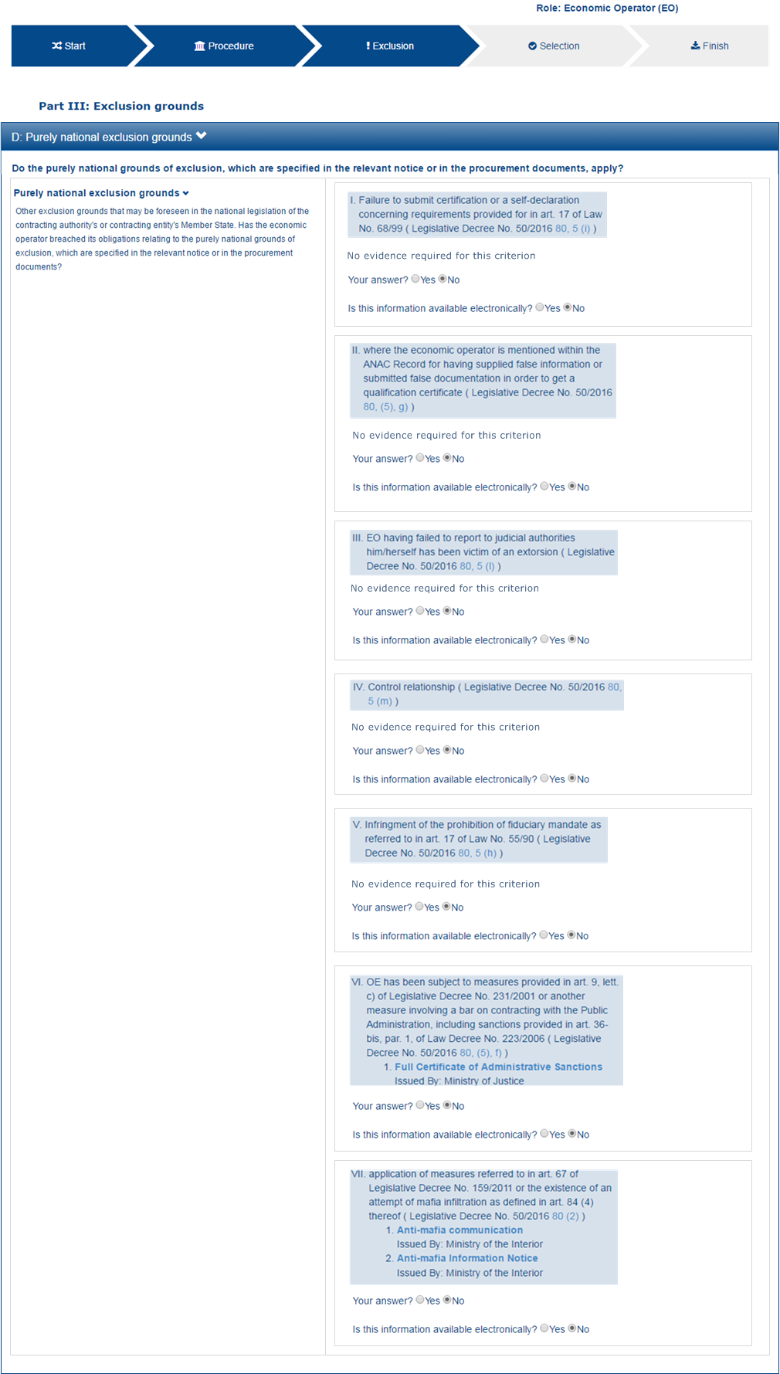

Figure 15: Purely national Exclusion grounds, mock-up

This other figure shows the data structure for this Criterion, extracted from the “Criteria Taxonomy” spread-sheet. Notice that:

* The Criterion is “Other exclusion grounds….” (as in the EU Regulated ESPD)
* The national criteria are sub-criteria (Cn/SCn) nested under the parent Criterion
* There may be many different national criteria



|  |
| --- |
| <cac:TenderingCriterion>  <cbc:ID schemeID="CriteriaTaxonomy" schemeAgencyID="EU-COM-GROW" schemeVersionID="2.0..0">63adb07d-db1b-4ef0-a14e-a99785cf8cf6</cbc:ID>  <cbc:CriterionTypeCode listID="CriteriaTypeCode" listAgencyID="EU-COM-GROW" listVersionID="2.0.0">CRITERION.EXCLUSION.NATIONAL.OTHER</cbc:CriterionTypeCode>  <cbc:Name>Purely National Exclusion Grounds</cbc:Name>  <cbc:Description>Other exclusion grounds that may be foreseen in the national legislation of the contracting authority’s or contracting entity’s Member State. Do the purely national grounds of exclusion, which are specified in the relevant notice or in the procurement documents, apply?</cbc:Description>  <cac:SubTenderingCriterion>  <cbc:ID schemeAgencyID="EU-COM-GROW" schemeVersionID="2.0.0">2cb2f4cc-33ef-4959-8f0f-03e16f182a7b</cbc:ID>  <cbc:Name>I. Unauthorised use of foreign labour ( The Criminal Code of Finland 39/1889</cbc:Name>  <cbc:Description>Has the tenderer, or a representative thereof, been sentenced for unauthorised use of foreign labour in accordance with Chapter 47, Section 6a of the Criminal Code?</cbc:Description>  <cac:Legislation>  <cbc:Title>Criminal Code</cbc:Title>  <cbc:Article>Chapter 47, Section 6a</cbc:Article>  <cbc:URI>http://www.finlex.fi/en/laki/kaannokset/1889/en18890039.pdf</cbc:URI>  </cac:Legislation>  <cac:TenderingCriterionPropertyGroup>  <cac:TenderingCriterionProperty>  <cbc:ID schemeAgencyID="EU-COM-GROW" schemeVersionID="2.0.0">e14a3f2d-ba93-4f6c-938f-50a373f7636c</cbc:ID>  <cbc:Description>Your answer?</cbc:Description>  <cbc:ValueDataTypeCode listID="ResponseDataType" listAgencyID="EU-COM-GROW" listVersionID="2.0.0">INDICATOR</cbc:ValueDataTypeCode>  </cac:TenderingCriterionProperty>  </cac:TenderingCriterionPropertyGroup>  </cac:SubTenderingCriterion>  <cac:SubTenderingCriterion>  <cbc:ID schemeAgencyID="EU-COM-GROW" schemeVersionID="2.0.0">3dc518ea-464a-4244-a8c9-0c2900e76401</cbc:ID>  <cbc:Name>II. Violation of the right to organise</cbc:Name>  <cbc:Description>Has the tenderer, or a representative thereof, been sentenced for violation of the right to organise in accordance with Chapter 47, Section 5 of the Criminal Code?</cbc:Description>  <cac:Legislation>  <cbc:Title>The Criminal Code of Finland 39/1889</cbc:Title>  <cbc:Article>Chapter 47, Section 5</cbc:Article>  <cbc:URI>http://www.finlex.fi/en/laki/kaannokset/1889/en18890039.pdf</cbc:URI>  </cac:Legislation>  <cac:TenderingCriterionPropertyGroup>  <cac:TenderingCriterionProperty>  <cbc:ID schemeAgencyID="EU-COM-GROW" schemeVersionID="2.0.0">e14a3f2d-ba93-4f6c-938f-50a373f7636c</cbc:ID>  <cbc:Description>Your answer?</cbc:Description>  <cbc:ValueDataTypeCode listID="ResponseDataType" listAgencyID="EU-COM-GROW" listVersionID="2.0.0">INDICATOR</cbc:ValueDataTypeCode>  </cac:TenderingCriterionProperty>  </cac:TenderingCriterionPropertyGroup>  </cac:SubTenderingCriterion>  <cac:SubTenderingCriterion>  <cbc:ID schemeAgencyID="EU-COM-GROW" schemeVersionID="2.0.0">e4b0cab3-ad2f-4d98-bee0-712dce2c0405</cbc:ID>  <cbc:Name>III. Extortionate work discrimination</cbc:Name>  <cbc:Description>Has the tenderer, or a representative thereof, been sentenced for extortionate work discrimination in accordance with Chapter 47, Section 3a of the Criminal Code?</cbc:Description>  <cac:Legislation>  <cbc:Title>The Criminal Code of Finland 39/1889</cbc:Title>  <cbc:Article>Chapter 47, Section 3a</cbc:Article>  <cbc:URI>http://www.finlex.fi/en/laki/kaannokset/1889/en18890039.pdf</cbc:URI>  </cac:Legislation>  <cac:TenderingCriterionPropertyGroup>  <cac:TenderingCriterionProperty>  <cbc:ID schemeAgencyID="EU-COM-GROW" schemeVersionID="2.0.0">e14a3f2d-ba93-4f6c-938f-50a373f7636c</cbc:ID>  <cbc:Description>Your answer?</cbc:Description>  <cbc:ValueDataTypeCode listID="ResponseDataType" listAgencyID="EU-COM-GROW" listVersionID="2.0.0">INDICATOR</cbc:ValueDataTypeCode>  </cac:TenderingCriterionProperty>  </cac:TenderingCriterionPropertyGroup>  </cac:SubTenderingCriterion>  <cac:TenderingCriterionPropertyGroup>  <cbc:ID schemeAgencyID="EU-COM-GROW" schemeVersionID="2.0.0">3e05e56d-fee2-43ba-b0c0-99df274505dd</cbc:ID>  <cac:TenderingCriterionProperty>  <cbc:ID schemeAgencyID="EU-COM-GROW" schemeVersionID="2.0.0">77ae3f29-7c5f-4afa-af97-24afec48c5bf</cbc:ID>  <cbc:Description>Information for [MS XXX] on e-Certis</cbc:Description>  <cbc:ValueDataTypeCode listID="ResponseDataType" listAgencyID="EU-COM-GROW" listVersionID="2.0.0">NONE</cbc:ValueDataTypeCode>  </cac:TenderingCriterionProperty>  </cac:TenderingCriterionPropertyGroup>  </cac:TenderingCriterion> |

## Selection criteria

The range of criteria related to the selection of Economic Operators is wider and more heterogeneous than the one related to the Exclusion grounds criteria. The figure below is intended to identify and list all the categories (branches in text boxes) and criteria (leaves in text without boxes):

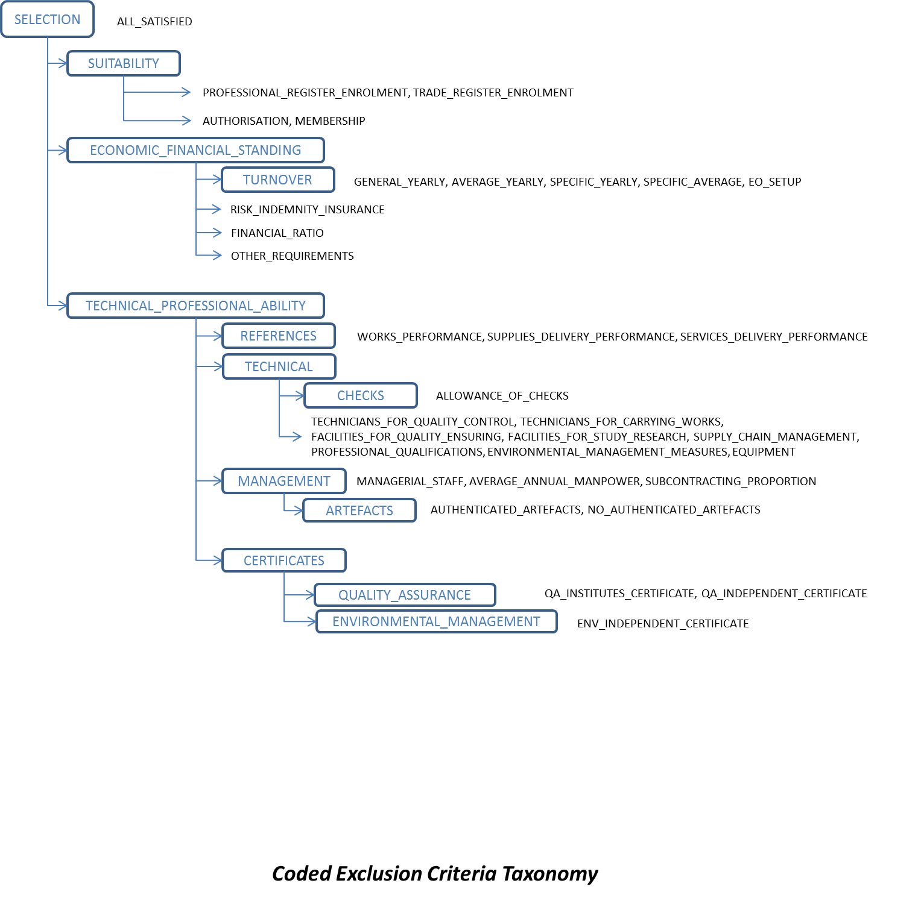

Figure 16: Representation of the Selection criteria

Some groups or sub-groups of selection criteria share the same structure, while other have their own specific structure. Beware that, differently to the exclusion criteria, some selection criteria do not provide additional data when answering ''Yes'' to the criterion question. When this occurs the ''yes'' answer is the expected data.

The following section provides examples on Selection Criteria XML Implementation where this behaviour and other features of the ESPD implementation can be studied.

### Example 1: Suitability

The Contracting Authority needs to be able to assess the suitability of the Economic Operators (EO) for which the CA will require to verify if the EOs are enroled in a relevant professional register or a trade register and, in the case of service contracts, the EO needs to be member of a particular organisation or needs a particular authorisation.

|  |  |
| --- | --- |
| SELF-CONTAINED ESPD FEATURE | Suitability:  Name of the register The name of the register or the organisation the EO must be part of;  The URL of the register;  When the procurement procedure is divided into lots, the CA will need to identify the lots that apply to Criterion Properties (e.g. to each enrolment);  For each register or organisation required by the CA, the EO will need to provide an answer YES/NO:   * + If the answer is YES, the EO will be required to provide the registration number.   + If the answer is NO, the EO will be able to provide the reasons why it is not registered. |

##### CA view

The mock-up below represents the requirements the CA should be able to specify for a Suitability Criterion without lots:

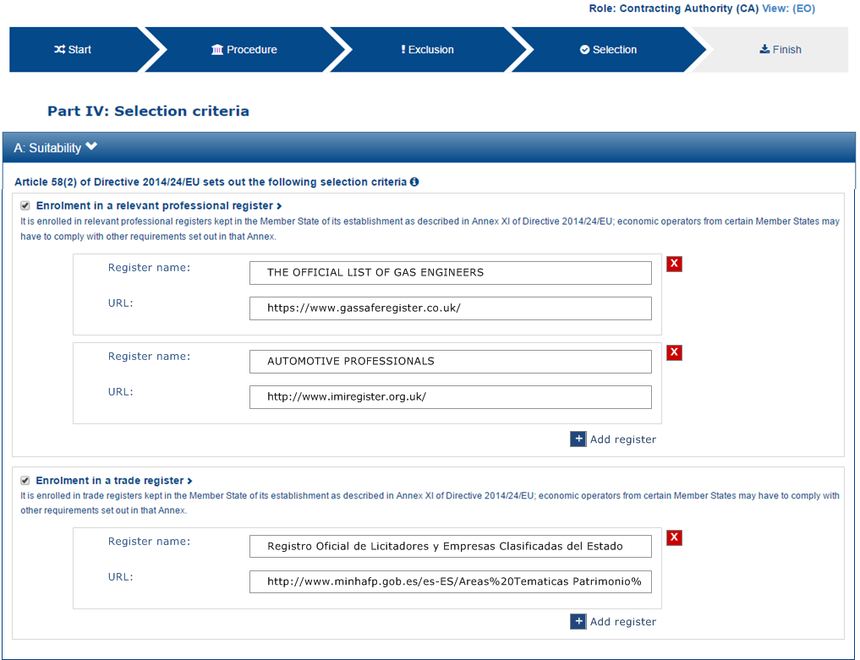

Figure 17: Suitability (not lots), CA-view, mock-up

This other mock-up represents the same situation when the Procurement Procedure is divided into lots.

Notice that:

**One set of lots per requirement**: The Contracting Authority (CA) MAY request that the EO is registered in one or multiple registers. Hence the term “requirement”, in the mock-up. One requirement in this case is a group of Criterion Properties made of one or more set of register-related data and the lots for which these data make sense (can be applied to). This behaviour of “one set of lots per requirement” is regular for all the Reference citeria, and for those Selection criteria where the allocation of lots to a set of Criterion Properties make sense;

The CA MAY specify multiple requirements and, per each requirement, groups of registers per set of lots.

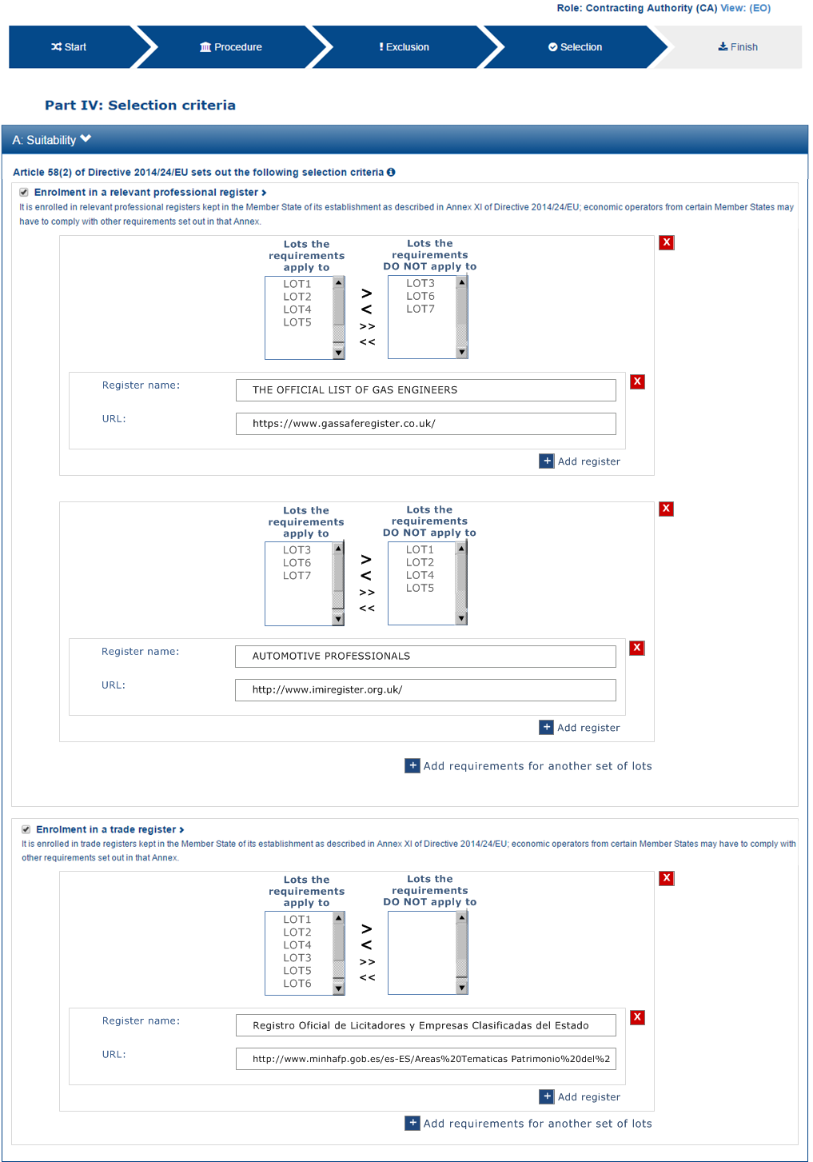

Figure 18: Suitability (not lots), CA-view, mock-up

##### EO view

The requirements specified by the Contracting Authority are to be shown to the Economic Operator: lots, register name and register URL. This mock-up below provides a possible representation for the EO point-of-view. Notice that the EO only needs to answer “yes” or “no” per each register, and in the negative case to provide a reason justifying why it is not registered. Notice that:

Per each register the EO MAY provide an online reference to additional information.

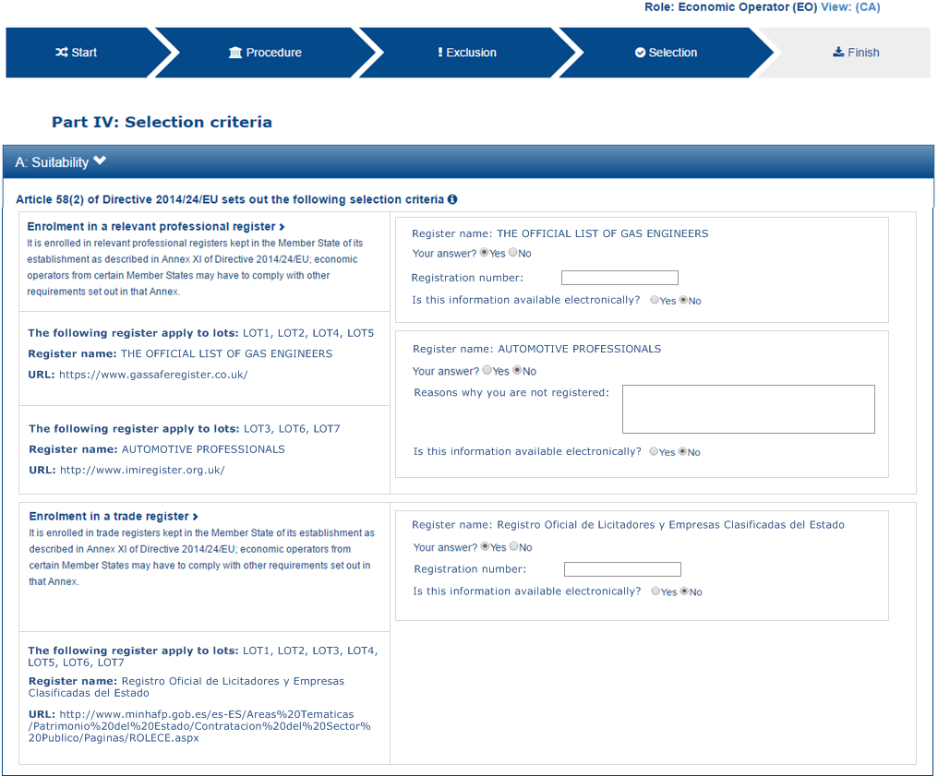

Figure 19: Suitability (not lots), EO-view, mock-up

##### Data structure

The data structure for both the requirements and the expected responses follow, extracted from the “Criteria Taxonomy” spread-sheet. Beware that the group of Criterion Properties set by the CA (C29/G1) may be instantiated n times.



##### XML example

|  |
| --- |
| [TODO:] |

### Example 2: Turnovers

The Contracting Authority needs to be able to assess the economic and financial standing of the Economic Operators (EO) for which the CA will require the EOs provide their Turnovers of the past N years.

|  |  |
| --- | --- |
| SELF-CONTAINED ESPD FEATURE | General Yearly and Average Turnovers:  The CA SHOULD be able to specify the number of the past recent years for which it will require Turnovers;  The EO MUST express the Turnover as an Amount, and must specify the currency for that Amount (the default should be €, Euros);  The CA SHOULD have the possibility of specifying the minimum amount it expects from the EO. |
| Specific Yearly and Average Turnovers:   * The CA SHOULD be able to specify the number of the past recent years for which it will require Specific Turnovers; * The EO MUST express the Specific Turnover as an Amount, and must specify the currency for that Amount (the default should be €, Euros); * For Turnovers "in the business covered by the contract" the EO MAY specify one or more Common Procurement Vocabulary codes to indicate the activities that were developed for that turnover; * The CA SHOULD have the possibility of specifying the minimum Amount it expects from the EO. |

#### General Yearly Turnover

##### CA view

The mock-up below represents the requirements the CA should be able to specify for a General Yearly Turnover Criterion:

The amount of yearly turnovers for which the economic operator will have to provide information;

The minimum amount expected by the CA per each yearly turnover.

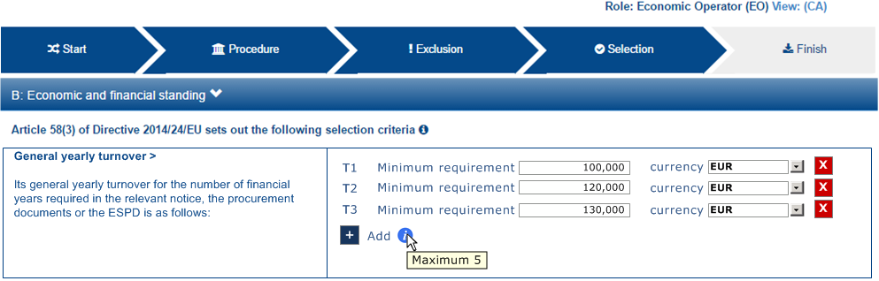

Figure 20: General Yearly Turnovers, Procurement Procedure requirements established by the CA, mock-up

##### EO view

The requirements specified by the Contracting Authority are to be shown to the Economic Operator. This mock-up below provides a possible representation for the EO point-of-view:

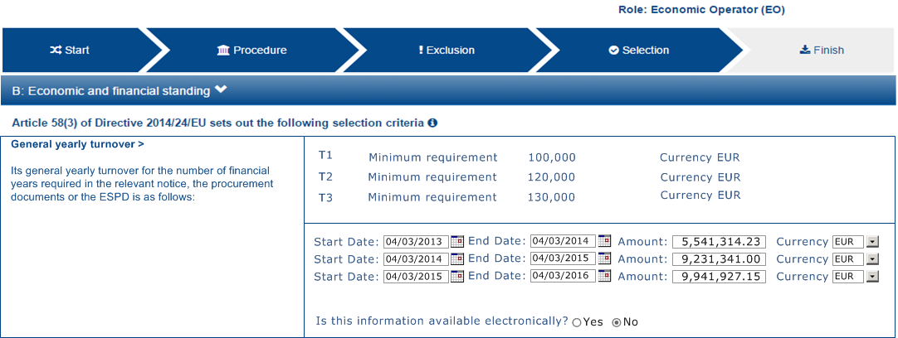

Figure 21: General Yearly Turnovers, EO view, mock-up

##### Data structure

The data structure for both the requirements and the expected responses follow, extracted from the “Criteria Taxonomy” spread-sheet. Beware that the group of Criterion Properties set by the CA (C29/G1) may be instantiated n times.



##### XML example

|  |
| --- |
| ...  <cac:TenderingCriterion>  <cbc:ID schemeID="CriteriaTaxonomy" schemeAgencyID="EU-COM-GROW" schemeVersionID="2.0..0">499efc97-2ac1-4af2-9e84-323c2ca67747</cbc:ID>  <cbc:CriterionTypeCode listID="CriteriaTypeCode" listAgencyID="EU-COM-GROW" listVersionID="2.0.0">CRITERION.SELECTION.ECONOMIC_FINANCIAL_STANDING.TURNOVER.GENERAL_YEARLY</cbc:CriterionTypeCode>  <cbc:Name>General Yearly Turnover</cbc:Name>  <cbc:Description>Its general yearly turnover for the number of financial years required in the relevant notice, the procurement documents or the ESPD is as follows:</cbc:Description>  <!-- EU Criterion Legislation-->  <cac:Legislation> ... </cac:Legislation>  <!—CA’s requirements-->  <cac:TenderingCriterionPropertyGroup>. .. </ cac:TenderingCriterionPropertyGroup>  <cac:TenderingCriterionPropertyGroup>. .. </ cac:TenderingCriterionPropertyGroup>  <cac:TenderingCriterionPropertyGroup>. .. </ cac:TenderingCriterionPropertyGroup>  <!—Turnovers -->  <cac:TenderingCriterionPropertyGroup>  <cbc:ID schemeAgencyID="EU-COM-GROW" schemeVersionID="2.0.0">e1886054-ada4-473c-9afc-2fde82c24cf4</cbc:ID>  <cac:TenderingCriterionProperty>  <cbc:ID schemeAgencyID="EU-COM-GROW" schemeVersionID="2.0.0">15335c12-ad77-4728-b5ad-3c06a60d65a4</cbc:ID>  <cbc:Description>Provide values for the turnovers</cbc:Description>  <cbc:ValueDataTypeCode listID="ResponseDataType" listAgencyID="EU-COM-GROW" listVersionID="2.0.0">NONE</cbc:ValueDataTypeCode>  </cac:TenderingCriterionProperty>  <!-- T1 -->  <cac:SubsidiaryTenderingCriterionPropertyGroup>  <cac:TenderingCriterionProperty>  <cbc:ID schemeAgencyID="EU-COM-GROW" schemeVersionID="2.0.0">362ea0d9-1d50-4764-a597-350b0b3700cc</cbc:ID>  <cbc:Description>Start date</cbc:Description>  <cbc:ValueDataTypeCode listID="ResponseDataType" listAgencyID="EU-COM-GROW" listVersionID="2.0.0">DATE</cbc:ValueDataTypeCode>  </cac:TenderingCriterionProperty>  <cac:TenderingCriterionProperty>  <cbc:ID schemeAgencyID="EU-COM-GROW" schemeVersionID="2.0.0">76924696-77a0-4fb7-8838-1fe7b9c7783a</cbc:ID>  <cbc:Description>End date</cbc:Description>  <cbc:ValueDataTypeCode listID="ResponseDataType" listAgencyID="EU-COM-GROW" listVersionID="2.0.0">DATE</cbc:ValueDataTypeCode>  </cac:TenderingCriterionProperty>  <cac:TenderingCriterionProperty>  <cbc:ID schemeAgencyID="EU-COM-GROW" schemeVersionID="2.0.0">aa0638b7-a723-48e1-93f4-af12ae04e487</cbc:ID>  <cbc:Description>Amount</cbc:Description>  <cbc:ValueDataTypeCode listID="ResponseDataType" listAgencyID="EU-COM-GROW" listVersionID="2.0.0">AMOUNT</cbc:ValueDataTypeCode> </cac:TenderingCriterionProperty>  </cac:SubsidiaryTenderingCriterionPropertyGroup>  <!-- T2-->  <cac:SubsidiaryTenderingCriterionPropertyGroup>  <cac:TenderingCriterionProperty>  <cbc:ID schemeAgencyID="EU-COM-GROW" schemeVersionID="2.0.0">9c68fbe4-e955-4185-a86e-6947ed9e2219</cbc:ID>  <cbc:Description>Start date</cbc:Description>  <cbc:ValueDataTypeCode listID="ResponseDataType" listAgencyID="EU-COM-GROW" listVersionID="2.0.0">DATE</cbc:ValueDataTypeCode>  </cac:TenderingCriterionProperty>  <cac:TenderingCriterionProperty>  <cbc:ID schemeAgencyID="EU-COM-GROW" schemeVersionID="2.0.0">9a27d9ca-f87f-4a5f-960c-6fe0859a7c99</cbc:ID>  <cbc:Description>End date</cbc:Description>  <cbc:ValueDataTypeCode listID="ResponseDataType" listAgencyID="EU-COM-GROW" listVersionID="2.0.0">DATE</cbc:ValueDataTypeCode>  </cac:TenderingCriterionProperty>  <cac:TenderingCriterionProperty>  <cbc:ID schemeAgencyID="EU-COM-GROW" schemeVersionID="2.0.0">c2ef50a1-61e7-47dd-a4b6-d8ff932b9bea</cbc:ID>  <cbc:Description>Amount</cbc:Description>  <cbc:ValueDataTypeCode listID="ResponseDataType" listAgencyID="EU-COM-GROW" listVersionID="2.0.0">AMOUNT</cbc:ValueDataTypeCode>  </cac:TenderingCriterionProperty>  </cac:SubsidiaryTenderingCriterionPropertyGroup>  <!-- T3 -->  <cac:SubsidiaryTenderingCriterionPropertyGroup>  <cac:TenderingCriterionProperty>  <cbc:ID schemeAgencyID="EU-COM-GROW" schemeVersionID="2.0.0">72fd26d8-090a-4c1c-bc93-4d76b805bbbe</cbc:ID>  <cbc:Description>Start date</cbc:Description>  <cbc:ValueDataTypeCode listID="ResponseDataType" listAgencyID="EU-COM-GROW" listVersionID="2.0.0">DATE</cbc:ValueDataTypeCode>  </cac:TenderingCriterionProperty>  <cac:TenderingCriterionProperty>  <cbc:ID schemeAgencyID="EU-COM-GROW" schemeVersionID="2.0.0">c0e23037-91a4-4062-aff7-dfc05f777f5a</cbc:ID>  <cbc:Description>End date</cbc:Description>  <cbc:ValueDataTypeCode listID="ResponseDataType" listAgencyID="EU-COM-GROW" listVersionID="2.0.0">DATE</cbc:ValueDataTypeCode>  </cac:TenderingCriterionProperty>  <cac:TenderingCriterionProperty>  <cbc:ID schemeAgencyID="EU-COM-GROW" schemeVersionID="2.0.0">cd832ae3-e09e-47a5-a204-dfc053dd5deb</cbc:ID>  <cbc:Description>Amount</cbc:Description>  <cbc:ValueDataTypeCode listID="ResponseDataType" listAgencyID="EU-COM-GROW" listVersionID="2.0.0">AMOUNT</cbc:ValueDataTypeCode>  </cac:TenderingCriterionProperty>  </cac:SubsidiaryTenderingCriterionPropertyGroup>  </cac:TenderingCriterionPropertyGroup>  </cac:TenderingCriterion> |

#### Average Yearly Turnover

##### CA view

The mock-up below represents the requirements the CA should be able to specify for an Average Yearly Turnover Criterion:

A period of time encompassing the yearly turnovers for which the average is to be calculated;

A minimum amount for which the EO’s average yearly turnover must equal or be greater.

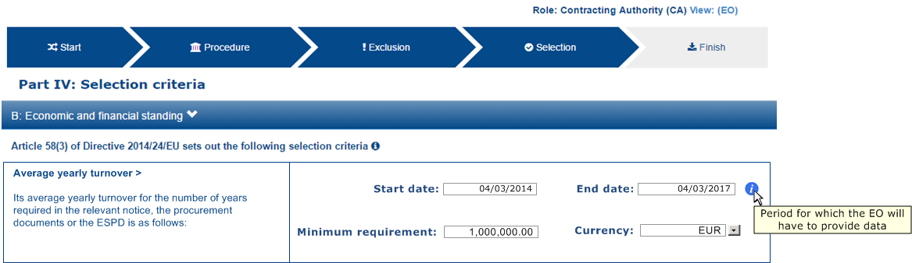

Figure 22: Average Yearly Turnovers, Procurement Procedure requirements established by the CA, mock-up

##### EO view

The requirements specified by the Contracting Authority are to be shown to the Economic Operator. This mock-up below provides a possible representation for the EO point-of-view. Notice that the CA’s requirement are shown (lower left side of the mock-up):

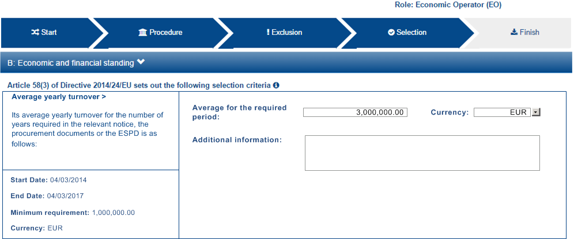

Figure 23: Average Yearly Turnovers, EO view, mock-up

##### Data structure

The data structure for both the requirements and the expected responses follow, extracted from the “Criteria Taxonomy” spread-sheet. Notice that, differently to the previous case, the sub-group of Criterion Properties set by the CA (C30/G1) is not to be instantiated n times (as this is an average turnover).



##### XML example

|  |
| --- |
| <cac:TenderingCriterion>  <cbc:ID schemeID="CriteriaTaxonomy" schemeAgencyID="EU-COM-GROW" schemeVersionID="2.0..0">e4d37adc-08cd-4f4d-a8d8-32b62b0a1f46</cbc:ID>  <cbc:CriterionTypeCode listID="CriteriaTypeCode" listAgencyID="EU-COM-GROW" listVersionID="2.0.0">CRITERION.SELECTION.ECONOMIC_FINANCIAL_STANDING.FINANCIAL_RATIO</cbc:CriterionTypeCode>  <cbc:Name>Financial Ratios</cbc:Name>  <cbc:Description>Concerning the financial ratios specified in the relevant notice, the procurement documents or the ESPD, the economic operator declares that the actual values for the required ratios are as follows:</cbc:Description>  <!-- EU Criterion Legislation-->  <cac:Legislation></cac:Legislation>  <!-- CA's group of requirements -->  <cac:TenderingCriterionPropertyGroup>  <cbc:ID schemeAgencyID="EU-COM-GROW" schemeVersionID="2.0.0">1f14001a-e177-4dcc-9039-819d4827bff6</cbc:ID>  <cac:TenderingCriterionProperty>  <cbc:ID schemeAgencyID="EU-COM-GROW" schemeVersionID="2.0.0">33baad9b-840c-4528-b0cf-0b4178e9e067</cbc:ID>  <cbc:Description>Select the period applicable for all ratios</cbc:Description>  <cbc:ValueDataTypeCode listID="ResponseDataType" listAgencyID="EU-COM-GROW" listVersionID="2.0.0">NONE</cbc:ValueDataTypeCode>  </cac:TenderingCriterionProperty>  <cac:SubsidiaryTenderingCriterionPropertyGroup>  <cbc:ID schemeAgencyID="EU-COM-GROW" schemeVersionID="2.0.0">43817640-cffa-44a6-b211-7dd5f852c60e</cbc:ID>  <cac:TenderingCriterionProperty>  <cbc:ID schemeAgencyID="EU-COM-GROW" schemeVersionID="2.0.0">5148bb65-3c1c-4689-b03d-41f3a0ad96b6</cbc:ID>  <cbc:Description>Period</cbc:Description>  <cbc:ValueDataTypeCode listID="ResponseDataType" listAgencyID="EU-COM-GROW" listVersionID="2.0.0">PERIOD</cbc:ValueDataTypeCode>  </cac:TenderingCriterionProperty>  <!-- RATIO 1 -->  <cac:SubsidiaryTenderingCriterionPropertyGroup>  <cbc:ID schemeAgencyID="EU-COM-GROW" schemeVersionID="2.0.0">e557397e-46ef-4f72-8908-02d8b63049b6</cbc:ID>  <cac:TenderingCriterionProperty>  <cbc:ID schemeAgencyID="EU-COM-GROW" schemeVersionID="2.0.0">171aebb5-e551-4356-a05f-2f9c6b1299df</cbc:ID>  <cbc:Description>Select the ratio type</cbc:Description>  <cbc:ValueDataTypeCode listID="ResponseDataType" listAgencyID="EU-COM-GROW" listVersionID="2.0.0">NONE</cbc:ValueDataTypeCode>  <cbc:ExpectedCode listID="FinancialRatioType" listAgencyName="BACH" listVersionID="1.0">R11</cbc:ExpectedCode>  </cac:TenderingCriterionProperty>  <cac:TenderingCriterionProperty>  <cbc:ID schemeAgencyID="EU-COM-GROW" schemeVersionID="2.0.0">8a38c20a-a144-4547-bf1f-596d2028cb22</cbc:ID>  <cbc:Description>Definition</cbc:Description>  <cbc:ValueDataTypeCode listID="ResponseDataType" listAgencyID="EU-COM-GROW" listVersionID="2.0.0">NONE</cbc:ValueDataTypeCode>  <cbc:CertificationLevelDescription>Balance Sheet / Total Equity</cbc:CertificationLevelDescription>  </cac:TenderingCriterionProperty>  <cac:TenderingCriterionProperty>  <cbc:ID schemeAgencyID="EU-COM-GROW" schemeVersionID="2.0.0">3cf2f60f-b8fd-47e0-b014-bd0d6eeef3d8</cbc:ID>  <cbc:Description>Minimum requirement</cbc:Description>  <cbc:ValueDataTypeCode listID="ResponseDataType" listAgencyID="EU-COM-GROW" listVersionID="2.0.0">NONE</cbc:ValueDataTypeCode> <cbc:ExpectedValueNumeric>0.7</cbc:ExpectedValueNumeric>  </cac:TenderingCriterionProperty>  </cac:SubsidiaryTenderingCriterionPropertyGroup>  <!-- RATIO 2 -->  <cac:SubsidiaryTenderingCriterionPropertyGroup>  <cbc:ID schemeAgencyID="EU-COM-GROW" schemeVersionID="2.0.0">817c9cec-dc49-4b41-8147-69b6ffc61776</cbc:ID>  <cac:TenderingCriterionProperty>  <cbc:ID schemeAgencyID="EU-COM-GROW" schemeVersionID="2.0.0">bbabf02e-d126-4bac-89db-9df4c66f3419</cbc:ID>  <cbc:Description>Select the ratio type</cbc:Description>  <cbc:ValueDataTypeCode listID="ResponseDataType" listAgencyID="EU-COM-GROW" listVersionID="2.0.0">NONE</cbc:ValueDataTypeCode>  <cbc:ExpectedCode listID="FinancialRatioType" listAgencyName="BACH" listVersionID="1.0">R21</cbc:ExpectedCode>  </cac:TenderingCriterionProperty>  <cac:TenderingCriterionProperty>  <cbc:ID schemeAgencyID="EU-COM-GROW" schemeVersionID="2.0.0">b9b469c1-d57b-4cc9-8a3b-65cdf322ab09</cbc:ID>  <cbc:Description>Definition</cbc:Description>  <cbc:ValueDataTypeCode listID="ResponseDataType" listAgencyID="EU-COM-GROW" listVersionID="2.0.0">NONE</cbc:ValueDataTypeCode>  <cbc:CertificationLevelDescription>Financial income net of charges other than interest over EBITDA</cbc:CertificationLevelDescription> </cac:TenderingCriterionProperty>  <cac:TenderingCriterionProperty>  <cbc:ID schemeAgencyID="EU-COM-GROW" schemeVersionID="2.0.0">8ec4f734-5ddd-47bb-aa73-111bf185626b</cbc:ID>  <cbc:Description>Minimum requirement</cbc:Description>  <cbc:ValueDataTypeCode listID="ResponseDataType" listAgencyID="EU-COM-GROW" listVersionID="2.0.0">NONE</cbc:ValueDataTypeCode> <cbc:ExpectedValueNumeric>0.5</cbc:ExpectedValueNumeric>  </cac:TenderingCriterionProperty>  </cac:SubsidiaryTenderingCriterionPropertyGroup>  <!-- RATIO 3 -->  <cac:SubsidiaryTenderingCriterionPropertyGroup>  <cbc:ID schemeAgencyID="EU-COM-GROW" schemeVersionID="2.0.0">4eea4639-c6cf-41af-b7dc-435ca7586357</cbc:ID>  <cac:TenderingCriterionProperty>  <cbc:ID schemeAgencyID="EU-COM-GROW" schemeVersionID="2.0.0">8e059cff-b644-4b90-afd0-136e0d8dd542</cbc:ID>  <cbc:Description>Select the ratio type</cbc:Description>  <cbc:ValueDataTypeCode listID="ResponseDataType" listAgencyID="EU-COM-GROW" listVersionID="2.0.0">NONE</cbc:ValueDataTypeCode>  <cbc:ExpectedCode listID="FinancialRatioType" listAgencyName="BACH" listVersionID="1.0">R31</cbc:ExpectedCode>  </cac:TenderingCriterionProperty>  <cac:TenderingCriterionProperty>  <cbc:ID schemeAgencyID="EU-COM-GROW" schemeVersionID="2.0.0">1d8def2b-4db6-403e-ba01-80a3a47e3df6</cbc:ID>  <cbc:Description>Definition</cbc:Description>  <cbc:ValueDataTypeCode listID="ResponseDataType" listAgencyID="EU-COM-GROW" listVersionID="2.0.0">NONE</cbc:ValueDataTypeCode>  <cbc:CertificationLevelDescription>Gross value added / Net turnover</cbc:CertificationLevelDescription>  </cac:TenderingCriterionProperty>  <cac:TenderingCriterionProperty>  <cbc:ID schemeAgencyID="EU-COM-GROW" schemeVersionID="2.0.0">8ec4f734-5ddd-47bb-aa73-111bf185626b</cbc:ID>  <cbc:Description>Minimum requirement</cbc:Description>  <cbc:ValueDataTypeCode listID="ResponseDataType" listAgencyID="EU-COM-GROW" listVersionID="2.0.0">NONE</cbc:ValueDataTypeCode>  <cbc:ExpectedValueNumeric>0.5</cbc:ExpectedValueNumeric>  </cac:TenderingCriterionProperty>  </cac:SubsidiaryTenderingCriterionPropertyGroup>  </cac:SubsidiaryTenderingCriterionPropertyGroup>  </cac:TenderingCriterionPropertyGroup>  <!-- Is this information available online? -->  <cac:TenderingCriterionPropertyGroup>...</cac:TenderingCriterionPropertyGroup>  </cac:TenderingCriterion> |

#### Specific Yearly Turnover

##### CA view

The mock-up below represents the requirements the CA should be able to specify for an Specific Yearly Criterion:

The number of fiscal years for which the Economic Operator will have to provide turnovers; e.g. last 5 years.

The CPV codes codes to indicate the activities that were developed during those fiscal years;

A description of the business area for which these turnovers are specific;

A minimum amount for which each specific yearly turnover must equal or be greater.

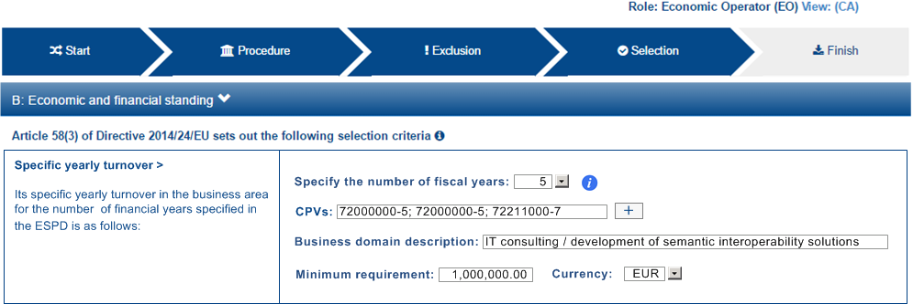

Figure 24: Specific Yearly Turnover, Procurement Procedure requirements established by the CA, mock-up

##### EO view

The requirements specified by the Contracting Authority are to be shown to the Economic Operator. This mock-up below provides a possible representation for the EO point-of-view. Notice that the CA’s requirement are shown (notice that the CA requirements are shown to the EO):

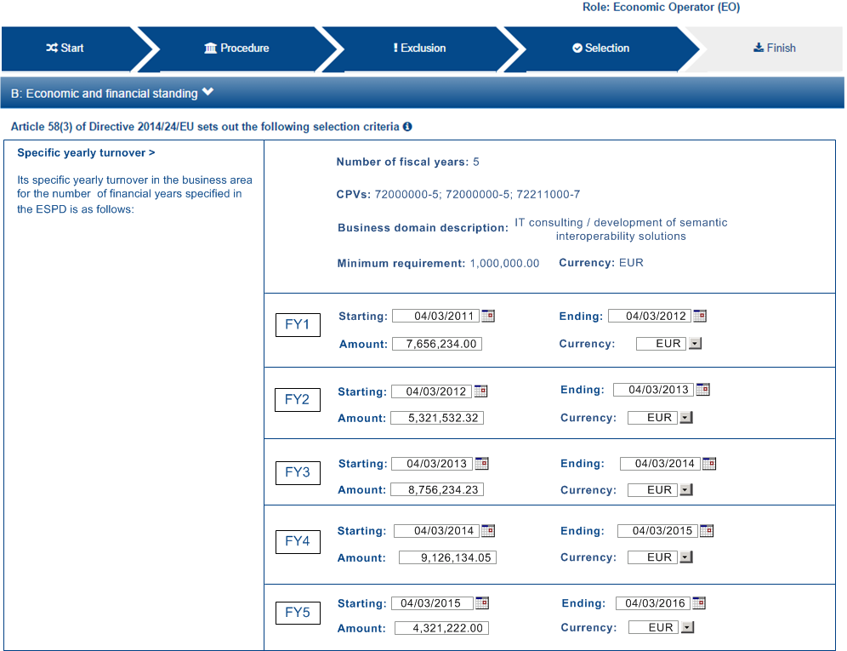

Figure 25: Specific Yearly Turnover, EO view, mock-up

##### Data structure

The data structure for both the requirements and the expected responses follow, extracted from the “Criteria Taxonomy” spread-sheet.



##### XML example

|  |
| --- |
| [TODO:] |

#### Specific Average Turnover

##### CA view

The mock-up below represents the requirements the CA should be able to specify for an Specific Turnover Criterion:

The number of fiscal years for the average turnover; e.g. last 3 years.

The CPV codes codes to indicate the activities that were developed during those fiscal years;

A description of the business area for which the average turnover is specific;

A minimum amount for which the EO’s average yearly turnover must equal or be greater.

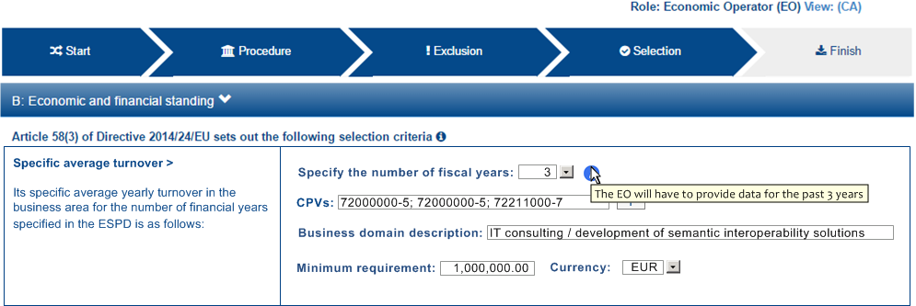

Figure 26: Specific Average Turnover, Procurement Procedure requirements established by the CA, mock-up

##### EO view

The requirements specified by the Contracting Authority are to be shown to the Economic Operator. This mock-up below provides a possible representation for the EO point-of-view. Notice that the CA’s requirement are shown:

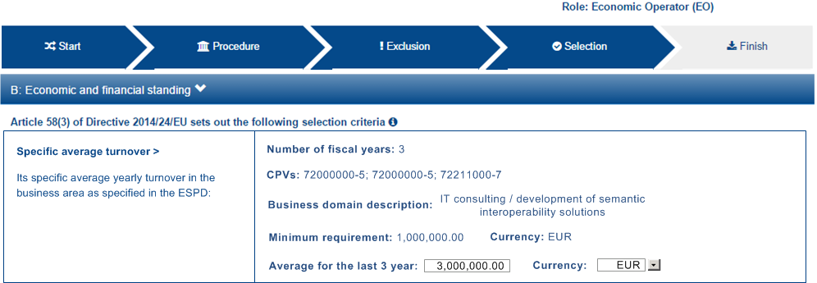

Figure 27: Specific Average Turnover, EO view, mock-up

##### Data structure

The data structure for both the CA requirements and the expected responses follow, extracted from the “Criteria Taxonomy” spread-sheet. Notice that, differently to the previous case, the sub-group of Criterion Properties set by the CA (C32/G1) is not to be instantiated n times (as this is an average turnover).



##### XML example

|  |
| --- |
| [TODO:] |

### Example 3: Financial Ratios

The Contracting Authority needs to be able to assess the economic and financial standing of the Economic Operators (EO) for which it will require the EOs provide different types of financial ratios for the past N years.

|  |  |
| --- | --- |
| SELF-CONTAINED ESPD FEATURE | Financial Ratios:  The CA SHOULD be able to specify the number of the past recent years for which it will require Ratios.  To specify a Ratio, the CA MUST use one of the codes defined by BACH (see [<https://www.bach.banque-france.fr/>](BACH Banque France), and [BACH-DataBase-Ratios.xlsx](https://github.com/ESPD/ESPD-EDM/files/569146/BACH-DataBase-Ratios.xlsx)).  Agreed types of Ratios that are not defined by BACH could be added to the BACH's list. |

##### CA view

The mock-up below represents the requirements the CA should be able to specify regarding the Financial Ratios Criterion:

The period applicable for all the Finanacial Ratios;

From 1 to n different types of Financial Ratios;

The minimum ratio the Economic Operator must equal or overcome.

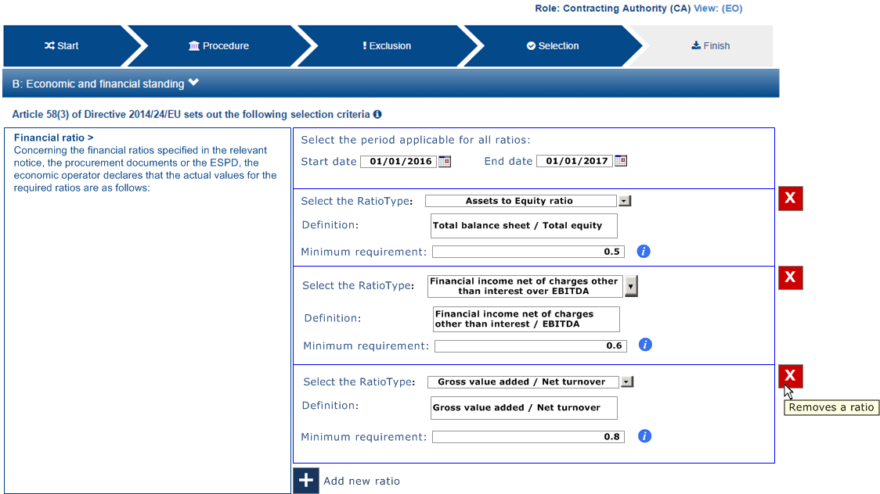

Figure 28: Financial Ratios, Procurement Procedure requirements established by the CA, mock-up

##### EO view

The requirements specified by the Contracting Authority are to be shown to the Economic Operator. This mock-up below provides a possible representation for the EO point-of-view:

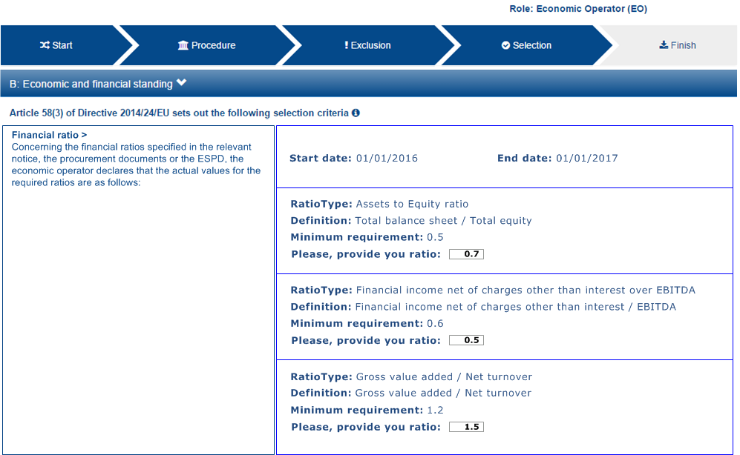

Figure 29: Financial Ratios, EO view, mock-up

##### Data structure

The data structure for both the requirements and the expected responses follow, extracted from the “Criteria Taxonomy” spread-sheet.



##### XML example

|  |
| --- |
| <cac:TenderingCriterionPropertyGroup>  <cbc:ID schemeAgencyID="EU-COM-GROW" schemeVersionID="2.0.0">1f14001a-e177-4dcc-9039-819d4827bff6</cbc:ID>  <cac:TenderingCriterionProperty>  <cbc:ID schemeAgencyID="EU-COM-GROW" schemeVersionID="2.0.0">33baad9b-840c-4528-b0cf-0b4178e9e067</cbc:ID>  <cbc:Description>Select the period applicable for all ratios</cbc:Description>  <cbc:ValueDataTypeCode listID="ResponseDataType" listAgencyID="EU-COM-GROW" listVersionID="2.0.0">NONE</cbc:ValueDataTypeCode>  </cac:TenderingCriterionProperty>  <cac:SubsidiaryTenderingCriterionPropertyGroup>  <cbc:ID schemeAgencyID="EU-COM-GROW" schemeVersionID="2.0.0">43817640-cffa-44a6-b211-7dd5f852c60e</cbc:ID>  <cac:TenderingCriterionProperty>  <cbc:ID schemeAgencyID="EU-COM-GROW" schemeVersionID="2.0.0">5148bb65-3c1c-4689-b03d-41f3a0ad96b6</cbc:ID>  <cbc:Description>Period</cbc:Description>  <cbc:ValueDataTypeCode listID="ResponseDataType" listAgencyID="EU-COM-GROW" listVersionID="2.0.0">NONE</cbc:ValueDataTypeCode>  <cac:ApplicablePeriod>  <cbc:StartDate>2016-01-01</cbc:StartDate>  <cbc:EndDate>2017-01-01</cbc:EndDate>  </cac:ApplicablePeriod>  </cac:TenderingCriterionProperty>  <!-- RATIO 1 -->  <cac:SubsidiaryTenderingCriterionPropertyGroup>  <cbc:ID schemeAgencyID="EU-COM-GROW" schemeVersionID="2.0.0">e557397e-46ef-4f72-8908-02d8b63049b6</cbc:ID>  <cac:TenderingCriterionProperty>  <cbc:ID schemeAgencyID="EU-COM-GROW" schemeVersionID="2.0.0">171aebb5-e551-4356-a05f-2f9c6b1299df</cbc:ID>  <cbc:Description>Select the ratio type</cbc:Description>  <cbc:ValueDataTypeCode listID="ResponseDataType" listAgencyID="EU-COM-GROW" listVersionID="2.0.0">NONE</cbc:ValueDataTypeCode>  <cbc:ExpectedCode listID="FinancialRatioType" listAgencyName="BACH" listVersionID="1.0">R11</cbc:ExpectedCode>  </cac:TenderingCriterionProperty>  <cac:TenderingCriterionProperty>  <cbc:ID schemeAgencyID="EU-COM-GROW" schemeVersionID="2.0.0">8a38c20a-a144-4547-bf1f-596d2028cb22</cbc:ID>  <cbc:Description>Definition</cbc:Description>  <cbc:ValueDataTypeCode listID="ResponseDataType" listAgencyID="EU-COM-GROW" listVersionID="2.0.0">NONE</cbc:ValueDataTypeCode>  <cbc:CertificationLevelDescription>Balance Sheet / Total Equity</cbc:CertificationLevelDescription>  </cac:TenderingCriterionProperty>  <cac:TenderingCriterionProperty>  <cbc:ID schemeAgencyID="EU-COM-GROW" schemeVersionID="2.0.0">3cf2f60f-b8fd-47e0-b014-bd0d6eeef3d8</cbc:ID>  <cbc:Description>Minimum requirement</cbc:Description>  <cbc:ValueDataTypeCode listID="ResponseDataType" listAgencyID="EU-COM-GROW" listVersionID="2.0.0">NONE</cbc:ValueDataTypeCode>  <cbc:ExpectedValueNumeric>0.7</cbc:ExpectedValueNumeric>  </cac:TenderingCriterionProperty>  <cac:TenderingCriterionProperty>  <cbc:ID schemeAgencyID="EU-COM-GROW" schemeVersionID="2.0.0">97a66ec4-4b18-4110-8d7b-dad4722d05da</cbc:ID>  <cbc:Description>Ratio</cbc:Description>  <cbc:ValueDataTypeCode listID="ResponseDataType" listAgencyID="EU-COM-GROW" listVersionID="2.0.0">PERCENTAGE</cbc:ValueDataTypeCode>  </cac:TenderingCriterionProperty>  </cac:SubsidiaryTenderingCriterionPropertyGroup>  <!-- RATIO 2 -->  <cac:SubsidiaryTenderingCriterionPropertyGroup>  <cbc:ID schemeAgencyID="EU-COM-GROW" schemeVersionID="2.0.0">817c9cec-dc49-4b41-8147-69b6ffc61776</cbc:ID>  <cac:TenderingCriterionProperty>  <cbc:ID schemeAgencyID="EU-COM-GROW" schemeVersionID="2.0.0">bbabf02e-d126-4bac-89db-9df4c66f3419</cbc:ID>  <cbc:Description>Select the ratio type</cbc:Description>  <cbc:ValueDataTypeCode listID="ResponseDataType" listAgencyID="EU-COM-GROW" listVersionID="2.0.0">NONE</cbc:ValueDataTypeCode>  <cbc:ExpectedCode listID="FinancialRatioType" listAgencyName="BACH" listVersionID="1.0">R21</cbc:ExpectedCode>  </cac:TenderingCriterionProperty>  <cac:TenderingCriterionProperty>  <cbc:ID schemeAgencyID="EU-COM-GROW" schemeVersionID="2.0.0">b9b469c1-d57b-4cc9-8a3b-65cdf322ab09</cbc:ID>  <cbc:Description>Definition</cbc:Description>  <cbc:ValueDataTypeCode listID="ResponseDataType" listAgencyID="EU-COM-GROW" listVersionID="2.0.0">NONE</cbc:ValueDataTypeCode>  <cbc:CertificationLevelDescription>Financial income net of charges other than interest over EBITDA</cbc:CertificationLevelDescription>  </cac:TenderingCriterionProperty>  <cac:TenderingCriterionProperty>  <cbc:ID schemeAgencyID="EU-COM-GROW" schemeVersionID="2.0.0">8ec4f734-5ddd-47bb-aa73-111bf185626b</cbc:ID>  <cbc:Description>Minimum requirement</cbc:Description>  <cbc:ValueDataTypeCode listID="ResponseDataType" listAgencyID="EU-COM-GROW" listVersionID="2.0.0">NONE</cbc:ValueDataTypeCode>  <cbc:ExpectedValueNumeric>0.5</cbc:ExpectedValueNumeric>  </cac:TenderingCriterionProperty>  <cac:TenderingCriterionProperty>  <cbc:ID schemeAgencyID="EU-COM-GROW" schemeVersionID="2.0.0">97a66ec4-4b18-4110-8d7b-dad4722d05da</cbc:ID>  <cbc:Description>Ratio</cbc:Description>  <cbc:ValueDataTypeCode listID="ResponseDataType" listAgencyID="EU-COM-GROW" listVersionID="2.0.0">PERCENTAGE</cbc:ValueDataTypeCode>  </cac:TenderingCriterionProperty>  </cac:SubsidiaryTenderingCriterionPropertyGroup>  <!-- RATIO 3 -->  <cac:SubsidiaryTenderingCriterionPropertyGroup>  <cbc:ID schemeAgencyID="EU-COM-GROW" schemeVersionID="2.0.0">4eea4639-c6cf-41af-b7dc-435ca7586357</cbc:ID>  <cac:TenderingCriterionProperty>  <cbc:ID schemeAgencyID="EU-COM-GROW" schemeVersionID="2.0.0">8e059cff-b644-4b90-afd0-136e0d8dd542</cbc:ID>  <cbc:Description>Select the ratio type</cbc:Description>  <cbc:ValueDataTypeCode listID="ResponseDataType" listAgencyID="EU-COM-GROW" listVersionID="2.0.0">NONE</cbc:ValueDataTypeCode>  <cbc:ExpectedCode listID="FinancialRatioType" listAgencyName="BACH" listVersionID="1.0">R31</cbc:ExpectedCode>  </cac:TenderingCriterionProperty>  <cac:TenderingCriterionProperty>  <cbc:ID schemeAgencyID="EU-COM-GROW" schemeVersionID="2.0.0">1d8def2b-4db6-403e-ba01-80a3a47e3df6</cbc:ID>  <cbc:Description>Definition</cbc:Description>  <cbc:ValueDataTypeCode listID="ResponseDataType" listAgencyID="EU-COM-GROW" listVersionID="2.0.0">NONE</cbc:ValueDataTypeCode>  <cbc:CertificationLevelDescription>Gross value added / Net turnover</cbc:CertificationLevelDescription>  </cac:TenderingCriterionProperty>  <cac:TenderingCriterionProperty>  <cbc:ID schemeAgencyID="EU-COM-GROW" schemeVersionID="2.0.0">8ec4f734-5ddd-47bb-aa73-111bf185626b</cbc:ID>  <cbc:Description>Minimum requirement</cbc:Description>  <cbc:ValueDataTypeCode listID="ResponseDataType" listAgencyID="EU-COM-GROW" listVersionID="2.0.0">NONE</cbc:ValueDataTypeCode>  <cbc:ExpectedValueNumeric>0.5</cbc:ExpectedValueNumeric>  </cac:TenderingCriterionProperty>  <cac:TenderingCriterionProperty>  <cbc:ID schemeAgencyID="EU-COM-GROW" schemeVersionID="2.0.0">97a66ec4-4b18-4110-8d7b-dad4722d05da</cbc:ID>  <cbc:Description>Ratio</cbc:Description>  <cbc:ValueDataTypeCode listID="ResponseDataType" listAgencyID="EU-COM-GROW" listVersionID="2.0.0">PERCENTAGE</cbc:ValueDataTypeCode>  </cac:TenderingCriterionProperty>  </cac:SubsidiaryTenderingCriterionPropertyGroup>  </cac:SubsidiaryTenderingCriterionPropertyGroup>  </cac:TenderingCriterionPropertyGroup>  <!-- Is this information available online? -->  <cac:TenderingCriterionPropertyGroup>  <cac:TenderingCriterionProperty></cac:TenderingCriterionProperty>  </cac:TenderingCriterionPropertyGroup>  </cac:TenderingCriterion> |
| **COMMENTS**:  Notice the use of the BACH Code List to specify the Financial Ratios. |

### Example 4: Weighting a selection Criterion

The Contracting Authority may like to score the Economic Operators in the evaluation phase for which the CA would need to inform the EO in a transparent way on how it will be weighted.

|  |  |
| --- | --- |
| SELF-CONTAINED ESPD FEATURE | Weighting:  In an open procedure the CA has to consider all tenders that pass the selection criteria. The contract is awarded based on award criteria;  For two stage procedures for section C "Technical and professional ability" in selection criteria weighting should be possible. Section A/B/D in selection criteria are used as pass/fail;  The CA should have a free text where they can describe the scoring methodology;  The CA should have a field to specify the weight as a percentage or points;  The CA should have a field to specify the weight as a percentage or points;  The EO must have the possibility to answer the requirement in a free text. |

##### CA view

The mock-up below represents the requirements the CA should be able to specify regarding the Weighting:

The general method used to score and evaluate the weighted criteria;

The evaluation method of the Criterion;

The weight allocated to the Criterion;

Complementary information regarding the evaluation of the Criterion.

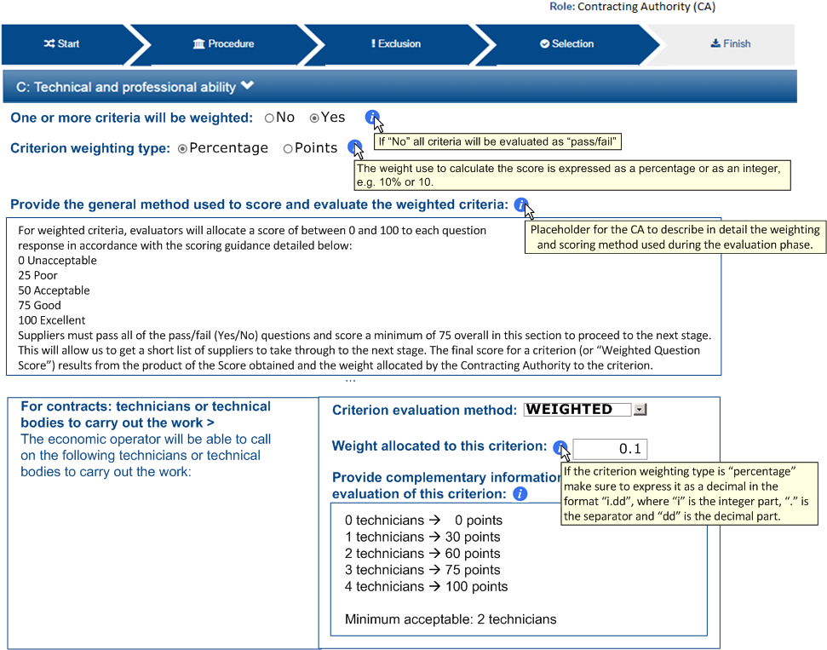

Figure 30:Weighting selection technical and professional ability criteria, CA-view mock-up

In this case all the Criterion Properties informing about the scoring and weighting methods are placed into the subcomponents of the UBL-2.2 cac:TeneringCriterion element:

cbc:WeightNumeric, to hold the weight allocated to the Criterion;

cbc:EvaluationMethodTypeCode, to hold the Criterion evaluation method; (compulsory use of the Code List “”; if no method is specificat it defaults to “Pass/Fail”;

cbc:WeightingConsiderationDescription, for additional information on the evaluation method;

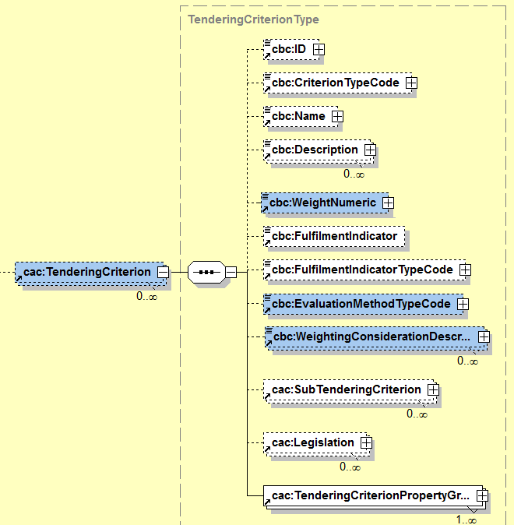

Figure 31: Elements used to weight a Criterion

##### EO view

The requirements specified by the Contracting Authority are to be shown to the Economic Operator. This mock-up below provides a possible representation for the EO point-of-view:

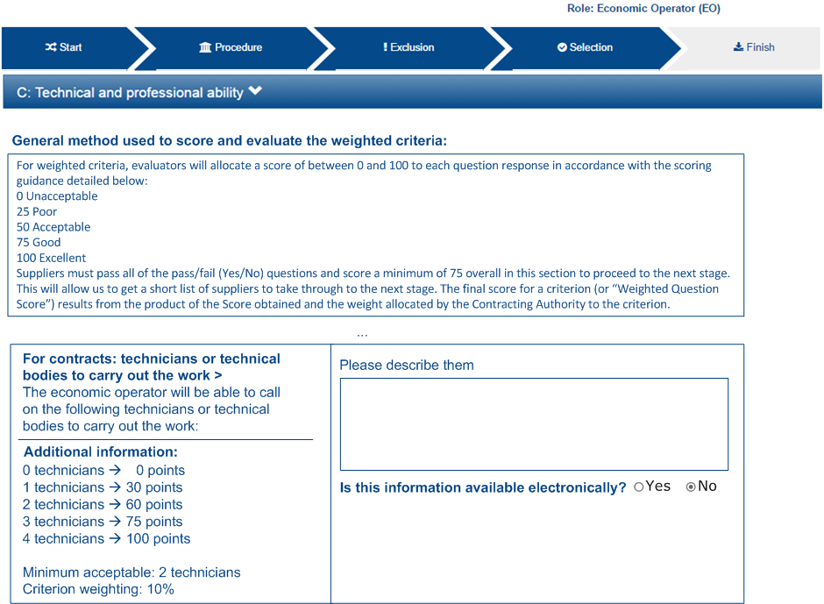

Figure 32: Weighting selection technical and professional ability criteria, EO-view mock-up

##### Data structure

In this case the data structure does not contain any requirement from the CA as all the data related to the weighting are placed in UBL-2.2 elements, out of the cac:TenderingCriterion component (the structure has not changed since the previous version of the ESPD-EDM).



##### XML example

|  |
| --- |
| [TODO:] |

### Example 5: References on similar works, deliveries or services

|  |  |
| --- | --- |
| SELF-CONTAINED ESPD FEATURE | References on similar works, deliveries or services:  The Contracting Authority (CA) has to be able to enter the minimum number of references required and to provide as many requirements as needed related to those references.  The specific requirements required by the CA have to be shown to the Economic Operator (EO). The EO needs to be able to add the references that comply with the requirements. For each reference, the EO will be able to provide one or several recipients and to indicate whether the information is available electronically or not;  The EO needs to be able to specify for which lots the reference is valid (relates to). |

##### CA view

The mock-up below represents the requirements the CA should be able to specify regarding the References:

The Lots to which the requirements DO NOT apply;

The minimum number of references necessary for the evaluation;

Specific requirements, as a free-text.

The mock-up presents the situation when the Procurement Procedure is divided into lots. Otherwise the software application managing the drafting of the Request document (e.g. the ESPD Service) would not show the boxes allowing for the selection of lots.

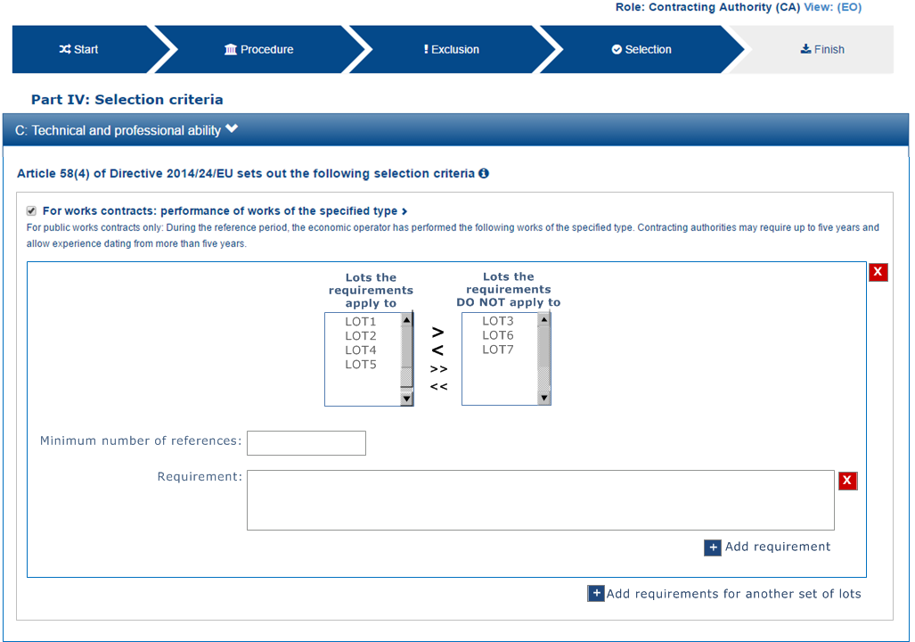

Figure 33:References, CA-view mock-up

##### EO view (NO LOTS)

The requirements specified by the Contracting Authority are to be shown to the Economic Operator. This mock-up below provides a possible representation for the EO point-of-view in the case the **Procurement Project is not divided into Lots**:

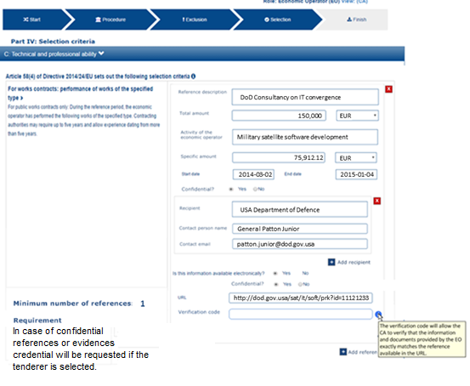

Figure 34: References, EO-view mock-up

##### EO view (WITH LOTS)

The requirements specified by the Contracting Authority are to be shown to the Economic Operator. This mock-up below provides a possible representation for the EO point-of-view in the case the **Procurement Project IS divided into Lots**:

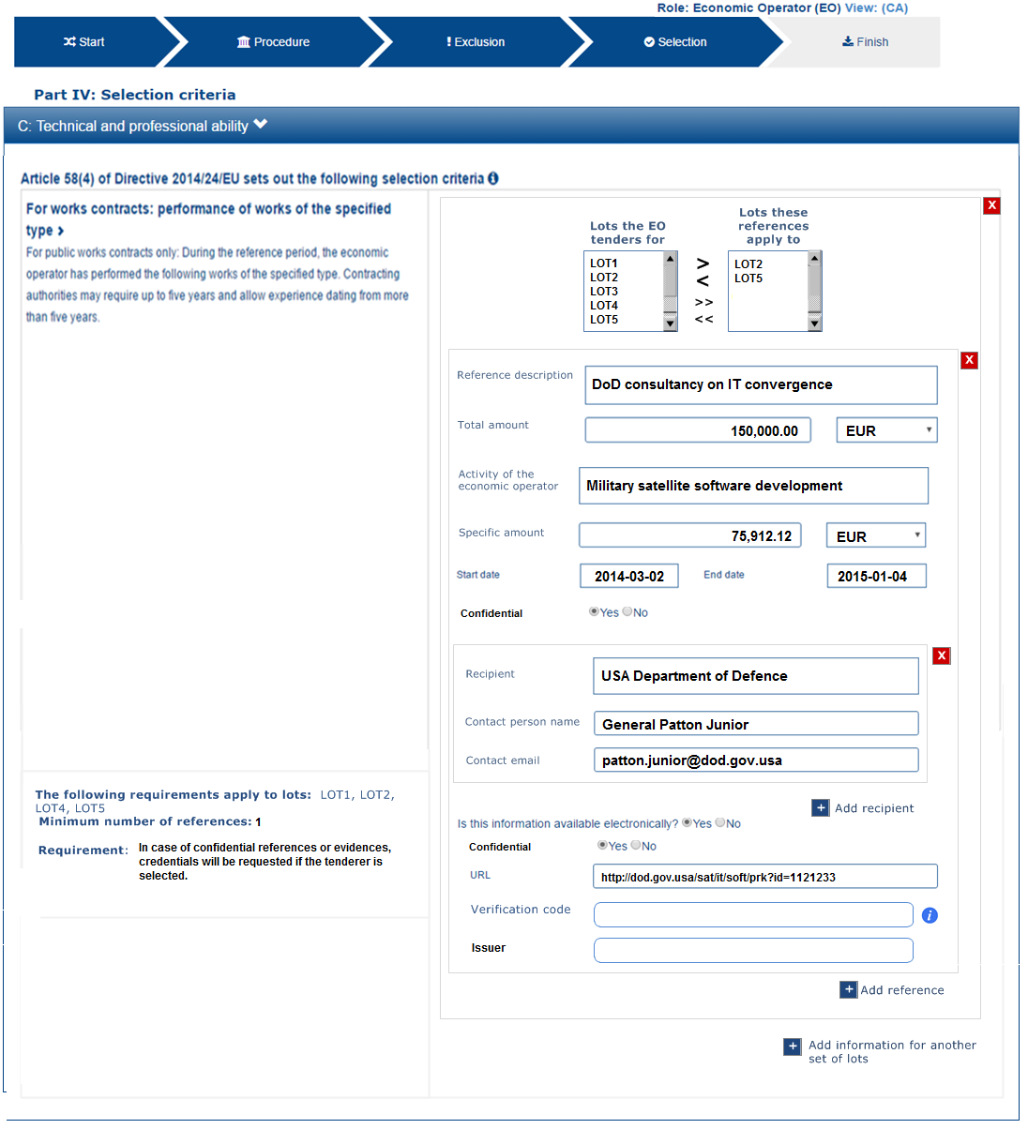

Figure 35: References WITH LOTS, EO-view mock-up

##### Data structure

The data structure for both the requirements and the expected responses follow, extracted from the “Criteria Taxonomy” spread-sheet. This structure contains the lots specified by the EO. In case the Procurement Procedure is not divided into lots the Criterion Property expecting the list of lots is not used (see the two XML examples below, one with lots and the other without lots):



##### XML example

See also section “6.6.5 Example 5: References and confidentiality” for an example on how the EO responds this Request.

|  |
| --- |
| <cac:TenderingCriterion>  <cbc:ID schemeID="CriteriaTaxonomy" schemeAgencyID="EU-COM-GROW" schemeVersionID="2.0..0">cdd3bb3e-34a5-43d5-b668-2aab86a73822</cbc:ID>  <cbc:CriterionTypeCode listID="CriteriaTypeCode" listAgencyID="EU-COM-GROW" listVersionID="2.0.0">CRITERION.SELECTION.TECHNICAL_PROFESSIONAL_ABILITY.REFERENCES</cbc:CriterionTypeCode>  <cbc:Name>References</cbc:Name>  <cbc:Description>During the reference period, the economic operator has delivered the following principal deliveries, performed services or executed works of the type specified.</cbc:Description>  <!-- EU Criterion Legislation-->  <cac:Legislation></cac:Legislation>  <!-- Requirement by the CA-->  <cac:TenderingCriterionPropertyGroup>  <cbc:ID schemeAgencyID="EU-COM-GROW" schemeVersionID="2.0.0">3e05e56d-fee2-43ba-b0c0-99df274505dd</cbc:ID>  <cac:TenderingCriterionProperty>  <cbc:ID schemeAgencyID="EU-COM-GROW" schemeVersionID="2.0.0">73943e4d-96c3-4884-9c72-0596d100c814</cbc:ID>  <cbc:Description>Minimum number of references</cbc:Description>  <cbc:ValueDataTypeCode listID="ResponseDataType" listAgencyID="EU-COM-GROW" listVersionID="2.0.0">NONE</cbc:ValueDataTypeCode>  </cac:TenderingCriterionProperty>  <cac:SubsidiaryTenderingCriterionPropertyGroup>  <cbc:ID schemeAgencyID="EU-COM-GROW" schemeVersionID="2.0.0">50a04664-ef71-4b2b-a071-aa81309210fd</cbc:ID>  <cac:TenderingCriterionProperty>  <cbc:ID schemeAgencyID="EU-COM-GROW" schemeVersionID="2.0.0">977f93ba-97ed-4e71-8bce-5844751e3661</cbc:ID>  <cbc:Description>The following requirements apply to lots</cbc:Description>  <cbc:ValueDataTypeCode listID="ResponseDataType" listAgencyID="EU-COM-GROW" listVersionID="2.0.0">NONE</cbc:ValueDataTypeCode>  </cac:TenderingCriterionProperty>  <cac:SubsidiaryTenderingCriterionPropertyGroup>  <cac:TenderingCriterionProperty>  <cbc:ID schemeAgencyID="EU-COM-GROW" schemeVersionID="2.0.0">570ba446-c564-433b-b922-e19e5eaf9b6d</cbc:ID>  <cbc:ValueDataTypeCode listID="ResponseDataType" listAgencyID="EU-COM-GROW" listVersionID="2.0.0">NONE</cbc:ValueDataTypeCode>  <cbc:ExpectedID>LOT1</cbc:ExpectedID>  </cac:TenderingCriterionProperty>  <cac:TenderingCriterionProperty>  <cbc:ID schemeAgencyID="EU-COM-GROW" schemeVersionID="2.0.0">c997e301-7555-4972-8665-107b2ddd49b5</cbc:ID>  <cbc:ValueDataTypeCode listID="ResponseDataType" listAgencyID="EU-COM-GROW" listVersionID="2.0.0">NONE</cbc:ValueDataTypeCode>  <cbc:ExpectedID>LOT2</cbc:ExpectedID>  </cac:TenderingCriterionProperty>  <cac:TenderingCriterionProperty>  <cbc:ID schemeAgencyID="EU-COM-GROW" schemeVersionID="2.0.0">c997e301-7555-4972-8665-107b2ddd49b5</cbc:ID>  <cbc:ValueDataTypeCode listID="ResponseDataType" listAgencyID="EU-COM-GROW" listVersionID="2.0.0">NONE</cbc:ValueDataTypeCode>  <cbc:ExpectedID>LOT4</cbc:ExpectedID>  </cac:TenderingCriterionProperty>  <cac:TenderingCriterionProperty>  <cbc:ID schemeAgencyID="EU-COM-GROW" schemeVersionID="2.0.0">c997e301-7555-4972-8665-107b2ddd49b5</cbc:ID>  <cbc:ValueDataTypeCode listID="ResponseDataType" listAgencyID="EU-COM-GROW" listVersionID="2.0.0">NONE</cbc:ValueDataTypeCode>  <cbc:ExpectedID>LOT5</cbc:ExpectedID>  </cac:TenderingCriterionProperty>  </cac:SubsidiaryTenderingCriterionPropertyGroup>  </cac:SubsidiaryTenderingCriterionPropertyGroup>  <cac:SubsidiaryTenderingCriterionPropertyGroup>  <cac:TenderingCriterionProperty>  <cbc:ID schemeAgencyID="EU-COM-GROW" schemeVersionID="2.0.0">3e05e56d-fee2-43ba-b0c0-99df274505dd</cbc:ID>  <cbc:Description>Requirement</cbc:Description>  <cbc:CertificationLevelDescription>Credentials will be required if the tenderer is selected.</cbc:CertificationLevelDescription>  </cac:TenderingCriterionProperty>  </cac:SubsidiaryTenderingCriterionPropertyGroup>  </cac:TenderingCriterionPropertyGroup>  <!-- Data to be provided by the EO -->  <cac:TenderingCriterionPropertyGroup>  <cbc:ID schemeAgencyID="EU-COM-GROW" schemeVersionID="2.0.0">41e69a73-da40-42bb-a35c-748218d26e92</cbc:ID>  <cac:TenderingCriterionProperty>  <cbc:ID schemeAgencyID="EU-COM-GROW" schemeVersionID="2.0.0">445954a0-5c70-4060-be8f-88ea2dd429b3</cbc:ID>  <cbc:ValueDataTypeCode listID="ResponseDataType" listAgencyID="EU-COM-GROW" listVersionID="2.0.0">NONE</cbc:ValueDataTypeCode>  </cac:TenderingCriterionProperty>  <cac:SubsidiaryTenderingCriterionPropertyGroup>  <cac:TenderingCriterionProperty>  <cbc:ID schemeAgencyID="EU-COM-GROW" schemeVersionID="2.0.0">09cf676d-377d-4edb-b927-d9adb53280e2</cbc:ID>  <cbc:Description>Lots these references apply to</cbc:Description>  <cbc:ValueDataTypeCode listID="ResponseDataType" listAgencyID="EU-COM-GROW" listVersionID="2.0.0">IDENTIFIER</cbc:ValueDataTypeCode>  </cac:TenderingCriterionProperty>  <cac:SubsidiaryTenderingCriterionPropertyGroup>  <cbc:ID schemeAgencyID="EU-COM-GROW" schemeVersionID="2.0.0">dcb40ae1-3f07-48a8-9cf9-a4be8954008f</cbc:ID>  <cbc:Description>One reference</cbc:Description>  <cac:TenderingCriterionProperty>  <cbc:ID schemeAgencyID="EU-COM-GROW" schemeVersionID="2.0.0">c7bd85b8-6e65-416c-90b8-f64d551bea24</cbc:ID>  <cbc:Description>Reference description</cbc:Description>  <cbc:ValueDataTypeCode listID="ResponseDataType" listAgencyID="EU-COM-GROW" listVersionID="2.0.0">DESCRIPTION</cbc:ValueDataTypeCode>  </cac:TenderingCriterionProperty>  <cac:TenderingCriterionProperty>  <cbc:ID schemeAgencyID="EU-COM-GROW" schemeVersionID="2.0.0">18606b15-6a4a-4b7a-82e5-aff5c4d065ab</cbc:ID>  <cbc:Description>Total amount</cbc:Description>  <cbc:ValueDataTypeCode listID="ResponseDataType" listAgencyID="EU-COM-GROW" listVersionID="2.0.0">AMOUNT</cbc:ValueDataTypeCode>  </cac:TenderingCriterionProperty>  <cac:TenderingCriterionProperty>  <cbc:ID schemeAgencyID="EU-COM-GROW" schemeVersionID="2.0.0">28235177-2eaf-4f64-b98d-8a77274fec38</cbc:ID>  <cbc:Description>Date</cbc:Description>  <cbc:ValueDataTypeCode listID="ResponseDataType" listAgencyID="EU-COM-GROW" listVersionID="2.0.0">DATE</cbc:ValueDataTypeCode>  </cac:TenderingCriterionProperty>  <cac:TenderingCriterionProperty>  <cbc:ID schemeAgencyID="EU-COM-GROW" schemeVersionID="2.0.0">695810f8-f788-4bda-97d6-53d3e2dd5796</cbc:ID>  <cbc:Description>Activity of the economic operator</cbc:Description>  <cbc:ValueDataTypeCode>DESCRIPTION</cbc:ValueDataTypeCode>  </cac:TenderingCriterionProperty>  <cac:TenderingCriterionProperty>  <cbc:ID schemeAgencyID="EU-COM-GROW" schemeVersionID="2.0.0">ee486082-93fa-4c17-8920-fdf01b890bd1</cbc:ID>  <cbc:Description>Specific amount</cbc:Description>  <cbc:ValueDataTypeCode listID="ResponseDataType" listAgencyID="EU-COM-GROW" listVersionID="2.0.0">AMOUNT</cbc:ValueDataTypeCode>  </cac:TenderingCriterionProperty>  <cac:TenderingCriterionProperty>  <cbc:ID schemeAgencyID="EU-COM-GROW" schemeVersionID="2.0.0">cc1da737-6c4e-4f4e-821d-c260029058f6</cbc:ID>  <cbc:Description>Period</cbc:Description>  <cbc:ValueDataTypeCode listID="ResponseDataType" listAgencyID="EU-COM-GROW" listVersionID="2.0.0">PERIOD</cbc:ValueDataTypeCode>  </cac:TenderingCriterionProperty>  <cac:SubsidiaryTenderingCriterionPropertyGroup>  <cbc:ID schemeAgencyID="EU-COM-GROW" schemeVersionID="2.0.0">42c4b5cf-d584-4f0d-8ae8-bfdc1b7c9074</cbc:ID>  <cac:TenderingCriterionProperty>  <cbc:ID schemeAgencyID="EU-COM-GROW" schemeVersionID="2.0.0">1308aee8-6183-43bc-8ddc-68b2fc2c6bf5</cbc:ID>  <cbc:Description>Recipient</cbc:Description>  <cbc:ValueDataTypeCode listID="ResponseDataType" listAgencyID="EU-COM-GROW" listVersionID="2.0.0">DESCRIPTION</cbc:ValueDataTypeCode>  </cac:TenderingCriterionProperty>  <cac:TenderingCriterionProperty>  <cbc:ID schemeAgencyID="EU-COM-GROW" schemeVersionID="2.0.0"></cbc:ID>  <cbc:Description>Contact person name</cbc:Description>  <cbc:ValueDataTypeCode listID="ResponseDataType" listAgencyID="EU-COM-GROW" listVersionID="2.0.0">DESCRIPTION</cbc:ValueDataTypeCode>  </cac:TenderingCriterionProperty>  <cac:TenderingCriterionProperty>  <cbc:ID schemeAgencyID="EU-COM-GROW" schemeVersionID="2.0.0">927897e8-b6c7-4c7e-ae0d-f4c21ac81634</cbc:ID>  <cbc:Description>Contact email</cbc:Description>  <cbc:ValueDataTypeCode listID="ResponseDataType" listAgencyID="EU-COM-GROW" listVersionID="2.0.0">DESCRIPTION</cbc:ValueDataTypeCode>  </cac:TenderingCriterionProperty>  </cac:SubsidiaryTenderingCriterionPropertyGroup>  </cac:SubsidiaryTenderingCriterionPropertyGroup>  </cac:SubsidiaryTenderingCriterionPropertyGroup>  </cac:TenderingCriterionPropertyGroup>    <!-- Is this information available electronically? -->  <cac:TenderingCriterionPropertyGroup>  <cbc:ID schemeAgencyID="EU-COM-GROW" schemeVersionID="2.0.0">7458d42a-e581-4640-9283-34ceb3ad4345</cbc:ID>  <cac:TenderingCriterionProperty>  <cbc:ID schemeAgencyID="EU-COM-GROW" schemeVersionID="2.0.0">c1347b74-1872-4060-a6db-f4044edcd7c4</cbc:ID>  <cbc:Description>Is this information available electronically?</cbc:Description>  <cbc:ValueDataTypeCode listID="ResponseDataType" listAgencyID="EU-COM-GROW" listVersionID="2.0.0">INDICATOR</cbc:ValueDataTypeCode>  </cac:TenderingCriterionProperty>  <cac:SubsidiaryTenderingCriterionPropertyGroup>  <cbc:ID schemeAgencyID="EU-COM-GROW" schemeVersionID="2.0.0">41dd2e9b-1bfd-44c7-93ee-56bd74a4334b</cbc:ID>  <cac:TenderingCriterionProperty>  <cbc:ID schemeAgencyID="EU-COM-GROW" schemeVersionID="2.0.0">f4313bb6-21b6-499e-bdff-debe10e11d2c</cbc:ID>  <cbc:Description>URL</cbc:Description>  <cbc:ValueDataTypeCode listID="ResponseDataType" listAgencyID="EU-COM-GROW" listVersionID="2.0.0">EVIDENCE_URL</cbc:ValueDataTypeCode>  </cac:TenderingCriterionProperty>  <cac:TenderingCriterionProperty>  <cbc:ID schemeAgencyID="EU-COM-GROW" schemeVersionID="2.0.0">1f1cd18e-3e01-4ca2-af4c-e2981924ba8d</cbc:ID>  <cbc:Description>Verification Code</cbc:Description>  <cbc:ValueDataTypeCode listID="ResponseDataType" listAgencyID="EU-COM-GROW" listVersionID="2.0.0">CODE</cbc:ValueDataTypeCode>  </cac:TenderingCriterionProperty>  <cac:TenderingCriterionProperty>  <cbc:ID schemeAgencyID="EU-COM-GROW" schemeVersionID="2.0.0">b01fe7d4-4486-4005-8a81-938409cfe082</cbc:ID>  <cbc:Description>Issuer</cbc:Description>  <cbc:ValueDataTypeCode listID="ResponseDataType" listAgencyID="EU-COM-GROW" listVersionID="2.0.0">DESCRIPTION</cbc:ValueDataTypeCode>  </cac:TenderingCriterionProperty>  </cac:SubsidiaryTenderingCriterionPropertyGroup>  </cac:TenderingCriterionPropertyGroup>  </cac:TenderingCriterion> |
| COMMENTS:  Beware that this exemple corresponds to the situation where the Procurement Project is divided into lots;  Notice how (1) the CA specifies the Lots for which the requirements apply to n lots; (2) To see how the EO specifies to which lots one reference applies to see section “6.6.5 Example 5: References and confidentiality ”. |

# The Qualification Application Response document

The UBL-2.2 document equivalent to the ESPD Response document is the “Qualification Application Response”.

This section describes and illustrates the main components of the document and provides guidelines on how to implement XML instances out of it.

## Global view

The figure below provides a global view of the UBL-2.2 Qualification Application Response document (it has been split in two portions to increase its readability).

This structure of this document is practically identical to the one for the Qualification Application Request, plus the following additions (and considerations):

|  |  |
| --- | --- |
|  |  |

Figure 36: QualificationApplicationResponse Schema, global view

## ESPD-EDM constraints related to the Response document

In the context of the ESPD-EDM the following requirements need to be satisfied:

Copy as many component instances as possible from the QualificationApplicationRequest, e.g. the information about the Contracting authority, the Procurement project, etc.;

All exclusion and selection criteria specified in the Request MUST also be instantiated in the Response document;

A reference to the Request document MUST be included in the Response. Use the component AdditionalDocumentReference for this purpose.

## Minimum set of elements for the Response document used in the ESPD-EDM

|  |  |  |  |  |
| --- | --- | --- | --- | --- |
| Document Name | QualificationApplicationResponse | | | |
| UBL Definition | A document issued by a procurement organization to notify an Economic Operator whether it has been admitted to or excluded from the tendering process. | | | |
| File | dist/main/xsdrt/UBL-QualificationApplicationRequest-2.2-Pre-award.xsd | | | |
| Components | **Type** | **UBL**  **Cardinality** | **ESPD**  **Cardinality** | **Description** |
| cbc:UBLVersionID | Identifier | 0..1 | 1 | Identifies the earliest version of the UBL 2 schema for this document type that defines all of the elements that might be encountered in the current instance. |
| cbc:CustomizationID | Identifier | 0..1 | 1 | Identifies a user-defined customization of UBL for a specific use. ESPD: use the value “ESPD-EDM-2.0.0”. See XML example below. |
| cbc:ID | Identifier | 0..1 | 1 | An identifier for this document, assigned by the sender. |
| cbc:UUID | Identifier | 0..1 | 1 | A universally unique identifier for an instance of this document. |
| cbc:ContractFolderID | Identifier | 1 | 1 | An identifier, assigned by the sender, for the process file (i.e., record) to which this document belongs. ESPD: This identifier is provided by the Contracting Authority and identifies (should be present in) all the contract documents related to the procurement procedure. |
| cbc:IssueDate | Date | 1 | 1 | The date, assigned by the sender, on which this document was issued. |
| cbc:IssueTime | Time | 0..1 | 0..1 | The time, assigned by the sender, at which this document was issued. |
| cbc:EconomicOperatorGroupName | Text | 0..1 | 0..1 | Economic Operator Group Name associated with this Qualification. ESPD: name of the group to which this Economic Operator belongs (e.g. a Consortium name). |
| cbc:QualificationApplicationTypeCode | Code | 0..1 | 1 | A code specifying the type of the Qualification Application. |
| cbc:Note | Text | 0..1 | 0..1 | Free-form text pertinent to this document, conveying information that is not contained explicitly in other structures. |
| cac:ContractingParty | Complex | 1..n | 1 | The Contracting Authority or entity in charge of the procurement procedure. |
| cac:EconomicOperatorParty | Complex | 1..n | 1 | The Economic Operator issuing the Qualification Application Response. |
| cac:ProcurementProject | Complex | 0..1 | 1 | An overall definition of this procurement procedure. |
| cac:ProcurementProjectLot | Complex | 0..n | 0..n | One of the procurement project lots into which this contract can be split. |
| cac:TenderingCriterion | Complex | 0..n | 1..n | The Criterion as described in the Qualification Application Request. |
| cac:TenderingCriterionResponse | Complex | 0..n | 1..n | Each Criterion property response. |
| cac:Evidence | Complex | 0..n | 0..n | Each Criterion property response. |
| cac:AdditionalDocumentReference | Complex | 0..n | 1..n | A reference to an additional document associated with this document. |

### XML instantiation of the basic components of the Qualification Application Request, example

|  |
| --- |
| <?xml version="1.0" encoding="UTF-8"?>  <QualificationApplicationResponse  xmlns="urn:X-test:UBL:Pre-award:QualificationApplicationResponse" xmlns:xsi="http://www.w3.org/2001/XMLSchema-instance"  xmlns:cac="urn:X-test:UBL:Pre-award:CommonAggregate"  xmlns:cbc="urn:X-test:UBL:Pre-award:CommonBasic"  xsi:schemaLocation="urn:X-test:UBL:Pre-award:QualificationApplicationResponse file:///C:/Users/estaromi/OneDrive%20-%20everis/Projects/GROW/QIS/ESPD-EDM/ESPD-EDM-V2.0.0/dist/xsdrt/maindoc/UBL-QualificationApplicationResponse-2.2-Pre-award.xsd">  <cbc:UBLVersionID schemeAgencyID="OASIS-UBL-TC">2.2</cbc:UBLVersionID>  <cbc:CustomizationID schemeAgencyID="EU-COM-GROW">2.0.0</cbc:CustomizationID>  <cbc:ID schemeAgencyID="DGPE" schemeVersionID="1.1"> PP.20170419.1024.EO</cbc:ID>  <cbc:UUID schemeID="ISO/IEC 9834-8:2008 - 4UUID" schemeAgencyID="EU-COM-GROW" schemeVersionID="2.0.0">f01c214f-2fe6-4664-83ff-353f118b8d6f</cbc:UUID>  <cbc:ContractFolderID schemeAgencyID="DGPE">PP.20170419.1024-9</cbc:ContractFolderID>  <cbc:IssueDate>2017-05-21</cbc:IssueDate>  <cbc:IssueTime>12:09:11</cbc:IssueTime>  <cbc:EconomicOperatorGroupName>BEOVEO</cbc:EconomicOperatorGroupName>  <cbc:QualificationApplicationTypeCode listID="QualificationApplicationType" listAgencyName="EU-COM-GROW" listVersionID="2.0.0">REGULATED</cbc:QualificationApplicationTypeCode>      <cac:ContractingParty> .. </cac:ContractingParty>  <cac:EconomicOperatorParty> .. </cac:EconomicOperatorParty>  ...    </QualificationApplicationResponse> |
| **COMMENTS**   * The Common Basis Components (CBC) are defined in the file dist/xsdrt/common/UBL-CommonBasicComponents-Pre-award.xsd; * UBL-2.2 is under public review, hence the temporary urn:X-test namespaces. Final version is foreseen by the end of 2017. |

### How to respond a Criterion

To answer each of the properties of a Criterion use the UBL-2.2 component cac:TenderingCriterionResponse component.

In the previous version of the ESDP-EDM the answers to each property where included in the element “ccv:Requirement”. In this new version, entirely based on UBL-2.2:

One Criterion Property from the Request document MAY be answered with a list of responses (not only one), provided all the responses are of the same type of data;

Each response MAY be supported by several evidences. The element cac:EvidenceSupplied is a pointer to the cac:Evidence component associated directly to the root QualificationApplicationResponse element (see section ”6.3.3 Evidences” below).

|  |  |  |  |  |
| --- | --- | --- | --- | --- |
| Element Name | cac:TenderingCriterionResponse | | | |
| ESPD Use | Used to answer the Contracting Authority questions and request for data expressed in a Criterion Property. | | | |
| File | dist/common/xsdrt/UBL-CommonAggregateComponents-Pre-award.xsd | | | |
| Absolute Path | /QualificationApplicationResponse/cac:TenderingCriterionResponse | | | |
| Diagram |  | | | |
| UBL Definition | A class to describe a response to a criterion property. | | | |
| Child Name | **Type** | **UBL Cardinality** | **ESPD Cardinality** | **Description** |
| cbc:ID | Identifier | 0..1 | 0..1 | An identifier for this criterion requirement response. |
| cbc:ValidatedCriterionRequirementID | Identifier | 0..1 | 1 | An identifier for this item of criterion support. **ESPD rule**: this ID MUST point at one Criterion Property ID that was included in the Request document. |
| cbc:ConfidentialityLevelCode | Code | 0..1 | 0..1 | A code specifying the confidentiality level of the response to this criterion. |
| cac:ResponseValue | Complex | 0..n | 0..n | The criterion property response values. **ESPD rule**: a collection of values is possible provided all the values are of the same expected data type. Beware of the cardinality 0..n: a cac:TenderingCriterionResponse may be used to refer to an cac:Evidence and do not provide any value. |
| cac:ApplicablePeriod | Complex | 0..n | 0..1 | The period to which this criterion property response applies. |
| cac:EvidenceSupplied | Complex | 0..n | 0..n | A reference to the evidence supporting this criterion requirement response. |

See examples below, in section “6.6 Answering the criteria and attaching evidences ”, for a grasp on how to implement the responses.

### Evidences

The element cac:EvidenceSupplied is in fact a pointer to another instance of the cac:Evidence component:

|  |  |  |  |  |  |
| --- | --- | --- | --- | --- | --- |
| Element Name | cac:EvidenceSupplied | | | | NEW! |
| ESPD Use | Used to point at an instance of the cac:Evidence component. | | | | |
| File | dist/common/xsdrt/UBL-CommonAggregateComponents-Pre-award.xsd | | | | |
| Absolute Path | /QualificationApplicationResponse/cac:TenderingCriterionResponse/cac:EvidenceSupplied | | | | |
| Diagram |  | | | | |
| UBL Definition | A reference to evidence. | | | | |
| Child Name | **Type** | **UBL Cardinality** | **ESPD Cardinality** | **Description** | |
| cbc:ID | Identifier | 0..1 | 1 | The identifier of the referenced evidence. | |

The evidence in itself is instantiated using the cac:Evidence component. This UBL-2.2. component is practically identical to the previous ESPD-EDM 1.0.2 version ccv:Evidence component.

|  |  |  |  |  |  |
| --- | --- | --- | --- | --- | --- |
| Element Name | cac:Evidence | | | | NEW! |
| ESPD Use | Used to refer to an evidence supporting one or more Criterion Properties. | | | | |
| File | dist/common/xsdrt/UBL-CommonAggregateComponents-Pre-award.xsd | | | | |
| Absolute Path | /QualificationApplicationResponse/cac:Evidence | | | | |
| Diagram |  | | | | |
| UBL Definition | A class to describe an item of evidentiary support for representations of capabilities or the ability to meet tendering requirements, which an economic operator must provide for acceptance into a tendering process. | | | | |
| Child Name | **Type** | **UBL Cardinality** | **ESPD Cardinality** | **Description** | |
| cbc:ID | Identifier | 0..1 | 1 | An identifier for this item of evidentiary support. | |
| cbc:EvidenceTypeCode | Code | 0..1 | 0..1 | A code signifying the type of evidence. | |
| cbc:Name | Text | 0..1 | 0..1 | The name of the evidence. | |
| cbc:Description | Text | 0..n | 0..1 | The textual description for this Evidence. | |
| cbc:CandidateStatement | Text | 0..n | 0..1 | Information about a candidate statement that the contracting authority accepts as a sufficient response. | |
| cbc:ConfidentialityLevelCode | Code | 0..1 | 0..1 | A code specifying the confidentiality level of this evidence. | |
| cac:EvidenceIssuingParty | Complex | 0..1 | 0..1 | A class to describe a party issuing an evidentiary document. | |
| cac:DocumentReference | Complex | 0..n | 0..n | A reference to the evidentiary document. | |
| cac:Language | Language | 0..1 | 0..1 | Information about a required translation to be part of the response, i.e. the language. | |

See examples below, in section “6.6 Answering the criteria and attaching evidences ”.

## The main elements of the Response document

This section describes the XSD schema elements used to respond an ESPD Request document. It also provides snippets of XML illustrate how to implement those elements in conformance to the ESPD-EDM expectations.

### Information common to the Request

Some information components in the Response document are identical to the ones in the Request. That is the case for the information about the publication of the CN, the identity of the procurer and information about the procurement procedure. The figure below shows a GUI mock-up for these three blocks of data. Notice that they’re identical to the ones in the Request. The UBL-2.2 components used in the Response to hold this data are also the same as the ones used for the Request (as they are reused from the UBL-2.2 Common Aggregate Components and Common Basic Components libraries).

For examples on how to instantiate this elements in XML please refer to section “4.4 The main elements of the Request document”.

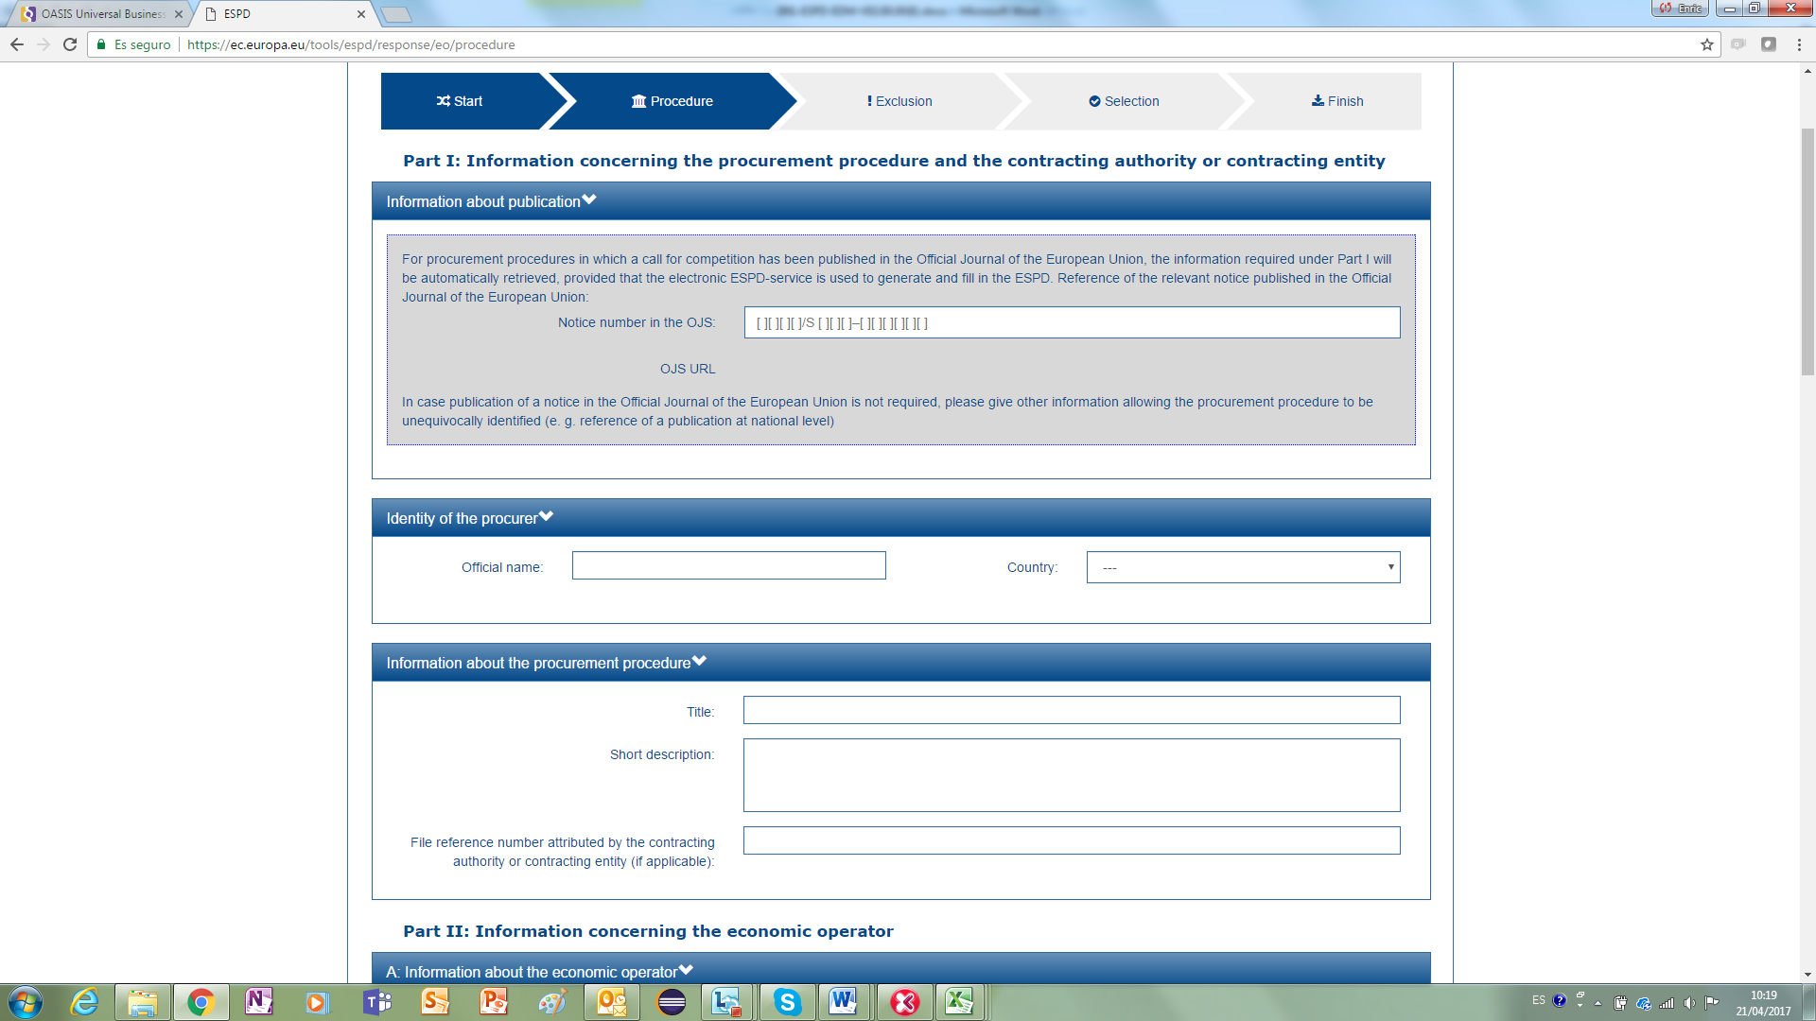

Figure 37: Information blocks common to the Request and the Response

## Information about the Economic Operator

The ESPD requests a wide range of data on the Economic Operator. The first block information that the Economic Operator needs to provide is basic data about itself. The mock-up below shows a possible representation of the fields required in the Response document.

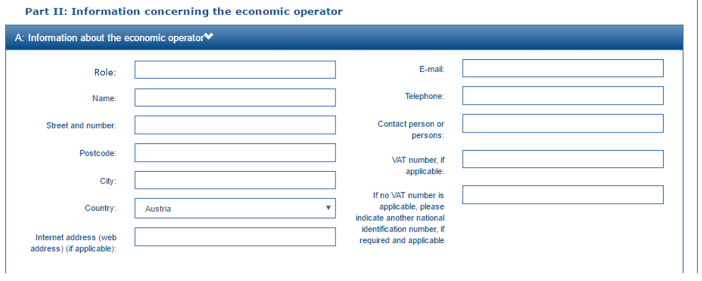

Figure 38: Basic data about the Economic Operator

To instantiate this data in the XML Response use the UBL-2.2 cac:EconomicOperatorParty component:

|  |  |  |  |  |  |
| --- | --- | --- | --- | --- | --- |
| Element Name | cac:EconomicOperatorParty | | | | NEW! |
| ESPD Use | The ESPD-EDM uses this component to provide information about the Economic Operator, its qualifications and representatives. | | | | |
| File | dist/common/xsdrt/UBL-CommonAggregateComponents-Pre-award.xsd | | | | |
| Absolute Path | /QualificationApplicationResponse/cac:EconomicOperatorParty | | | | |
| Diagram |  | | | | |
| UBL Definition |  | | | | |
| Child Name | **Type** | **UBL Cardinality** | **ESPD Cardinality** | **Description** | |
| cac:QualifyingParty | Complex | 0..n | 0..n | The party qualifying this Economic Operator. ESPD: e.g. official qualification service providers in the Member States. | |
| cac:EconomicOperatorRole | Complex | 0..1 | 1 | The role of the party in a tender consortium. | |
| cac:Party | Complex | 1 | 1 | The party information about the Economic Operator in a tender. | |

### The Economic Operator role

The ESPD-EDM defines different roles for the Economic Operator (EO). The mock-up below shows and describes these roles. The roles are also described in the Code List “EORoleType”.

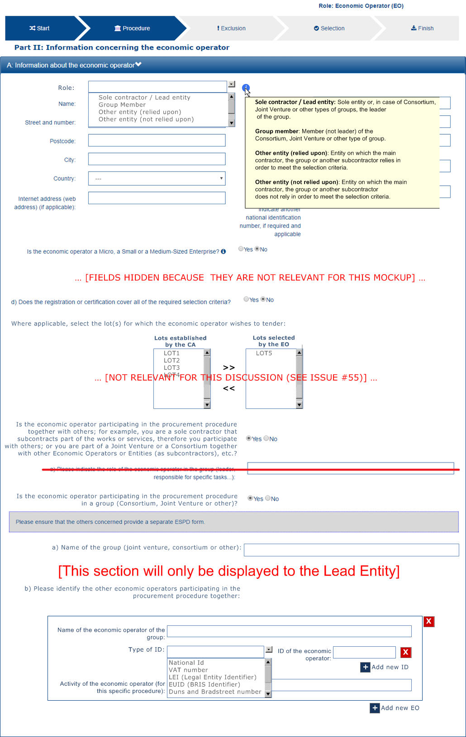

Figure 39: Roles of the Economic Operator

Depending on the EO role different information will be requested or not; thus:

If the role is “Sole contractor” or the “Lead entity”, the EO MUST produce a complete ESPD Response;

If the role is “Group member” (not the leader), the EO MUST produce a complete ESPD Response but doesn’t have to identify the rest of tenderers (procurers);

If the role is “Other entity (relied upon)”, the entity MUST produce a complete ESPD Response but doesn’t have to identify the rest of tenderers (procurers);

If the role is “Other entity (not relied upon), the role MUST produce an ESPD Response but doesn’t have to complete Part IV (Selection Criteria) nor Part V (Reduction of the number of qualified candidates).

A software application managing the drafting of an ESPD Response document (e.g. the ESPD Service) may take into account the role of the EO to, dynamically, hide or show to the user those parts that need or not to be completed depending on the selected role.

For the implementation of the EO role use the UBL-2.2 component cac:EconomicOperatorRole:

|  |  |  |  |  |  |
| --- | --- | --- | --- | --- | --- |
| Element Name | cac:EconomicOperatorRole | | | | NEW! |
| ESPD Use | The ESPD-EDM uses this component to specify the role of the Economic Operator in the procurement procedure. | | | | |
| File | dist/common/xsdrt/UBL-CommonAggregateComponents-Pre-award.xsd | | | | |
| Absolute Path | /QualificationApplicationResponse/cac:EconomicOperatorParty/cac:EconomicOperatorRole | | | | |
| Diagram |  | | | | |
| UBL Definition | The role of the party in a tender consortium. | | | | |
| Child Name | **Type** | **UBL Cardinality** | **ESPD Cardinality** | **Description** | |
| cbc:RoleCode | Code | 0..1 | 1 | A code specifying the role of the party. | |
| cbc:RoleDescription | Text | 0..n | 0..1 | A textual description of the party role. | |

|  |
| --- |
| <?xml version="1.0" encoding="UTF-8"?>  <QualificationApplicationResponse  xmlns="urn:X-test:UBL:Pre-award:QualificationApplicationResponse" xmlns:xsi="http://www.w3.org/2001/XMLSchema-instance"  xmlns:cac="urn:X-test:UBL:Pre-award:CommonAggregate"  xmlns:cbc="urn:X-test:UBL:Pre-award:CommonBasic"  xsi:schemaLocation="urn:X-test:UBL:Pre-award:QualificationApplicationResponse ../maindoc/UBL-QualificationApplicationResponse-2.2-Pre-award.xsd">  ...  <cac:ContractingParty> ... </cac:ContractingParty>  <cac:EconomicOperatorParty>  <cac:EconomicOperatorRole>  <cbc:RoleCode listID="EORoleType" listAgencyName="EU-COM-GROW" listVersionID="2.0.0">SCLE</cbc:RoleCode>  <cbc:RoleDescription>Sole entity or, in case of Consortium, Joint Venture or other types of groups, the leader of the group.</cbc:RoleDescription>  </cac:EconomicOperatorRole>  <cac:Party> ... </cac:Party>  </cac:EconomicOperatorParty>    ...  </QualificationApplicationResponse> |

### The Party-related information

To hold the data about a legal entity or a natural person party, UBL-2.2 uses a very rich component “cac:Party”. The ESPD-EDM however only uses a small portion of its elements. The table below contains the complete representation of this UBL class and lists the set of elements used by the ESPD-EDM (the image has been split to enhance its quality and readability).

|  |  |  |  |  |  |
| --- | --- | --- | --- | --- | --- |
| Element Name | cac:Party | | | | |
| ESPD Use | The ESPD-EDM uses this component to hold the basic components of a party, in this case the Economic Operator. | | | | |
| File | dist/common/xsdrt/UBL-CommonAggregateComponents-Pre-award.xsd | | | | |
| Absolute Path | /QualificationApplicationResponse/cac:EconomicOperatorParty/cac:Party | | | | |
| Diagram |  | | |  | |
| UBL Definition | The party information about the Economic Operator in a tender. | | | | |
| Child Name | **Type** | **UBL Cardinality** | **ESPD Cardinality** | | **Description** |
| cac:PartyIdentification | Complex | 0..n | 1..n | | An identifier for this party. ESPD: multiple identifiers may be provided. Compulsory use of the attributes of the Identifier to specify the issuer and pattern of the Identifier (see example below). |
| cac:PartyName | Complex | 0..n | 1 | | A name for this party. |
| cac:PostalAddress | Complex | 0..1 | 0..1 | | The party's postal address. |
| cac:Contact | Complex | 0..1 | 0..1 | | The primary contact for this party. |
| cac:AgentParty | Complex | 0..1 | 0..1 | | A party who acts as an agent for this party. ESPD: e.g. a representative natural person. |

Some MS, EC or private Qualification Systems may benefit of the rest of components of Party, namely:

cac:PowerOfAttorney, several powers of attorney are associated with the party;

cac:FinancialAccount, use this component if the Economic Operator is requested to provide a bank account;

cac:PartyLegalEntity, allows to specify the information about the Economic Operator as registered in an official registry, e.g. a Business Register;

cac:AdditionalWebSite and cac:SocialMediaProfile may specify additional online resources associated with this party (e.g. a satellite web site, a seller profile, etc.).

The XML snippet below illustrates how to implement the minimum set of data used normally in the ESPD-EDM (e.g. by the ESPD Service):

|  |
| --- |
| <cac:EconomicOperatorParty>  <cac:Party>  <cbc:WebsiteURI>http://acme.org</cbc:WebsiteURI>  <cac:PartyIdentification>  <!-- VAT number -->  <cbc:ID schemeID="CIF" schemeAgencyID="AEAT">B20778012</cbc:ID>  </cac:PartyIdentification>  <cac:PartyName>  <cbc:Name>Asociación de Corporaciones Mediáticas</cbc:Name>  </cac:PartyName>  <cac:PostalAddress>  <cbc:StreetName>Abascal, 212</cbc:StreetName>  <cbc:CityName>Madrid</cbc:CityName>  <cbc:PostalZone>08201</cbc:PostalZone>  <cac:Country>  <cbc:IdentificationCode listID="CountryCodeIdentifier" listName="ISO-1-ALPHA-2" listAgencyID="ISO" listVersionID="1.0">ES</cbc:IdentificationCode>  </cac:Country>  </cac:PostalAddress>  <cac:Contact>  <cbc:Name>Vicent Rodríguez de la Peña</cbc:Name>  <cbc:Telephone>+34917612323</cbc:Telephone>  <cbc:ElectronicMail>info@acme.org</cbc:ElectronicMail>  </cac:Contact>  </cac:Party>  </cac:EconomicOperatorParty> |

### Additional information about the Economic Operator

#### SME?

The MS or other EU and international institutions may be interested in studying the type of companies that participate in public procurement. The ESPD-EDM provides a Criterion data structure to capture very basic data about the company, namely the number of employees and its yearly turnover. One of the objectives of the study is to analyse the participation of SMEs in public procurement.

Beware that this Criterion is also part of the Request document, as the rest of criteria.

The structure of this Criterion is simple, a question is asked, and in case of an affirmative response, two data are collected:



The fragment of XML below illustrates how this is implemented in the ESPD-EDM:

|  |
| --- |
| <cac:TenderingCriterion>  <cbc:ID schemeID="CriteriaTaxonomy" schemeAgencyID="EU-COM-GROW" schemeVersionID="2.0.0">fab9ab25-9b2a-43c0-ab46-c3b2bd4859a1</cbc:ID>  <cbc:Name>SME</cbc:Name>  <cbc:Description>Is the economic operator a Micro, Small or Medium-Sized Enterprise?</cbc:Description>  <cac:TenderingCriterionPropertyGroup>  <cbc:ID schemeID="CriteriaTaxonomy" schemeAgencyID="EU-COM-GROW" schemeVersionID="2.0.0">74639b31-c397-4b96-ad77-9ebc4d05d460</cbc:ID>  <cac:TenderingCriterionProperty>  <cbc:ID schemeID="CriteriaTaxonomy" schemeAgencyID="EU-COM-GROW" schemeVersionID="2.0.0">2f15716c-1cf8-4017-8863-9f1dc600eb70</cbc:ID>  <cbc:Description>Please provide:</cbc:Description>  <cbc:ValueDataTypeCode listID="ResponseDataType" listAgencyName="EU-COM-GROW" listVersionID="2.0.0">NONE</cbc:ValueDataTypeCode>  </cac:TenderingCriterionProperty>  <cac:SubsidiaryTenderingCriterionPropertyGroup>  <cbc:ID schemeID="CriteriaTaxonomy" schemeAgencyID="EU-COM-GROW" schemeVersionID="2.0.0">2f15716c-1cf8-4017-8863-9f1dc600eb70</cbc:ID>  <cac:TenderingCriterionProperty>  <cbc:ID schemeID="CriteriaTaxonomy" schemeAgencyID="EU-COM-GROW" schemeVersionID="2.0.0">2f15716c-1cf8-4017-8863-9f1dc600eb70</cbc:ID>  <cbc:Description>Number of employees</cbc:Description>  <cbc:ValueDataTypeCode listID="ResponseDataType" listAgencyName="EU-COM-GROW" listVersionID="2.0.0">QUANTITY</cbc:ValueDataTypeCode>  </cac:TenderingCriterionProperty>  <cac:TenderingCriterionProperty>  <cbc:ID schemeID="CriteriaTaxonomy" schemeAgencyID="EU-COM-GROW" schemeVersionID="2.0.0">2f15716c-1cf8-4017-8863-9f1dc600eb70</cbc:ID>  <cbc:Description>Yearly turnover</cbc:Description>  <cbc:ValueDataTypeCode listID="ResponseDataType" listAgencyName="EU-COM-GROW" listVersionID="2.0.0">AMOUNT</cbc:ValueDataTypeCode>  </cac:TenderingCriterionProperty>  </cac:SubsidiaryTenderingCriterionPropertyGroup>  </cac:TenderingCriterionPropertyGroup>  </cac:TenderingCriterion> |

#### Procurement reserved

As shown in previous examples the cac:TenderingCriterion component permits expressing many different data structures. This is also the case in the ESPD-EDM to require additional information about the Economic Operator, as in this case:

*“Only in case the procurement is reserved: is the economic operator a sheltered workshop, a 'social business' or will it provide for the performance of the contract in the context of sheltered employment programmes?”*

The data structure and XML example follow:



|  |
| --- |
| <cac:TenderingCriterion>  <cbc:ID schemeID="CriteriaID" schemeAgencyID="EU-COM-GROW" schemeVersionID="1.0">2043338f-a38a-490b-b3ec-2607cb25a017</cbc:ID>  <cbc:CriterionTypeCode listID="CriteriaTypeCode" listAgencyID="EU-COM-GROW" listVersionID="1.0.2">CRITERION.OTHER.EO_DATA.SHELTERED_WORKSHOP</cbc:CriterionTypeCode>  <cbc:Name>Procurement reserved</cbc:Name>  <cbc:Description>Only in case the procurement is reserved: is the economic operator a sheltered workshop, a 'social business' or will it provide for the performance of the contract in the context of sheltered employment programmes?</cbc:Description>  <cac:TenderingCriterionPropertyGroup>  <cbc:ID schemeAgencyID="EU-COM-GROW" schemeVersionID="2.0.0">6febbe4a-e715-427c-a2b1-19cfabadaef0</cbc:ID>  <cac:TenderingCriterionProperty>  <cbc:ID schemeID="CriterionRelatedIDs" schemeAgencyID="EU-COM-GROW" schemeVersionID="1.0">7f18c64e-ae09-4646-9400-f3666d50af51</cbc:ID>  <cbc:Description>Your answer?</cbc:Description>  <cbc:ValueDataTypeCode listID="ResponseDataType" listAgencyID="EU-COM-GROW" listVersionID="2.0.0">INDICATOR</cbc:ValueDataTypeCode>  </cac:TenderingCriterionProperty>  <cac:SubsidiaryTenderingCriterionPropertyGroup>  <cbc:ID schemeAgencyID="EU-COM-GROW" schemeVersionID="2.0.0">7f18c64e-ae09-4646-9400-f3666d50af51</cbc:ID>  <cac:TenderingCriterionProperty>  <cbc:ID schemeID="CriterionRelatedIDs" schemeAgencyID="EU-COM-GROW" schemeVersionID="1.0">4e552658-d532-4770-943b-b90efcc9788d</cbc:ID>  <cbc:Description>What is the corresponding percentage of disabled or disadvantaged workers?</cbc:Description>  <cbc:ValueDataTypeCode listID="ResponseDataType" listAgencyID="EU-COM-GROW" listVersionID="2.0.0">PERCENTAGE</cbc:ValueDataTypeCode>  </cac:TenderingCriterionProperty>  <cac:TenderingCriterionProperty>  <cbc:ID schemeID="CriterionRelatedIDs" schemeAgencyID="EU-COM-GROW" schemeVersionID="1.0">e01d0929-c7a9-455a-aaf9-e1f7cd966336</cbc:ID>  <cbc:Description>If required, please provide details on whether the employees concerned belong to a specific category of disabled or disadvantaged workers?</cbc:Description>  <cbc:ValueDataTypeCode listID="ResponseDataType" listAgencyID="EU-COM-GROW" listVersionID="2.0.0">DESCRIPTION</cbc:ValueDataTypeCode>  </cac:TenderingCriterionProperty>  </cac:SubsidiaryTenderingCriterionPropertyGroup>  </cac:TenderingCriterionPropertyGroup>  </cac:TenderingCriterion> |

#### Qualification of Economic Operators

|  |  |
| --- | --- |
| SELF-CONTAINED ESPD FEATURE | In the Response document, the Economic Operator (EO) MAY provide the Pre-Qualification System (PQS) the EO is registered on from a list retrieved from e-Certis (in case the EO is registered on several pre-qualification systems, it will need to choose the one that applies to this particular procurement procedure). The EO is also required to provide the identification of the EO in the selected pre-qualification system. |

The mock-up below shows a possible GUI requesting this type of information. Notice that the Economic Operator MAY provide more than one Pre-Qualification System:

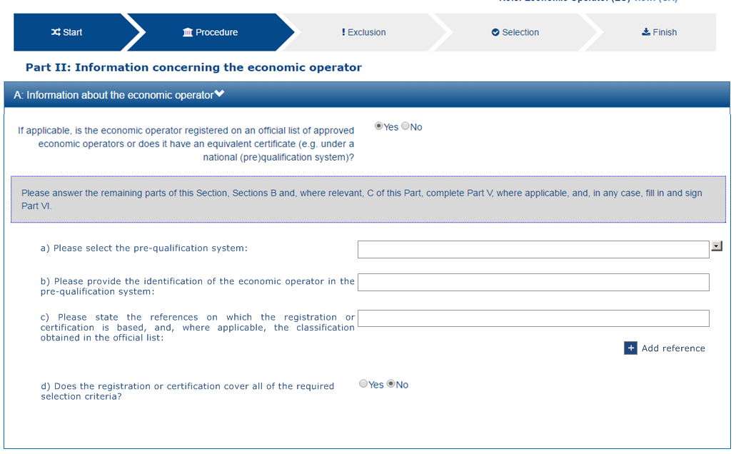

Figure 40. Qualifications of the Economic Operator

To complete all the information requested the XML instance will have to:

1. Instantiate a Criterion data structure (as in the previous version, but simplified, see also Annex I, section “1.3 Updated criteria”):



1. Instantiate as many UBL-2.2 cac:QualifyingParty components (inside cac:EconomicOperatorParty) as PQS need to be referred to;

The following table shows the UBL-2.2. cac:QualifyingParty component and lists the set of elements requested in the ESPD-EDM:

|  |  |  |  |  |
| --- | --- | --- | --- | --- |
| Element Name | cac:QualifyingParty | | | |
| ESPD Use | The ESPD-EDM uses this component to specify the information about Qualifications of the EO. | | | |
| File | dist/common/xsdrt/UBL-CommonAggregateComponents-Pre-award.xsd | | | |
| Absolute Path | /QualificationApplicationResponse/cac:EconomicOperatorParty/cac:QualifyingParty | | | |
| Diagram |  | | | |
| UBL Definition |  | | | |
| Child Name | **Type** | **UBL Cardinality** | **ESPD Cardinality** | **Description** |
| cbc:TendererID | Identifier | 0..1 | 1 | The Identifier of the Economic Operator in the pre-qualification system. |
| cac:CompletedTask | Complex | 0..n | 0..n | A former task completed by this qualifying party. ESPD: use this element to state the references on which the registration or certification is based, and, where applicable, the classification obtained in the official list. |
| cac:Party | Complex | 0..1 | 1 | The qualifying party itself. |

|  |
| --- |
| [XML Example TODO] |

### Participation in Consortia

|  |  |
| --- | --- |
| SELF-CONTAINED ESPD FEATURE | When Economic Operators tender as part of a group, e.g. a Consortium, Joint Venture or other types of groups, the leader of the group MUST provide information about the other Economic Operators that will participate in the group. |

The mock-up below shows a possible way of collecting the information requested in the Self-contained ESPD-EDM.

**A software application managing the Response document (e.g. the ESPD Service) should take into account that this information is only shown in the case the role of the Economic Operator is a Sole Contractor or a Lead Entity.**

Therefore the rest of participant do not have to provide this information on their Response documents.

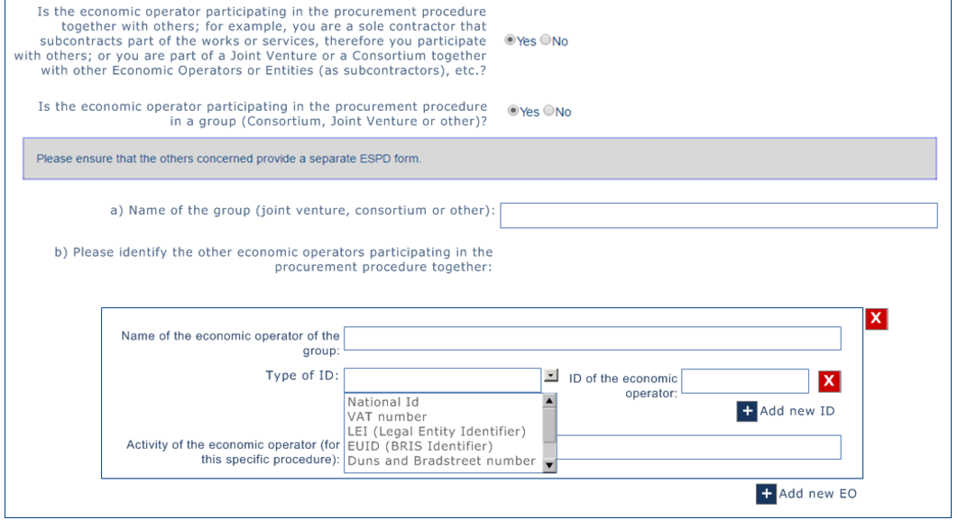

Figure 41: The leader of a Consortium provides information about the participants

The Criterion data structure is represented in the figure below, extracted from the Criteria Taxonomy spread-sheet. Beware that:

1. The sub-group requesting the data about the economic operator may be repeated several times, as many as economic operators participate in the consortium;
2. Inside the previous sub-group, the sub-sub-group requesting the ID and ID type of the economic operator may be repeated several times.



|  |
| --- |
| [XML Example TODO] |
| **COMMENTS:**  Very important: the Lead entity MUST specify a name for the group. The Lead entity SHOULD ensure that all the Economic Operators and entities related to that group use **EXACTLY** the same name in their Response documents, whithout any misspelling errors;  Compulsory use of the CodeList “EOIDType” to categorise the type of the Economic Operator ID. |

### Reliance on other entities

|  |  |
| --- | --- |
| SELF-CONTAINED ESPD FEATURE | If the Economic Operator relies on the capacities of other entites (e.g subcontractors) to meet the selection criteria, it MUST provide information about those entities. |

The mock-up below represents the information that needs to be provided. Observe that the group of data requested per entity MUST be provided several times:

Name of the entity relied on;

Identifier and type of identifier of the entity;

Activity of the entity (for this specific procedure);

The lots in which the entity participates in.

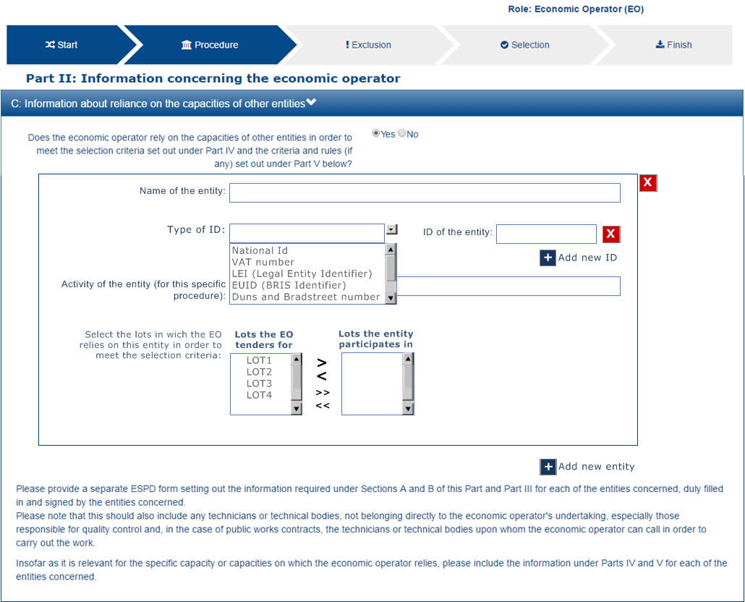

Figure 42: Reliance on the capacities of other entites, mock-up

The Criterion data structure is represented in the figure below, extracted from the Criteria Taxonomy spread-sheet. As in the previous case, beware that:

1. The sub-group requesting the data about the entity may be repeated several times, as many as economic operators participate in the consortium;
2. Inside the previous sub-group, the sub-sub-group requesting the ID and ID type of the entity may be repeated several times.



|  |
| --- |
| [XML Example TODO] |
| **COMMENTS:**  Compulsory use of the CodeList “EOIDType” to categorise the type of the entity ID. |

### Not reliance on other entities

|  |  |
| --- | --- |
| SELF-CONTAINED ESPD FEATURE | For those entities that the Economic Operator works with but does not rely on their capacities to meet the selection criteria, the Economic Operator MUST provide information about those entities. |

The mock-up below represents the information that needs to be provided. Observe that the group of data requested per entity MUST be provided several times:

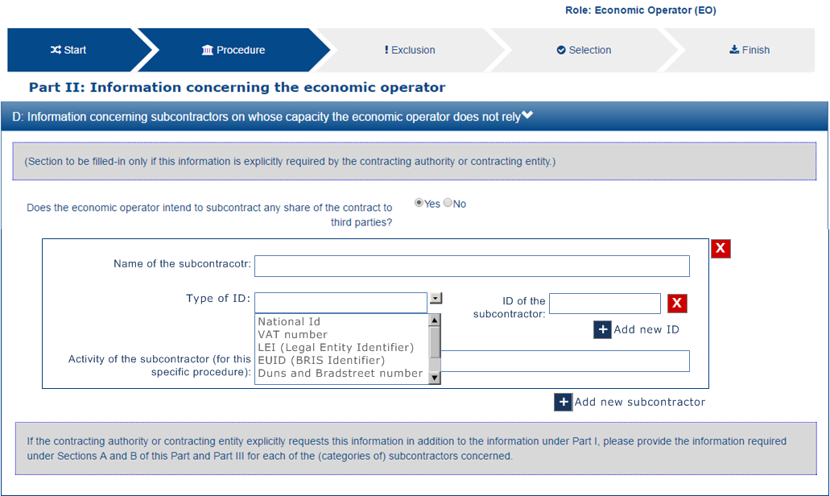

Figure 43: Not reliance on the capacities of other entites, mock-up



In terms of XML implementation this case is identical to the previous one (Reliance on other entites). Please see that XML example above.

## Answering the criteria and attaching evidences

This section provides fragments of XML code aimed at illustrating how the criteria expressed in the Request document (and also replicated in the Response document) MUST be answered. Beware that:

One answer is an instance of the UBL-2.2 element cac:TenderingCriterionResponse (see section “6.3.2 How to respond a Criterion ” for more details on this element).

Each answer responds to a concrete Criterion Property (UBL-2.2 element cac:TenderingCriterionProperty) by indicating the Identifier the Property has in the Request document (and which was originated by the e-Certis system at Criterion definition time);

One answer MAY be associated to one or more evidences. Use the UBL-2.2. element cac:EvidenceSupplied to refer to the evidences attached to the Response document. See also section “6.3.3 Evidences “ for more details on the component cac:Evidence

### Example 1: EO specifies the lots to which it tenders

#### Situation

The Contracting Operator has divided the Procurement Procedure into 7 lots;

The Economic Operator states that it will tender for lots 5, 6 and 7.



#### Data structure



#### XML instance copied from the Request document

|  |
| --- |
| <cac:TenderingCriterion>  <cbc:ID schemeID="CriteriaTaxonomy" schemeAgencyID="EU-COM-GROW" schemeVersionID="2.0.0">1e430aa8-2875-4269-a751-8124549019c6</cbc:ID>  <cbc:CriterionTypeCode listID="CriteriaTypeCode" listAgencyID="EU-COM-GROW" listVersionID="2.0.0">CRITERION.OTHER.LOTS_REQUIREMENTS</cbc:CriterionTypeCode>  <cbc:Name>Requirements on lots</cbc:Name>  <cbc:Description>Criteria established by the Contracting Authority regarding the lots into which this procurement procedure is divided.</cbc:Description>  <!-- Requirements set by the CA follow -->  <cac:TenderingCriterionPropertyGroup> .. </cac:TenderingCriterionPropertyGroup>  <!-- Data expected from the EO: list of lots -->  <cac:TenderingCriterionPropertyGroup>  <cbc:ID schemeID="CriteriaID" schemeAgencyID="EU-COM-GROW" schemeVersionID="2.0.0">7ad7f4b0-98eb-4d7e-8fd5-e1350de20cc2</cbc:ID>  <cac:TenderingCriterionProperty>  <cbc:ID schemeID="CriteriaID" schemeAgencyID="EU-COM-GROW" schemeVersionID="2.0.0">13441726-e488-40ff-8202-758a325c1a38</cbc:ID>  <cbc:Description>Please provide the lots to which you are tendering</cbc:Description>  <cbc:ValueDataTypeCode listID="ResponseDataType" listAgencyID="EU-COM-GROW" listVersionID="2.0.0">IDENTIFIER</cbc:ValueDataTypeCode>  </cac:TenderingCriterionProperty>  </cac:TenderingCriterionPropertyGroup>  </cac:TenderingCriterion> |

#### Answers provided by the EO

|  |
| --- |
| <cac:TenderingCriterionResponse>  <cbc:ID schemeAgencyID="EU-COM-GROW" schemeVersionID="2.0.0">6280178c-a3a3-46e7-9b57-67c3aa81d25f</cbc:ID>  <cbc:ValidatedCriterionRequirementID>13441726-e488-40ff-8202-758a325c1a38</cbc:ValidatedCriterionRequirementID>  <cac:ResponseValue><cbc:ResponseID>Lot5</cbc:ResponseID></cac:ResponseValue>  <cac:ResponseValue><cbc:ResponseID>Lot6</cbc:ResponseID></cac:ResponseValue>  <cac:ResponseValue><cbc:ResponseID>Lot7</cbc:ResponseID></cac:ResponseValue>  </cac:TenderingCriterionResponse> |
| **COMMENTS:**  This response answers the Criterion Property “Please provide the lots to which you are tendering”;  The EO provides three values, Lot1, Lot2 and Lot3, all three of the same type (IDENTIFIER) as requested in the cac:ValueDataTypeCode element from the Request. These are the EO will tender. |

### Example 2: Payment of taxes

#### Situation

The EO is tendering in Latvia, where a maximum debt of 50 Euros with the Tax Agency is allowed.

The EO has a debt of 35 Euros in its country of origin, and so it declares it.

The EO also declares that an apparent breach with its obligations occurred but that it was an administrative error that was duly solved, for which it provides a certificate provided by the Tax Agency of its country.

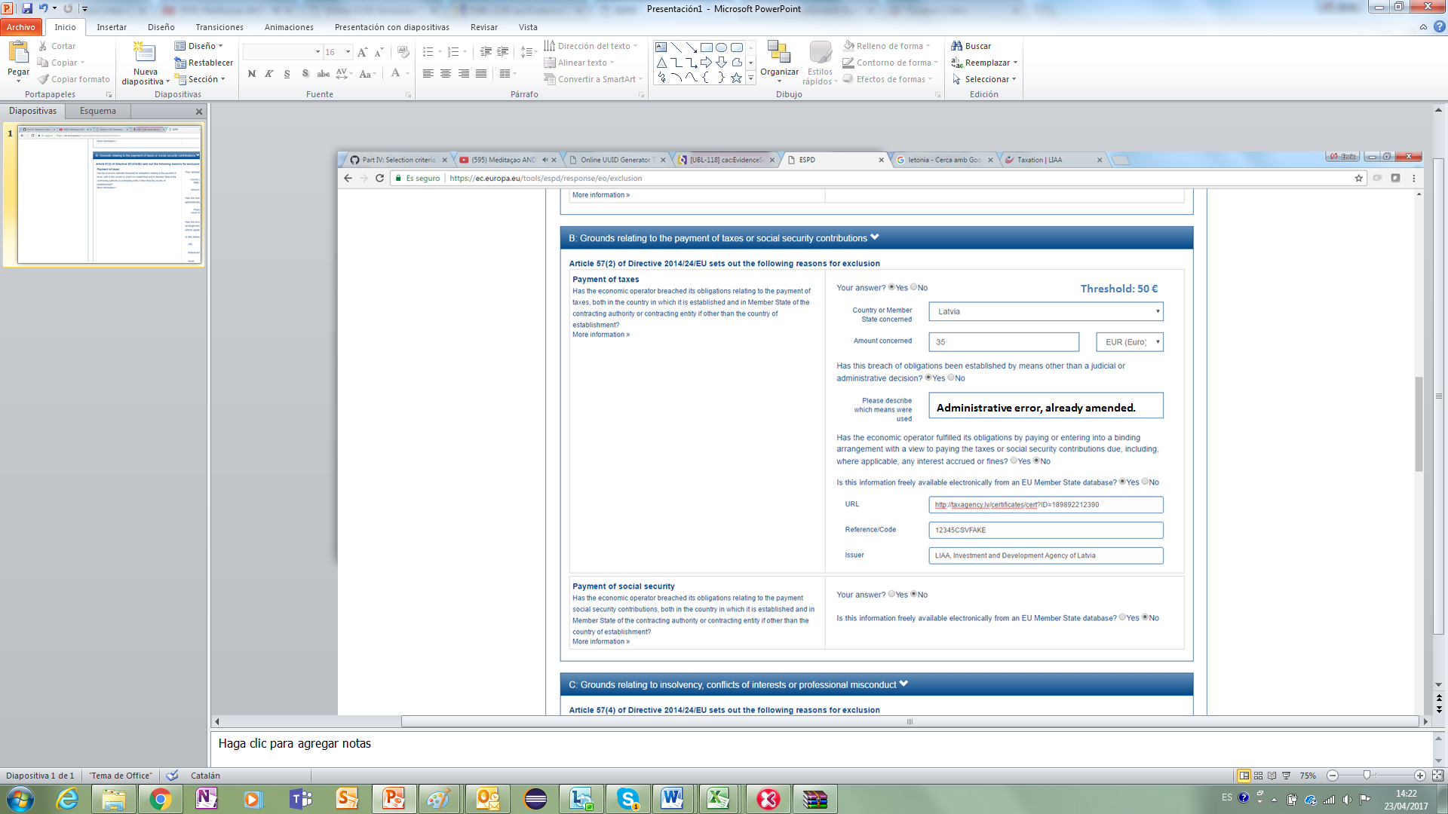

#### Data structure



#### XML instance copied from the Request document

This example has been abbreviated; thus the Legislation and the MS-specific requirement of a 50 € are not shown. For the complete example see section “5.5.3 Example 2: EU Payment of Taxes Criterion with a national specific requirement”.

|  |
| --- |
| <cac:TenderingCriterion>  <cbc:ID schemeID="CriteriaTaxonomy" schemeAgencyID="EU-COM-GROW" schemeVersionID="2.0..0">b61bbeb7-690e-4a40-bc68-d6d4ecfaa3d4</cbc:ID>  <cbc:CriterionTypeCode listID="CriteriaTypeCode" listAgencyID="EU-COM-GROW" listVersionID="2.0.0">CRITERION.EXCLUSION.CONTRIBUTIONS.PAYMENT_OF_TAXES</cbc:CriterionTypeCode>  <cbc:Name>Payment of Taxes</cbc:Name>  <cbc:Description>Has the economic operator breached its obligations relating to the payment of taxes, both in the country in which it is established and in Member State of the contracting authority or contracting entity if other than the country of establishment?</cbc:Description>  <!-- EU Criterion Legislation-->  <cac:Legislation> .. </cac:Legislation>  <!— MS specific requirement: threshold 50 €. Defined in e-Certis-->  <cac:TenderingCriterionPropertyGroup> .. </cac:TenderingCriterionPropertyGroup>  <cac:TenderingCriterionPropertyGroup>  <cbc:ID schemeAgencyID="EU-COM-GROW" schemeVersionID="2.0.0">098fd3cc-466e-4233-af1a-affe09471bce</cbc:ID>  <cac:TenderingCriterionProperty>  <cbc:ID schemeAgencyID="EU-COM-GROW" schemeVersionID="2.0.0">974c8196-9d1c-419c-9ca9-45bb9f5fd59a</cbc:ID>  <cbc:Description>Your answer?</cbc:Description>  <cbc:ValueDataTypeCode listID="ResponseDataType" listAgencyID="EU-COM-GROW" listVersionID="2.0.0">INDICATOR</cbc:ValueDataTypeCode>  </cac:TenderingCriterionProperty>  <cac:SubsidiaryTenderingCriterionPropertyGroup>  <cbc:ID schemeAgencyID="EU-COM-GROW" schemeVersionID="2.0.0">f8499787-f9f8-4355-95e2-9784426f4d7b</cbc:ID>  <cac:TenderingCriterionProperty>  <cbc:ID schemeAgencyID="EU-COM-GROW" schemeVersionID="2.0.0">6c87d3d4-e8eb-4253-b385-6373020ab886</cbc:ID>  <cbc:Description>Country or member state concerned</cbc:Description>  <cbc:ValueDataTypeCode listID="ResponseDataType" listAgencyID="EU-COM-GROW" listVersionID="2.0.0">CODE</cbc:ValueDataTypeCode>  </cac:TenderingCriterionProperty>  <cac:TenderingCriterionProperty>  <cbc:ID schemeAgencyID="EU-COM-GROW" schemeVersionID="2.0.0">9052cc59-cfe5-41c6-a314-02a7f378ffe8</cbc:ID>  <cbc:Description>Amount concerned</cbc:Description>  <cbc:ValueDataTypeCode listID="ResponseDataType" listAgencyID="EU-COM-GROW" listVersionID="2.0.0">AMOUNT</cbc:ValueDataTypeCode>  </cac:TenderingCriterionProperty>  <cac:SubsidiaryTenderingCriterionPropertyGroup>  <cbc:ID schemeAgencyID="EU-COM-GROW" schemeVersionID="2.0.0">7c2aec9f-4876-4c33-89e6-2ab6d6cf5d02</cbc:ID>  <cac:TenderingCriterionProperty>  <cbc:ID schemeAgencyID="EU-COM-GROW" schemeVersionID="2.0.0">9b4497e6-a166-46f9-8581-7fc39ff975c4</cbc:ID>  <cbc:Description>Has this breach of obligations been established by means other than a judicial or administrative decision?</cbc:Description>  <cbc:ValueDataTypeCode listID="ResponseDataType" listAgencyID="EU-COM-GROW" listVersionID="2.0.0">INDICATOR</cbc:ValueDataTypeCode>  </cac:TenderingCriterionProperty>  <cac:SubsidiaryTenderingCriterionPropertyGroup>  <cbc:ID schemeAgencyID="EU-COM-GROW" schemeVersionID="2.0.0">3cb7abf1-662a-4756-b61c-7bc716c1fafc</cbc:ID>  <cac:TenderingCriterionProperty>  <cbc:ID schemeAgencyID="EU-COM-GROW" schemeVersionID="2.0.0">201f11c3-1fa2-4464-acc0-f021266fd881</cbc:ID>  <cbc:Description>Please describe which means were used</cbc:Description>  <cbc:ValueDataTypeCode listID="ResponseDataType" listAgencyID="EU-COM-GROW" listVersionID="2.0.0">DESCRIPTION</cbc:ValueDataTypeCode>  </cac:TenderingCriterionProperty>  </cac:SubsidiaryTenderingCriterionPropertyGroup>  <cac:SubsidiaryTenderingCriterionPropertyGroup>  <cbc:ID schemeAgencyID="EU-COM-GROW" schemeVersionID="2.0.0">c882afa4-6971-4b00-8970-0c283eb122cc</cbc:ID>  <cac:TenderingCriterionProperty>  <cbc:ID schemeAgencyID="EU-COM-GROW" schemeVersionID="2.0.0">08b0c984-c5e6-4143-8493-868c39745637</cbc:ID>  <cbc:Description>If this breach of obligations was established through a judicial or administrative decision, was this decision final and binding?</cbc:Description>  <cbc:ValueDataTypeCode listID="ResponseDataType" listAgencyID="EU-COM-GROW" listVersionID="2.0.0">INDICATOR</cbc:ValueDataTypeCode>  </cac:TenderingCriterionProperty>  <cac:SubsidiaryTenderingCriterionPropertyGroup>  <cbc:ID schemeAgencyID="EU-COM-GROW" schemeVersionID="2.0.0">815422d6-f8a1-418a-8bf0-3524f7c8f721</cbc:ID>  <cac:TenderingCriterionProperty>  <cbc:ID schemeAgencyID="EU-COM-GROW" schemeVersionID="2.0.0">ecf40999-7b64-4e10-b960-7f8ff8674cf6</cbc:ID>  <cbc:Description>Date of conviction</cbc:Description>  <cbc:ValueDataTypeCode listID="ResponseDataType" listAgencyID="EU-COM-GROW" listVersionID="2.0.0">DATE</cbc:ValueDataTypeCode>  </cac:TenderingCriterionProperty>  <cac:TenderingCriterionProperty>  <cbc:ID schemeAgencyID="EU-COM-GROW" schemeVersionID="2.0.0">9ca9096f-edd2-4f19-b6b1-b55c83a2d5c8</cbc:ID>  <cbc:Description>Length of the period of exclusion</cbc:Description>  <cbc:ValueDataTypeCode listID="ResponseDataType" listAgencyID="EU-COM-GROW" listVersionID="2.0.0">PERIOD</cbc:ValueDataTypeCode>  </cac:TenderingCriterionProperty>  </cac:SubsidiaryTenderingCriterionPropertyGroup>  <cac:SubsidiaryTenderingCriterionPropertyGroup>  <cbc:ID schemeAgencyID="EU-COM-GROW" schemeVersionID="2.0.0">fc57e473-d63e-4a04-b589-dcf81cab8052</cbc:ID>  <cac:TenderingCriterionProperty>  <cbc:ID schemeAgencyID="EU-COM-GROW" schemeVersionID="2.0.0">70f8697b-8953-411a-a489-4ff62e5250d2</cbc:ID>  <cbc:Description>Has the economic operator fulfilled its obligations by paying or entering into a binding arrangement with a view to paying the taxes or social security contributions due, including, where applicable, any interest accrued or fines?</cbc:Description>  <cbc:ValueDataTypeCode listID="ResponseDataType" listAgencyID="EU-COM-GROW" listVersionID="2.0.0">INDICATOR</cbc:ValueDataTypeCode>  </cac:TenderingCriterionProperty>  <cac:SubsidiaryTenderingCriterionPropertyGroup>  <cbc:ID schemeAgencyID="EU-COM-GROW" schemeVersionID="2.0.0">6c3609e1-9add-4fa9-9409-62ce72ae4548</cbc:ID>  <cac:TenderingCriterionProperty>  <cbc:ID schemeAgencyID="EU-COM-GROW" schemeVersionID="2.0.0">55905dd0-38f0-4f93-8c74-5ae05a21afc5</cbc:ID>  <cbc:Description>Please describe them</cbc:Description>  <cbc:ValueDataTypeCode listID="ResponseDataType" listAgencyID="EU-COM-GROW" listVersionID="2.0.0">DESCRIPTION</cbc:ValueDataTypeCode>  </cac:TenderingCriterionProperty>  </cac:SubsidiaryTenderingCriterionPropertyGroup>  </cac:SubsidiaryTenderingCriterionPropertyGroup>  </cac:SubsidiaryTenderingCriterionPropertyGroup>  </cac:SubsidiaryTenderingCriterionPropertyGroup>  </cac:SubsidiaryTenderingCriterionPropertyGroup>  </cac:TenderingCriterionPropertyGroup>  <!-- Is this information available electronically? -->  <cac:TenderingCriterionPropertyGroup>  <cbc:ID schemeAgencyID="EU-COM-GROW" schemeVersionID="2.0.0">7458d42a-e581-4640-9283-34ceb3ad4345</cbc:ID>  <cac:TenderingCriterionProperty>  <cbc:ID schemeAgencyID="EU-COM-GROW" schemeVersionID="2.0.0">c1347b74-1872-4060-a6db-f4044edcd7c4</cbc:ID>  <cbc:Description>Is this information available electronically?</cbc:Description>  <cbc:ValueDataTypeCode listID="ResponseDataType" listAgencyID="EU-COM-GROW" listVersionID="2.0.0">INDICATOR</cbc:ValueDataTypeCode>  </cac:TenderingCriterionProperty>  <cac:SubsidiaryTenderingCriterionPropertyGroup>  <cbc:ID schemeAgencyID="EU-COM-GROW" schemeVersionID="2.0.0">41dd2e9b-1bfd-44c7-93ee-56bd74a4334b</cbc:ID>  <cac:TenderingCriterionProperty>  <cbc:ID schemeAgencyID="EU-COM-GROW" schemeVersionID="2.0.0">f4313bb6-21b6-499e-bdff-debe10e11d2c</cbc:ID>  <cbc:Description>URL</cbc:Description>  <cbc:ValueDataTypeCode listID="ResponseDataType" listAgencyID="EU-COM-GROW" listVersionID="2.0.0">EVIDENCE_URL</cbc:ValueDataTypeCode>  </cac:TenderingCriterionProperty>  <cac:TenderingCriterionProperty>  <cbc:ID schemeAgencyID="EU-COM-GROW" schemeVersionID="2.0.0">1f1cd18e-3e01-4ca2-af4c-e2981924ba8d</cbc:ID>  <cbc:Description>Verification Code</cbc:Description>  <cbc:ValueDataTypeCode listID="ResponseDataType" listAgencyID="EU-COM-GROW" listVersionID="2.0.0">CODE</cbc:ValueDataTypeCode>  </cac:TenderingCriterionProperty>  <cac:TenderingCriterionProperty>  <cbc:ID schemeAgencyID="EU-COM-GROW" schemeVersionID="2.0.0">b01fe7d4-4486-4005-8a81-938409cfe082</cbc:ID>  <cbc:Description>Issuer</cbc:Description>  <cbc:ValueDataTypeCode listID="ResponseDataType" listAgencyID="EU-COM-GROW" listVersionID="2.0.0">DESCRIPTION</cbc:ValueDataTypeCode>  </cac:TenderingCriterionProperty>  </cac:SubsidiaryTenderingCriterionPropertyGroup>  </cac:TenderingCriterionPropertyGroup>  </cac:TenderingCriterion> |

#### Answers provided by the EO

|  |
| --- |
| …  <!-- Responses -->  <cac:TenderingCriterionResponse>  <!-- Criterion Property : Your answer -->  <cbc:ValidatedCriterionRequirementID schemeAgencyID="EU-COM-GROW" schemeVersionID="2.0.0">974c8196-9d1c-419c-9ca9-45bb9f5fd59a</cbc:ValidatedCriterionRequirementID>  <cac:ResponseValue><cbc:ResponseIndicator>true</cbc:ResponseIndicator></cac:ResponseValue>  </cac:TenderingCriterionResponse>  <cac:TenderingCriterionResponse>  <!-- Criterion Property : Country or member state concerned -->  <cbc:ValidatedCriterionRequirementID schemeAgencyID="EU-COM-GROW" schemeVersionID="2.0.0">6c87d3d4-e8eb-4253-b385-6373020ab886</cbc:ValidatedCriterionRequirementID>  <cac:ResponseValue><cbc:ResponseCode listID="CountryCodeIdentifier" listAgencyID="EU-COM-GROW" listVersionID="2.0.0">LV</cbc:ResponseCode></cac:ResponseValue>  </cac:TenderingCriterionResponse>  <cac:TenderingCriterionResponse>  <!-- Criterion Property : Amount concerned -->  <cbc:ValidatedCriterionRequirementID schemeAgencyID="EU-COM-GROW" schemeVersionID="2.0.0">9052cc59-cfe5-41c6-a314-02a7f378ffe8</cbc:ValidatedCriterionRequirementID>  <cac:ResponseValue><cbc:ResponseAmount currencyID="EUR">35.00</cbc:ResponseAmount></cac:ResponseValue>  </cac:TenderingCriterionResponse>  <cac:TenderingCriterionResponse>  <!-- Criterion Property : Has this breach of obligations been established by means other than a judicial or administrative decision? -->  <cbc:ValidatedCriterionRequirementID schemeAgencyID="EU-COM-GROW" schemeVersionID="2.0.0">9b4497e6-a166-46f9-8581-7fc39ff975c4</cbc:ValidatedCriterionRequirementID>  <cac:ResponseValue><cbc:ResponseIndicator>true</cbc:ResponseIndicator></cac:ResponseValue>  </cac:TenderingCriterionResponse>  <cac:TenderingCriterionResponse>  <!-- Criterion Property : Please describe which means were used -->  <cbc:ValidatedCriterionRequirementID schemeAgencyID="EU-COM-GROW" schemeVersionID="2.0.0">9b4497e6-a166-46f9-8581-7fc39ff975c4</cbc:ValidatedCriterionRequirementID>  <cac:ResponseValue><cbc:Description>Administrative error, already mended.</cbc:Description></cac:ResponseValue>  </cac:TenderingCriterionResponse>  <cac:TenderingCriterionResponse>  <!-- Criterion Property:Is this information available electronically? -->  <cbc:ValidatedCriterionRequirementID schemeAgencyID="EU-COM-GROW" schemeVersionID="2.0.0">9b4497e6-a166-46f9-8581-7fc39ff975c4</cbc:ValidatedCriterionRequirementID>  <cac:ResponseValue><cbc:ResponseIndicator>true</cbc:ResponseIndicator></cac:ResponseValue>  </cac:TenderingCriterionResponse>  <cac:TenderingCriterionResponse>  <!-- Criterion Property:URL -->  <cbc:ValidatedCriterionRequirementID schemeAgencyID="EU-COM-GROW" schemeVersionID="2.0.0">f4313bb6-21b6-499e-bdff-debe10e11d2c</cbc:ValidatedCriterionRequirementID>  <cac:EvidenceSupplied><cbc:ID schemeAgencyID="EU-COM-GROW" schemeVersionID="2.0.0">07d17b1e-4524-434f-8a29-68675e5c2d33</cbc:ID></cac:EvidenceSupplied>  </cac:TenderingCriterionResponse>  <cac:TenderingCriterionResponse>  <!-- Criterion Property:Verification Code -->  <cbc:ValidatedCriterionRequirementID schemeAgencyID="EU-COM-GROW" schemeVersionID="2.0.0">1f1cd18e-3e01-4ca2-af4c-e2981924ba8d</cbc:ValidatedCriterionRequirementID>  <cac:ResponseValue><cbc:Description>12345CSVFAKE</cbc:Description></cac:ResponseValue>  </cac:TenderingCriterionResponse>  <cac:TenderingCriterionResponse>  <!-- Criterion Property:Issuer -->  <cbc:ValidatedCriterionRequirementID schemeAgencyID="EU-COM-GROW" schemeVersionID="2.0.0">b01fe7d4-4486-4005-8a81-938409cfe082</cbc:ValidatedCriterionRequirementID>  <cac:EvidenceSupplied><cbc:ID>07d17b1e-4524-434f-8a29-68675e5c2d33</cbc:ID></cac:EvidenceSupplied>  </cac:TenderingCriterionResponse>  <!-- Evidences -->  <cac:Evidence>  <cbc:ID>07d17b1e-4524-434f-8a29-68675e5c2d33</cbc:ID>  <cbc:Description>Proof of administrative error.</cbc:Description>  <cac:DocumentReference>  <cbc:ID>CERT-189892212390</cbc:ID>  <cac:Attachment><cac:ExternalReference><cbc:URI>http://taxagency.lv/certificates/cert?ID=189892212390</cbc:URI></cac:ExternalReference></cac:Attachment>  <cac:IssuerParty><cac:PartyName><cbc:Name>LIAA, Investment and Development Agency of Latvia</cbc:Name></cac:PartyName></cac:IssuerParty>  </cac:DocumentReference>  </cac:Evidence>  </QualificationApplicationResponse> |
| **COMMENTS:**  In the Criterion Property Group (C7/G3/P1) “Is this information available electronically?” there are two Properties no value provided but a reference to the same evidence;  The reference to the Evidence uses the ID of the evidence (07d17b1e-4524-434f-8a29-68675e5c2d33) which points at the instance of the object cac:Evidence;  The object cac:Evidence contains both the URL and the Issuer of the evidence. |

### Example 3: Turnovers

#### Situation

The EO answers a General Yearly Turnover Selection Criterion for which the the CA has established the following requirements:

* + To specify the turnovers for the past three years
  + To have a yearly turnover equal or greater to the amounts specified (see mock-up below).

The EO does not provide online evidences



#### Data Structure



#### XML instance copied from the Request document

Copied from XML code in section “5.6.2.1 General Yearly Turnover”.

|  |
| --- |
| ...  <cac:TenderingCriterion>  <cbc:ID schemeID="CriteriaTaxonomy" schemeAgencyID="EU-COM-GROW" schemeVersionID="2.0..0">499efc97-2ac1-4af2-9e84-323c2ca67747</cbc:ID>  <cbc:CriterionTypeCode listID="CriteriaTypeCode" listAgencyID="EU-COM-GROW" listVersionID="2.0.0">CRITERION.SELECTION.ECONOMIC_FINANCIAL_STANDING.TURNOVER.GENERAL_YEARLY</cbc:CriterionTypeCode>  <cbc:Name>General Yearly Turnover</cbc:Name>  <cbc:Description>Its general yearly turnover for the number of financial years required in the relevant notice, the procurement documents or the ESPD is as follows:</cbc:Description>  <!-- EU Criterion Legislation-->  <cac:Legislation> ... </cac:Legislation>  <!—CA’s requirements-->  <cac:TenderingCriterionPropertyGroup>. .. </ cac:TenderingCriterionPropertyGroup>  <cac:TenderingCriterionPropertyGroup>. .. </ cac:TenderingCriterionPropertyGroup>  <cac:TenderingCriterionPropertyGroup>. .. </ cac:TenderingCriterionPropertyGroup>  <!—Turnovers -->  <cac:TenderingCriterionPropertyGroup>  <cbc:ID schemeAgencyID="EU-COM-GROW" schemeVersionID="2.0.0">e1886054-ada4-473c-9afc-2fde82c24cf4</cbc:ID>  <cac:TenderingCriterionProperty>  <cbc:ID schemeAgencyID="EU-COM-GROW" schemeVersionID="2.0.0">15335c12-ad77-4728-b5ad-3c06a60d65a4</cbc:ID>  <cbc:Description>Provide values for the turnovers</cbc:Description>  <cbc:ValueDataTypeCode listID="ResponseDataType" listAgencyID="EU-COM-GROW" listVersionID="2.0.0">NONE</cbc:ValueDataTypeCode>  </cac:TenderingCriterionProperty>  <!-- T1 -->  <cac:SubsidiaryTenderingCriterionPropertyGroup>  <cac:TenderingCriterionProperty>  <cbc:ID schemeAgencyID="EU-COM-GROW" schemeVersionID="2.0.0">362ea0d9-1d50-4764-a597-350b0b3700cc</cbc:ID>  <cbc:Description>Start date</cbc:Description>  <cbc:ValueDataTypeCode listID="ResponseDataType" listAgencyID="EU-COM-GROW" listVersionID="2.0.0">DATE</cbc:ValueDataTypeCode>  </cac:TenderingCriterionProperty>  <cac:TenderingCriterionProperty>  <cbc:ID schemeAgencyID="EU-COM-GROW" schemeVersionID="2.0.0">76924696-77a0-4fb7-8838-1fe7b9c7783a</cbc:ID>  <cbc:Description>End date</cbc:Description>  <cbc:ValueDataTypeCode listID="ResponseDataType" listAgencyID="EU-COM-GROW" listVersionID="2.0.0">DATE</cbc:ValueDataTypeCode>  </cac:TenderingCriterionProperty>  <cac:TenderingCriterionProperty>  <cbc:ID schemeAgencyID="EU-COM-GROW" schemeVersionID="2.0.0">aa0638b7-a723-48e1-93f4-af12ae04e487</cbc:ID>  <cbc:Description>Amount</cbc:Description>  <cbc:ValueDataTypeCode listID="ResponseDataType" listAgencyID="EU-COM-GROW" listVersionID="2.0.0">AMOUNT</cbc:ValueDataTypeCode> </cac:TenderingCriterionProperty>  </cac:SubsidiaryTenderingCriterionPropertyGroup>  <!-- T2-->  <cac:SubsidiaryTenderingCriterionPropertyGroup>  <cac:TenderingCriterionProperty>  <cbc:ID schemeAgencyID="EU-COM-GROW" schemeVersionID="2.0.0">9c68fbe4-e955-4185-a86e-6947ed9e2219</cbc:ID>  <cbc:Description>Start date</cbc:Description>  <cbc:ValueDataTypeCode listID="ResponseDataType" listAgencyID="EU-COM-GROW" listVersionID="2.0.0">DATE</cbc:ValueDataTypeCode>  </cac:TenderingCriterionProperty>  <cac:TenderingCriterionProperty>  <cbc:ID schemeAgencyID="EU-COM-GROW" schemeVersionID="2.0.0">9a27d9ca-f87f-4a5f-960c-6fe0859a7c99</cbc:ID>  <cbc:Description>End date</cbc:Description>  <cbc:ValueDataTypeCode listID="ResponseDataType" listAgencyID="EU-COM-GROW" listVersionID="2.0.0">DATE</cbc:ValueDataTypeCode>  </cac:TenderingCriterionProperty>  <cac:TenderingCriterionProperty>  <cbc:ID schemeAgencyID="EU-COM-GROW" schemeVersionID="2.0.0">c2ef50a1-61e7-47dd-a4b6-d8ff932b9bea</cbc:ID>  <cbc:Description>Amount</cbc:Description>  <cbc:ValueDataTypeCode listID="ResponseDataType" listAgencyID="EU-COM-GROW" listVersionID="2.0.0">AMOUNT</cbc:ValueDataTypeCode>  </cac:TenderingCriterionProperty>  </cac:SubsidiaryTenderingCriterionPropertyGroup>  <!-- T3 -->  <cac:SubsidiaryTenderingCriterionPropertyGroup>  <cac:TenderingCriterionProperty>  <cbc:ID schemeAgencyID="EU-COM-GROW" schemeVersionID="2.0.0">72fd26d8-090a-4c1c-bc93-4d76b805bbbe</cbc:ID>  <cbc:Description>Start date</cbc:Description>  <cbc:ValueDataTypeCode listID="ResponseDataType" listAgencyID="EU-COM-GROW" listVersionID="2.0.0">DATE</cbc:ValueDataTypeCode>  </cac:TenderingCriterionProperty>  <cac:TenderingCriterionProperty>  <cbc:ID schemeAgencyID="EU-COM-GROW" schemeVersionID="2.0.0">c0e23037-91a4-4062-aff7-dfc05f777f5a</cbc:ID>  <cbc:Description>End date</cbc:Description>  <cbc:ValueDataTypeCode listID="ResponseDataType" listAgencyID="EU-COM-GROW" listVersionID="2.0.0">DATE</cbc:ValueDataTypeCode>  </cac:TenderingCriterionProperty>  <cac:TenderingCriterionProperty>  <cbc:ID schemeAgencyID="EU-COM-GROW" schemeVersionID="2.0.0">cd832ae3-e09e-47a5-a204-dfc053dd5deb</cbc:ID>  <cbc:Description>Amount</cbc:Description>  <cbc:ValueDataTypeCode listID="ResponseDataType" listAgencyID="EU-COM-GROW" listVersionID="2.0.0">AMOUNT</cbc:ValueDataTypeCode>  </cac:TenderingCriterionProperty>  </cac:SubsidiaryTenderingCriterionPropertyGroup>  </cac:TenderingCriterionPropertyGroup>  </cac:TenderingCriterion> |

#### Answers provided by the EO

|  |
| --- |
| ...  <!-- Responses -->  <!-- T1 Start Date-->  <cac:TenderingCriterionResponse>  <cbc:ValidatedCriterionRequirementID schemeAgencyID="EU-COM-GROW" schemeVersionID="2.0.0">362ea0d9-1d50-4764-a597-350b0b3700cc</cbc:ValidatedCriterionRequirementID>  <cac:ResponseValue><cbc:ResponseDate>2013-04-03</cbc:ResponseDate></cac:ResponseValue>  </cac:TenderingCriterionResponse>  <!-- T1 End Date-->  <cac:TenderingCriterionResponse>  <cbc:ValidatedCriterionRequirementID schemeAgencyID="EU-COM-GROW" schemeVersionID="2.0.0">76924696-77a0-4fb7-8838-1fe7b9c7783a</cbc:ValidatedCriterionRequirementID>  <cac:ResponseValue><cbc:ResponseDate>2014-04-03</cbc:ResponseDate></cac:ResponseValue>  </cac:TenderingCriterionResponse>  <!-- T1 Amount-->  <cac:TenderingCriterionResponse>  <cbc:ValidatedCriterionRequirementID schemeAgencyID="EU-COM-GROW" schemeVersionID="2.0.0">aa0638b7-a723-48e1-93f4-af12ae04e487</cbc:ValidatedCriterionRequirementID>  <cac:ResponseValue><cbc:ResponseAmount currencyID="EUR">5541314.23</cbc:ResponseAmount></cac:ResponseValue>  </cac:TenderingCriterionResponse>  <!-- T2 Start Date-->  <cac:TenderingCriterionResponse>  <cbc:ValidatedCriterionRequirementID schemeAgencyID="EU-COM-GROW" schemeVersionID="2.0.0">9c68fbe4-e955-4185-a86e-6947ed9e2219</cbc:ValidatedCriterionRequirementID>  <cac:ResponseValue><cbc:ResponseDate>2014-04-03</cbc:ResponseDate></cac:ResponseValue>  </cac:TenderingCriterionResponse>  <!-- T2 End Date-->  <cac:TenderingCriterionResponse>  <cbc:ValidatedCriterionRequirementID schemeAgencyID="EU-COM-GROW" schemeVersionID="2.0.0">9a27d9ca-f87f-4a5f-960c-6fe0859a7c99</cbc:ValidatedCriterionRequirementID>  <cac:ResponseValue><cbc:ResponseDate>2015-04-03</cbc:ResponseDate></cac:ResponseValue>  </cac:TenderingCriterionResponse>  <!-- T2 Amount-->  <cac:TenderingCriterionResponse>  <cbc:ValidatedCriterionRequirementID schemeAgencyID="EU-COM-GROW" schemeVersionID="2.0.0">c2ef50a1-61e7-47dd-a4b6-d8ff932b9bea</cbc:ValidatedCriterionRequirementID>  <cac:ResponseValue><cbc:ResponseAmount currencyID="EUR">9231341.00</cbc:ResponseAmount></cac:ResponseValue>  </cac:TenderingCriterionResponse>  <!-- T3 Start Date-->  <cac:TenderingCriterionResponse>  <cbc:ValidatedCriterionRequirementID schemeAgencyID="EU-COM-GROW" schemeVersionID="2.0.0">72fd26d8-090a-4c1c-bc93-4d76b805bbbe</cbc:ValidatedCriterionRequirementID>  <cac:ResponseValue><cbc:ResponseDate>2015-04-03</cbc:ResponseDate></cac:ResponseValue>  </cac:TenderingCriterionResponse>  <!—T3 End Date-->  <cac:TenderingCriterionResponse>  <cbc:ValidatedCriterionRequirementID schemeAgencyID="EU-COM-GROW" schemeVersionID="2.0.0">c0e23037-91a4-4062-aff7-dfc05f777f5a</cbc:ValidatedCriterionRequirementID>  <cac:ResponseValue><cbc:ResponseDate>2016-04-03</cbc:ResponseDate></cac:ResponseValue>  </cac:TenderingCriterionResponse>  <!—T3 Amount-->  <cac:TenderingCriterionResponse>  <cbc:ValidatedCriterionRequirementID schemeAgencyID="EU-COM-GROW" schemeVersionID="2.0.0">cd832ae3-e09e-47a5-a204-dfc053dd5deb</cbc:ValidatedCriterionRequirementID>  <cac:ResponseValue><cbc:ResponseAmount currencyID="EUR">9941927.15</cbc:ResponseAmount></cac:ResponseValue>  </cac:TenderingCriterionResponse>  <!-- No Evidences -->  </QualificationApplicationResponse> |

### Example 4: Financial Ratios

#### Situation

The Contracting Authority (CA) has requires that for this Procurement Procedure and a specific period of time, the Economic Operator (EO) provides three different ratios, and a minimum percentage per each of this ratios.

The Economic Operator provides the three ratios for the period specified.



#### Data Structure



#### XML instance copied from the Request document

Copied from the XML code in section “5.6.3 Example 3: Financial Ratios”.

|  |
| --- |
| <cac:TenderingCriterionPropertyGroup>  <cbc:ID schemeAgencyID="EU-COM-GROW" schemeVersionID="2.0.0">1f14001a-e177-4dcc-9039-819d4827bff6</cbc:ID>  <cac:TenderingCriterionProperty>  <cbc:ID schemeAgencyID="EU-COM-GROW" schemeVersionID="2.0.0">33baad9b-840c-4528-b0cf-0b4178e9e067</cbc:ID>  <cbc:Description>Select the period applicable for all ratios</cbc:Description>  <cbc:ValueDataTypeCode listID="ResponseDataType" listAgencyID="EU-COM-GROW" listVersionID="2.0.0">NONE</cbc:ValueDataTypeCode>  </cac:TenderingCriterionProperty>  <cac:SubsidiaryTenderingCriterionPropertyGroup>  <cbc:ID schemeAgencyID="EU-COM-GROW" schemeVersionID="2.0.0">43817640-cffa-44a6-b211-7dd5f852c60e</cbc:ID>  <cac:TenderingCriterionProperty>  <cbc:ID schemeAgencyID="EU-COM-GROW" schemeVersionID="2.0.0">5148bb65-3c1c-4689-b03d-41f3a0ad96b6</cbc:ID>  <cbc:Description>Period</cbc:Description>  <cbc:ValueDataTypeCode listID="ResponseDataType" listAgencyID="EU-COM-GROW" listVersionID="2.0.0">NONE</cbc:ValueDataTypeCode>  <cac:ApplicablePeriod>  <cbc:StartDate>2016-01-01</cbc:StartDate>  <cbc:EndDate>2017-01-01</cbc:EndDate>  </cac:ApplicablePeriod>  </cac:TenderingCriterionProperty>  <!-- RATIO 1 -->  <cac:SubsidiaryTenderingCriterionPropertyGroup>  <cbc:ID schemeAgencyID="EU-COM-GROW" schemeVersionID="2.0.0">e557397e-46ef-4f72-8908-02d8b63049b6</cbc:ID>  <cac:TenderingCriterionProperty>  <cbc:ID schemeAgencyID="EU-COM-GROW" schemeVersionID="2.0.0">171aebb5-e551-4356-a05f-2f9c6b1299df</cbc:ID>  <cbc:Description>Select the ratio type</cbc:Description>  <cbc:ValueDataTypeCode listID="ResponseDataType" listAgencyID="EU-COM-GROW" listVersionID="2.0.0">NONE</cbc:ValueDataTypeCode>  <cbc:ExpectedCode listID="FinancialRatioType" listAgencyName="BACH" listVersionID="1.0">R11</cbc:ExpectedCode>  </cac:TenderingCriterionProperty>  <cac:TenderingCriterionProperty>  <cbc:ID schemeAgencyID="EU-COM-GROW" schemeVersionID="2.0.0">8a38c20a-a144-4547-bf1f-596d2028cb22</cbc:ID>  <cbc:Description>Definition</cbc:Description>  <cbc:ValueDataTypeCode listID="ResponseDataType" listAgencyID="EU-COM-GROW" listVersionID="2.0.0">NONE</cbc:ValueDataTypeCode>  <cbc:CertificationLevelDescription>Balance Sheet / Total Equity</cbc:CertificationLevelDescription>  </cac:TenderingCriterionProperty>  <cac:TenderingCriterionProperty>  <cbc:ID schemeAgencyID="EU-COM-GROW" schemeVersionID="2.0.0">3cf2f60f-b8fd-47e0-b014-bd0d6eeef3d8</cbc:ID>  <cbc:Description>Minimum requirement</cbc:Description>  <cbc:ValueDataTypeCode listID="ResponseDataType" listAgencyID="EU-COM-GROW" listVersionID="2.0.0">NONE</cbc:ValueDataTypeCode>  <cbc:ExpectedValueNumeric>0.7</cbc:ExpectedValueNumeric>  </cac:TenderingCriterionProperty>  <cac:TenderingCriterionProperty>  <cbc:ID schemeAgencyID="EU-COM-GROW" schemeVersionID="2.0.0">97a66ec4-4b18-4110-8d7b-dad4722d05da</cbc:ID>  <cbc:Description>Ratio</cbc:Description>  <cbc:ValueDataTypeCode listID="ResponseDataType" listAgencyID="EU-COM-GROW" listVersionID="2.0.0">PERCENTAGE</cbc:ValueDataTypeCode>  </cac:TenderingCriterionProperty>  </cac:SubsidiaryTenderingCriterionPropertyGroup>  <!-- RATIO 2 -->  <cac:SubsidiaryTenderingCriterionPropertyGroup>  <cbc:ID schemeAgencyID="EU-COM-GROW" schemeVersionID="2.0.0">817c9cec-dc49-4b41-8147-69b6ffc61776</cbc:ID>  <cac:TenderingCriterionProperty>  <cbc:ID schemeAgencyID="EU-COM-GROW" schemeVersionID="2.0.0">bbabf02e-d126-4bac-89db-9df4c66f3419</cbc:ID>  <cbc:Description>Select the ratio type</cbc:Description>  <cbc:ValueDataTypeCode listID="ResponseDataType" listAgencyID="EU-COM-GROW" listVersionID="2.0.0">NONE</cbc:ValueDataTypeCode>  <cbc:ExpectedCode listID="FinancialRatioType" listAgencyName="BACH" listVersionID="1.0">R21</cbc:ExpectedCode>  </cac:TenderingCriterionProperty>  <cac:TenderingCriterionProperty>  <cbc:ID schemeAgencyID="EU-COM-GROW" schemeVersionID="2.0.0">b9b469c1-d57b-4cc9-8a3b-65cdf322ab09</cbc:ID>  <cbc:Description>Definition</cbc:Description>  <cbc:ValueDataTypeCode listID="ResponseDataType" listAgencyID="EU-COM-GROW" listVersionID="2.0.0">NONE</cbc:ValueDataTypeCode>  <cbc:CertificationLevelDescription>Financial income net of charges other than interest over EBITDA</cbc:CertificationLevelDescription>  </cac:TenderingCriterionProperty>  <cac:TenderingCriterionProperty>  <cbc:ID schemeAgencyID="EU-COM-GROW" schemeVersionID="2.0.0">8ec4f734-5ddd-47bb-aa73-111bf185626b</cbc:ID>  <cbc:Description>Minimum requirement</cbc:Description>  <cbc:ValueDataTypeCode listID="ResponseDataType" listAgencyID="EU-COM-GROW" listVersionID="2.0.0">NONE</cbc:ValueDataTypeCode>  <cbc:ExpectedValueNumeric>0.5</cbc:ExpectedValueNumeric>  </cac:TenderingCriterionProperty>  <cac:TenderingCriterionProperty>  <cbc:ID schemeAgencyID="EU-COM-GROW" schemeVersionID="2.0.0">97a66ec4-4b18-4110-8d7b-dad4722d05da</cbc:ID>  <cbc:Description>Ratio</cbc:Description>  <cbc:ValueDataTypeCode listID="ResponseDataType" listAgencyID="EU-COM-GROW" listVersionID="2.0.0">PERCENTAGE</cbc:ValueDataTypeCode>  </cac:TenderingCriterionProperty>  </cac:SubsidiaryTenderingCriterionPropertyGroup>  <!-- RATIO 3 -->  <cac:SubsidiaryTenderingCriterionPropertyGroup>  <cbc:ID schemeAgencyID="EU-COM-GROW" schemeVersionID="2.0.0">4eea4639-c6cf-41af-b7dc-435ca7586357</cbc:ID>  <cac:TenderingCriterionProperty>  <cbc:ID schemeAgencyID="EU-COM-GROW" schemeVersionID="2.0.0">8e059cff-b644-4b90-afd0-136e0d8dd542</cbc:ID>  <cbc:Description>Select the ratio type</cbc:Description>  <cbc:ValueDataTypeCode listID="ResponseDataType" listAgencyID="EU-COM-GROW" listVersionID="2.0.0">NONE</cbc:ValueDataTypeCode>  <cbc:ExpectedCode listID="FinancialRatioType" listAgencyName="BACH" listVersionID="1.0">R31</cbc:ExpectedCode>  </cac:TenderingCriterionProperty>  <cac:TenderingCriterionProperty>  <cbc:ID schemeAgencyID="EU-COM-GROW" schemeVersionID="2.0.0">1d8def2b-4db6-403e-ba01-80a3a47e3df6</cbc:ID>  <cbc:Description>Definition</cbc:Description>  <cbc:ValueDataTypeCode listID="ResponseDataType" listAgencyID="EU-COM-GROW" listVersionID="2.0.0">NONE</cbc:ValueDataTypeCode>  <cbc:CertificationLevelDescription>Gross value added / Net turnover</cbc:CertificationLevelDescription>  </cac:TenderingCriterionProperty>  <cac:TenderingCriterionProperty>  <cbc:ID schemeAgencyID="EU-COM-GROW" schemeVersionID="2.0.0">8ec4f734-5ddd-47bb-aa73-111bf185626b</cbc:ID>  <cbc:Description>Minimum requirement</cbc:Description>  <cbc:ValueDataTypeCode listID="ResponseDataType" listAgencyID="EU-COM-GROW" listVersionID="2.0.0">NONE</cbc:ValueDataTypeCode>  <cbc:ExpectedValueNumeric>0.5</cbc:ExpectedValueNumeric>  </cac:TenderingCriterionProperty>  <cac:TenderingCriterionProperty>  <cbc:ID schemeAgencyID="EU-COM-GROW" schemeVersionID="2.0.0">97a66ec4-4b18-4110-8d7b-dad4722d05da</cbc:ID>  <cbc:Description>Ratio</cbc:Description>  <cbc:ValueDataTypeCode listID="ResponseDataType" listAgencyID="EU-COM-GROW" listVersionID="2.0.0">PERCENTAGE</cbc:ValueDataTypeCode>  </cac:TenderingCriterionProperty>  </cac:SubsidiaryTenderingCriterionPropertyGroup>  </cac:SubsidiaryTenderingCriterionPropertyGroup>  </cac:TenderingCriterionPropertyGroup>  <!-- Is this information available online? -->  <cac:TenderingCriterionPropertyGroup>  <cac:TenderingCriterionProperty></cac:TenderingCriterionProperty>  </cac:TenderingCriterionPropertyGroup>  </cac:TenderingCriterion> |

#### Answers provided by the EO

|  |
| --- |
| …  <!-- Responses -->  <!-- Ratio 1-->  <cac:TenderingCriterionResponse>  <cbc:ValidatedCriterionRequirementID schemeAgencyID="EU-COM-GROW" schemeVersionID="2.0.0">97a66ec4-4b18-4110-8d7b-dad4722d05da</cbc:ValidatedCriterionRequirementID>  <cac:ResponseValue><cbc:ResponseNumeric>0.7</cbc:ResponseNumeric></cac:ResponseValue>  </cac:TenderingCriterionResponse>  <!-- Ratio 2-->  <cac:TenderingCriterionResponse>  <cbc:ValidatedCriterionRequirementID schemeAgencyID="EU-COM-GROW" schemeVersionID="2.0.0">f52d3d24-ec01-45bc-a525-8728889e115e</cbc:ValidatedCriterionRequirementID>  <cac:ResponseValue><cbc:ResponseNumeric>0.5</cbc:ResponseNumeric></cac:ResponseValue>  </cac:TenderingCriterionResponse>  <!-- Ratio 3-->  <cac:TenderingCriterionResponse>  <cbc:ValidatedCriterionRequirementID schemeAgencyID="EU-COM-GROW" schemeVersionID="2.0.0">a14bdfcb-5399-47a9-a0fd-a55a4785d1c6</cbc:ValidatedCriterionRequirementID>  <cac:ResponseValue><cbc:ResponseNumeric>1.5</cbc:ResponseNumeric></cac:ResponseValue>  </cac:TenderingCriterionResponse> |
| **COMMENTS**:  Check that the cac:ResponseValue elements point at the ID of the Criterion Properties that expect the dat tyape PERCENTAGE;  The rest of Criterion Properties are requirements set by the CA. |

### Example 5: References and confidentiality

#### Situation

During the provision of references for works, the Economic Operator wishes to claim that both one reference and the Evidence related to that reference are confidential.

The Contracting Authority SHALL NOT make this reference and evidence public.

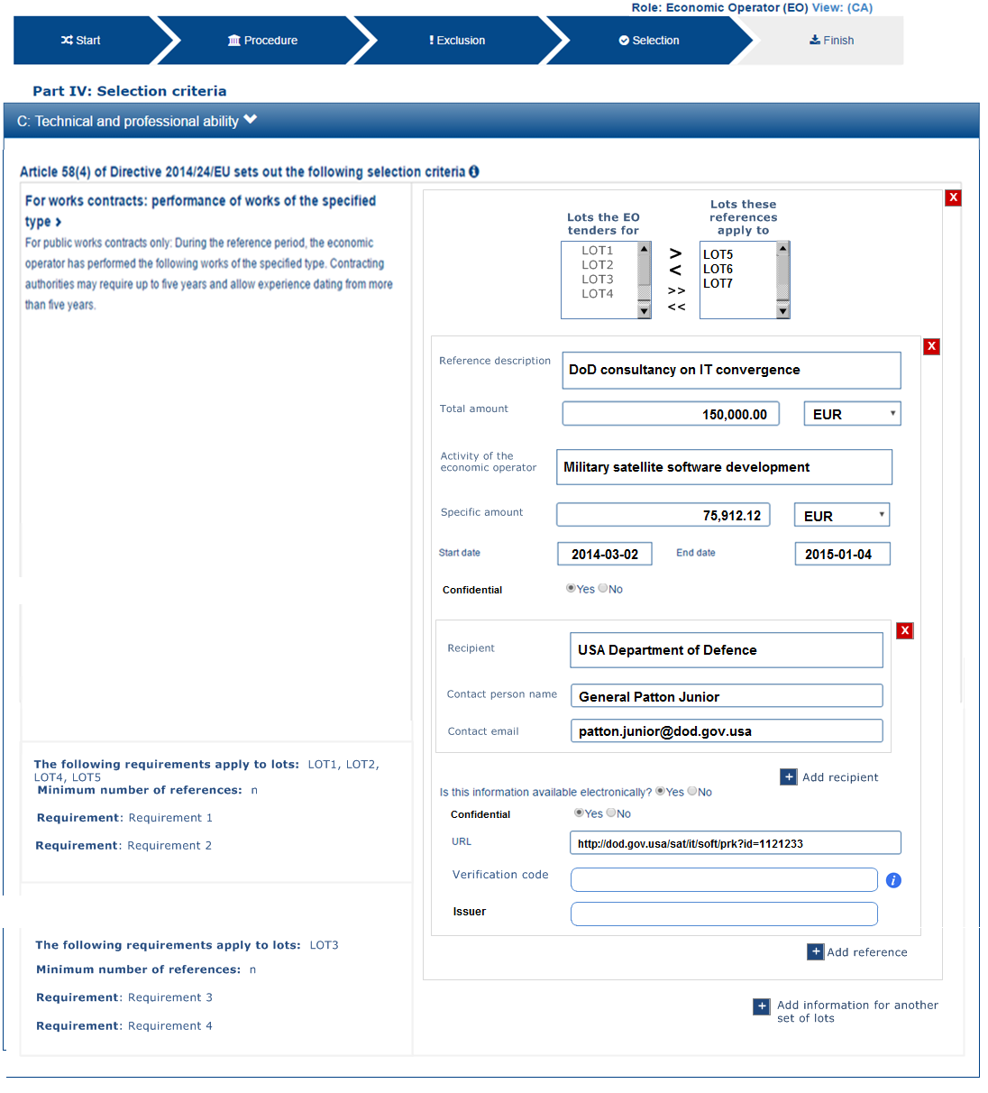

Figure 44: EO states that a reference and its evidences are confidential

#### Data Structure

#### XML instance copied from the Request document

|  |
| --- |
| See XML code in section “5.6.5 Example 5: References on similar works, deliveries or services”. |

#### Answer provided by the EO

|  |
| --- |
| <!-- EO Responses -->  <!-- Lots to which the Reference applies to-->  <cac:TenderingCriterionResponse>  <cbc:ValidatedCriterionRequirementID schemeAgencyID="EU-COM-GROW" schemeVersionID="2.0.0">f6e919fc-bfe3-4120-8ad7-d9d159998a88</cbc:ValidatedCriterionRequirementID>  <cbc:ConfidentialityLevelCode listID="ConfidentialityLevel" listAgencyID="EU-COM-GROS" listVersionID="2.0.0">CONFIDENTIAL</cbc:ConfidentialityLevelCode>  <cac:ResponseValue><cbc:ResponseID>LOT5</cbc:ResponseID></cac:ResponseValue>  <cac:ResponseValue><cbc:ResponseID>LOT6</cbc:ResponseID></cac:ResponseValue>  <cac:ResponseValue><cbc:ResponseID>LOT7</cbc:ResponseID></cac:ResponseValue>  </cac:TenderingCriterionResponse>  <!-- Reference description-->  <cac:TenderingCriterionResponse>  <cbc:ValidatedCriterionRequirementID schemeAgencyID="EU-COM-GROW" schemeVersionID="2.0.0">c7bd85b8-6e65-416c-90b8-f64d551bea24</cbc:ValidatedCriterionRequirementID>  <cbc:ConfidentialityLevelCode listID="ConfidentialityLevel" listAgencyID="EU-COM-GROS" listVersionID="2.0.0">CONFIDENTIAL</cbc:ConfidentialityLevelCode>  <cac:ResponseValue><cbc:Description>DoD consultancy on IT convergence</cbc:Description></cac:ResponseValue>  </cac:TenderingCriterionResponse>  <!-- Total amount-->  <cac:TenderingCriterionResponse>  <cbc:ValidatedCriterionRequirementID schemeAgencyID="EU-COM-GROW" schemeVersionID="2.0.0">18606b15-6a4a-4b7a-82e5-aff5c4d065ab</cbc:ValidatedCriterionRequirementID>  <cbc:ConfidentialityLevelCode listID="ConfidentialityLevel" listAgencyID="EU-COM-GROS" listVersionID="2.0.0">CONFIDENTIAL</cbc:ConfidentialityLevelCode>  <cac:ResponseValue><cbc:ResponseAmount currencyID="EUR">15000</cbc:ResponseAmount></cac:ResponseValue>  </cac:TenderingCriterionResponse>  <!-- Activity of the economic operator -->  <cac:TenderingCriterionResponse>  <cbc:ValidatedCriterionRequirementID schemeAgencyID="EU-COM-GROW" schemeVersionID="2.0.0">695810f8-f788-4bda-97d6-53d3e2dd5796</cbc:ValidatedCriterionRequirementID>  <cbc:ConfidentialityLevelCode listID="ConfidentialityLevel" listAgencyID="EU-COM-GROS" listVersionID="2.0.0">CONFIDENTIAL</cbc:ConfidentialityLevelCode>  <cac:ResponseValue><cbc:Description>Military satellite software development</cbc:Description></cac:ResponseValue>  </cac:TenderingCriterionResponse>  <!-- Specific amount -->  <cac:TenderingCriterionResponse>  <cbc:ValidatedCriterionRequirementID schemeAgencyID="EU-COM-GROW" schemeVersionID="2.0.0">ee486082-93fa-4c17-8920-fdf01b890bd1</cbc:ValidatedCriterionRequirementID>  <cbc:ConfidentialityLevelCode listID="ConfidentialityLevel" listAgencyID="EU-COM-GROS" listVersionID="2.0.0">CONFIDENTIAL</cbc:ConfidentialityLevelCode>  <cac:ResponseValue><cbc:ResponseAmount currencyID="EUR">75912.12</cbc:ResponseAmount></cac:ResponseValue>  </cac:TenderingCriterionResponse>  <!-- Period-->  <cac:TenderingCriterionResponse>  <cbc:ValidatedCriterionRequirementID schemeAgencyID="EU-COM-GROW" schemeVersionID="2.0.0">cc1da737-6c4e-4f4e-821d-c260029058f6</cbc:ValidatedCriterionRequirementID>  <cbc:ConfidentialityLevelCode listID="ConfidentialityLevel" listAgencyID="EU-COM-GROS" listVersionID="2.0.0">CONFIDENTIAL</cbc:ConfidentialityLevelCode>  <cac:ApplicablePeriod><cbc:StartDate>2014-03-02</cbc:StartDate><cbc:EndDate>2015-01-04</cbc:EndDate></cac:ApplicablePeriod>  </cac:TenderingCriterionResponse>  <!-- Recipients of the Reference start here. More than one recipient per Reference is possible -->  <!-- Recipient name -->  <cac:TenderingCriterionResponse>  <cbc:ValidatedCriterionRequirementID schemeAgencyID="EU-COM-GROW" schemeVersionID="2.0.0"></cbc:ValidatedCriterionRequirementID>  <cbc:ConfidentialityLevelCode listID="ConfidentialityLevel" listAgencyID="EU-COM-GROS" listVersionID="2.0.0">CONFIDENTIAL</cbc:ConfidentialityLevelCode>  <cac:ApplicablePeriod><cbc:Description>USA Department of Defence</cbc:Description></cac:ApplicablePeriod>  </cac:TenderingCriterionResponse>  <!-- Recipient Contact Person -->  <cac:TenderingCriterionResponse>  <cbc:ValidatedCriterionRequirementID schemeAgencyID="EU-COM-GROW" schemeVersionID="2.0.0">db7112d6-c689-4d25-b14f-889d89e4dc69</cbc:ValidatedCriterionRequirementID>  <cbc:ConfidentialityLevelCode listID="ConfidentialityLevel" listAgencyID="EU-COM-GROS" listVersionID="2.0.0">CONFIDENTIAL</cbc:ConfidentialityLevelCode>  <cac:ApplicablePeriod><cbc:Description>General Patton Junior</cbc:Description></cac:ApplicablePeriod>  </cac:TenderingCriterionResponse>  <!-- Recipient e-mail -->  <cac:TenderingCriterionResponse>  <cbc:ValidatedCriterionRequirementID schemeAgencyID="EU-COM-GROW" schemeVersionID="2.0.0">927897e8-b6c7-4c7e-ae0d-f4c21ac81634</cbc:ValidatedCriterionRequirementID>  <cbc:ConfidentialityLevelCode listID="ConfidentialityLevel" listAgencyID="EU-COM-GROS" listVersionID="2.0.0">CONFIDENTIAL</cbc:ConfidentialityLevelCode>  <cac:ApplicablePeriod><cbc:Description>patton.junior@dod.gov.usa</cbc:Description></cac:ApplicablePeriod>  </cac:TenderingCriterionResponse>  <!-- Evidence URL -->  <cac:TenderingCriterionResponse>  <cbc:ValidatedCriterionRequirementID schemeAgencyID="EU-COM-GROW" schemeVersionID="2.0.0">f4313bb6-21b6-499e-bdff-debe10e11d2c</cbc:ValidatedCriterionRequirementID>  <cbc:ConfidentialityLevelCode listID="ConfidentialityLevel" listAgencyID="EU-COM-GROS" listVersionID="2.0.0">CONFIDENTIAL</cbc:ConfidentialityLevelCode>  <cac:EvidenceSupplied><cbc:ID>2c295020-1263-4a88-a3f4-c2590b45936e</cbc:ID></cac:EvidenceSupplied>  </cac:TenderingCriterionResponse>  <!-- Evidences -->  <cac:Evidence>  <cbc:ID>2c295020-1263-4a88-a3f4-c2590b45936e</cbc:ID>  <cbc:ConfidentialityLevelCode listID="ConfidentialityLevel" listAgencyID="EU-COM-GROS" listVersionID="2.0.0">CONFIDENTIAL</cbc:ConfidentialityLevelCode>  <cac:DocumentReference>  <cbc:ID>SAT-11121233</cbc:ID>  <cac:Attachment><cac:ExternalReference><cbc:URI>http:dod.gov.usa/sat/it/soft/prk?id=11121233</cbc:URI></cac:ExternalReference></cac:Attachment>  </cac:DocumentReference>  </cac:Evidence> |
| **COMMENTS:**  Beware that this exemple corresponds to the situation where the Procurement Project is divided into lots. Notice how the EO specifies the lots for which the Reference applies to;  In this exemple only reference is provided, following the CA requirement. Many references could have been been referrenced too;  This reference referrences one recipient, but could have referrenced many; |

### Example 6: Purely national exclusion grounds

#### Situation

The Economic Operator answers “no” to all the national grounds; thus meaning that it has not breached the national law.



#### Data Structure



Notice that in this situation the Criterion has “national sub-criteria” (UBL-2.2 component cac:SubTenderingCriterion)

XML instance copied from the Request document

|  |
| --- |
| See XML code in section “5.5.4 Example 3: Purely national Exclusion grounds”. |

#### Answer provided by the EO

|  |
| --- |
| <!-- EO answers -->  <cac:TenderingCriterionResponse>  <cbc:ValidatedCriterionRequirementID>e14a3f2d-ba93-4f6c-938f-50a373f7636c</cbc:ValidatedCriterionRequirementID>  <cac:ResponseValue><cbc:ResponseIndicator>false</cbc:ResponseIndicator></cac:ResponseValue>  </cac:TenderingCriterionResponse>  <cac:TenderingCriterionResponse>  <cbc:ValidatedCriterionRequirementID>b780d1a1-1c2d-4c0d-94e6-0a0170c64bba</cbc:ValidatedCriterionRequirementID>  <cac:ResponseValue><cbc:ResponseIndicator>false</cbc:ResponseIndicator></cac:ResponseValue>  </cac:TenderingCriterionResponse>  <cac:TenderingCriterionResponse>  <cbc:ValidatedCriterionRequirementID>4997b235-1e9b-4d42-83f9-e5e2a949f79f</cbc:ValidatedCriterionRequirementID>  <cac:ResponseValue><cbc:ResponseIndicator>false</cbc:ResponseIndicator></cac:ResponseValue>  </cac:TenderingCriterionResponse> |

# Annex I: Mapping Version 1.0.2 and Version 2.0.0

* **ProcurementProject**: Differently to what was done in version 1.0.2 UBL-2.2 adds a ProcurementProject component at the root level of the document (absolute path /QualificationApplicationRequest/cac:ProcurementProject) to identify the procurement procedure;
* **Lots**: If the procurement procedure is not divided into lots the Request document should not contain instances of the component ProcurementProjectLot. In previous versions it was necessary to use always the component ProcurementProjectLot, even for procurement procedures that were not divided into lots. In the new version 2.0.0 of the ESPD-EDM this is no longer necessary. However it the document contains one, and only one ProcurementProjectLot component the ESPD Service will consider that the procurement procedure is not divided into lots;
* **Criterion**: the UBL-2.2 specification names this component “TenderingCriterion”;
* **RequirementGroup:** the UBL-2.2 specification names this component “TenderingCriteriaGroup”;
* **RequirementGroup “PI” attribute:** the “processing instruction” attribute is not defined in UBL-2.2. Instead, if needed, use the cbc:PropertyGroupTypeCode” component;
* **Requirement:** 
  + The UBL-2.2 specification names this component “TenderingCriterionRequirement”;
  + The attribute “responseDataType” does not exist in the UBL-2.2 specification. Instead the element cbc:ValueDataTypeCode is used. The Code List used by the ESPD-Service is the same as for the previous version of the ESDP-EDM: “ResponseDataType”. Beware thought that a new code “NONE” has been added at the end of the list as in the Self-contained ESPD some requirements might not expect any response (e.g. Requirements on lots);
  + The attribute “PI” of RequirementGroup does not exist in UBL-2.2. Instead you may use the cbc:TypeCode element of the cac:TenderingCriterionPropertyGroup;
* **JurisdictionLevel**: the UBL-2.2 Legislation component uses a text (multiple cardinality). It also adds a class “” that allows the codification of the geographical region corresponding to the jurisdiction.

## Code Lists

In this Version 2.0.0 of the ESDP-EDM:

* Except in two cases (“CurrencyCode” and “EULanguageCode”) all the Code Lists that ended in “Code” have been renamed. They all now end in “Type” or “Level”;
* All the Code Lists maintained by DG GROW (European Commission) have upgraded the version number to 2.0.0;
* CEN/BII Code List “TendererRole” has been replaced with a GROW “EORoleType” Code List. The values of the lists are now different from the previous version;
* “CriterionJurisdictionLevel” has been renamed into “LegislationType”. The values have not changed in respect of the previous version;
* A new Code List “JurisdictionLevel” has been created, namely used to specify the jurisdiction level of a gazette or publication board where the contract documents of the procurement procedure have been published, see values below;
* The Code List “CustomizationID” is not currently used by the ESPD Service;
* A new Code List “QualificationApplicationType” has been created to specify whether the ESPD is “Regulated” or “Self-contained”;
* A new code “NONE” has been added to the Code List “ResponseDataType”. This code is used for those Requirement(s) used to specify requirements the response to which is calculated out from the responses in other criteria (e.g. see Criterion “Requirements on lots”);
* A new Code List “NumberOfLotsCode” has been created to specify to how many lots the economic operator may tender;
* A new Code List “EvaluationMethodType” has been created to specify whether the Criterion is weighted or a pass/fail one;
* A new Code List “EOIDType” has been created to state the type of identifier of an Economic Operator of a group of tenderers (see section about Consortia);
* A new Code List “ConfidentialityLevel” has been create to set whether an answer to a Criterion Property or and evidence can be publicly accessible or not;
* A new code “IDENTIFER” has been added to the Code List “ResponseDataType”, namely used to identify lists of lots when identifying the lots into which a Procurement Procedure is divided or the lots to which the Economic Operator tenders.

### New Code Lists

See the distribution packages for the complete spread-sheet with all the Code Lists (folder /dist/cl/xls), and the Genericode files ((folder /dist/cl/gc).

#### EORole Code List

|  |  |
| --- | --- |
| **ShortName** | EORole |
| **LongName** | Economic Operator Role |
| **ListID** | EORole |
| **Version** | 2.0.0 |
| **CanonicalUri** | Placeholder |
| **CanonicalVersionUri** | Placeholder |
| **LocationUri** |  |
| **AgencyLongName** | DG GROW (European Commission) |
| **AgencyIdentifier** | EU-COM-GROW |
| **Locale** | en |

|  |  |  |
| --- | --- | --- |
| **Code** | **Value** | **Description** |
| **SCLE** | Sole contractor/Lead entity | Sole entity or, in case of Consortium, Joint Venture or other types of groups, the leader of the group. This role has to produce a complete ESPD. |
| **GM** | Group member | Member (not leader) of the Consortium, Joint Venture or other type of group. This role has to produce a complete ESPD except Part II A - b (identify procurers). |
| **OERON** | Other entity (relied upon) | Entity on which the main contractor, the group or another subcontractor relies in order to meet the selection criteria. This role has to produce a complete ESPD except Part II A - b (identify procurers). |
| **OENRON** | Other entity (not relied upon) | Entity on which the main contractor, the group or another subcontractor does not rely in order to meet the selection criteria. This role has to produce an ESPD without Part IV and Part V. |

#### JurisdictionLevel Code List

|  |  |
| --- | --- |
| **ShortName** | JurisdictionLevel |
| **LongName** | JURISDICTION LEVEL |
| **ListID** | JurisdictionLevel |
| **Version** | 2.0.0 |
| **CanonicalUri** | Placeholder |
| **CanonicalVersionUri** | Placeholder |
| **LocationUri** |  |
| **AgencyLongName** | DG GROW (European Commission) |
| **AgencyIdentifier** | EU-COM-GROW |
| **Locale** | en |

|  |  |
| --- | --- |
| **Code** | **Value** |
| **INT** | International |
| **EU** | European Union |
| **MS** | National (Member State) |
| **REGIONAL** | Regional (e.g. Länder, Autonomous Government, etc.) |
| **LOCAL** | Local (e.g. municipal) |

#### QualificationApplicationType

|  |  |
| --- | --- |
| **ShortName** | QualificationApplicationType |
| **LongName** | QUALIFICATION APPLICATION TYPE |
| **ListID** | QualificationApplicationType |
| **Version** | 2.0.0 |
| **CanonicalUri** | Placeholder |
| **CanonicalVersionUri** | Placeholder |
| **LocationUri** |  |
| **AgencyLongName** | DG GROW (European Commission) |
| **AgencyIdentifier** | EU-COM-GROW |
| **Locale** | en |

|  |  |  |
| --- | --- | --- |
| **Code** | **Value** | **Description** |
| **REGULATED** | Regulated | The contents are the ones specified in the Commission Implementing Regulation (EU) 2016/7. References to the contract documents are made. |
| **SELFCONTAINED** | Self-contained | Requirements additional to the ones specified in the Commission Implementing Regulation (EU) 2016/7 are added by the contracting authority or entity. No references to the contract notice nor other contract documents. All necessary information is contained or provided by trusted service providers. |

#### NumberOfLotsCode

|  |  |
| --- | --- |
| **ShortName** | NumberOfLotsCode |
| **LongName** | NUMBER OF LOTS CODE |
| **ListID** |  |
| **Version** | 2.0.0 |
| **CanonicalUri** | Placeholder |
| **CanonicalVersionUri** | Placeholder |
| **LocationUri** |  |
| **AgencyLongName** | DG GROW (European Commission) |
| **AgencyIdentifier** | EU-COM-GROW |
| **Locale** | en |

|  |  |  |
| --- | --- | --- |
| **Code** | **Value** | **Description** |
| ALL | All lots | The economic operator can tender to all the lots of this procurement procedure. |
| MAX | Maximum number of lots | The economic operator can tender only to a maximum number of lots established by the contracting authority. |
| ONE | Only one lot | The economic operator can tender only to one of the lots into which this procurement procedure is divided. |

#### EvaluationMethodType

|  |  |
| --- | --- |
| **ShortName** | EvaluationMethodType |
| **LongName** | EVALUATION METHOD TYPE |
| **ListID** | EvaluationMethodType |
| **Version** | 2.0.0 |
| **CanonicalUri** | Placeholder |
| **CanonicalVersionUri** | Placeholder |
| **LocationUri** |  |
| **AgencyLongName** | DG GROW (European Commission) |
| **AgencyIdentifier** | EU-COM-GROW |
| **Locale** | en |

|  |  |
| --- | --- |
| **Code** | **Value** |
| PASSFAIL | Pass or Fail method. |
| WEIGHTED | The Criterion is weighted. |

#### EOIDType

|  |  |
| --- | --- |
| **ShortName** | EOIDType |
| **LongName** | EOIDType |
| **ListID** | EORoleType |
| **Version** | 2.0.0 |
| **CanonicalUri** | Placeholder |
| **CanonicalVersionUri** | Placeholder |
| **LocationUri** |  |
| **AgencyLongName** | DG GROW (European Commission) |
| **AgencyIdentifier** | EU-COM-GROW |
| **Locale** | en |

|  |  |
| --- | --- |
| **Code** | **Value** |
| NATIONAL | National Identifier |
| VAT | VAT number |
| LEI | Legal Entity Identifier |
| BRIS | Business Registry European Unique Identifier |
| DUNS | Duns & Bradstreet number |

#### ConfidentialityLevel

|  |  |
| --- | --- |
| **ShortName** | ConfidentialityLevel |
| **LongName** | CONFIDENTIALITY LEVEL |
| **ListID** | ConfidentialityLevel |
| **Version** | 2.0.0 |
| **CanonicalUri** | Placeholder |
| **CanonicalVersionUri** | Placeholder |
| **LocationUri** |  |
| **AgencyLongName** | DG GROW (European Commission) |
| **AgencyIdentifier** | EU-COM-GROW |
| **Locale** | en |

|  |  |
| --- | --- |
| **Code** | **Value** |
| CONFIDENTIAL | Confidential |
| PUBLIC | Public |

## New criteria

Some new criteria have been added to extend the ESPD Exchange Data Model, namely to cater for the Self-contained mode. New criteria are always added to the end of the “CriteriaTaxonomy” spread-sheet. See this list to study the data structure of these criteria.

|  |  |  |
| --- | --- | --- |
| **NEW CRITERIA** | | |
| **Criterion** | **ID** | **Use in ESPD** |
| **Requirement on lots** | 1e430aa8-2875-4269-a751-8124549019c6 | CA informs the EO about the lots in this Procurement Procedure. |
| **Procurement Procedure CPVs** | fab9ab25-9b2a-43c0-ab46-c3b2bd4859a1 | CA informs the EO about the activities to perform of goods to deliver in this Procurement Procedure. |
| **SME** | fab9ab25-9b2a-43c0-ab46-c3b2bd4859a1 | Information gathered by the MS and EU institutions namely for statistical purposes. |

## Updated criteria

Some of the criteria defined in previous versions have been modified – generally extended –, namely to cater for the Self-contained mode. See the spread-sheet “CriteriaTaxonomy” to study the new data structure of these criteria.

|  |  |  |
| --- | --- | --- |
| **UPDATED CRITERIA** | | |
| **Criterion** | **ID** | **Modification** |
| If applicable, is the economic operator registered on an official list of approved economic operators or does it have an equivalent certificate (e.g. under a national (pre)qualification system)? | 9b19e869-6c89-4cc4-bd6c-ac9ca8602165 | The Criterion Properties have been simplified. The data about the Pre-Qualification System is to be provided now in the UBL-2.2 cac:EconomicOperatorParty/cac:QualifyinParty component. |
| Is the economic operator participating in the procurement procedure together with others? | ee51100f-8e3e-40c9-8f8b-57d5a15be1f2 | The Criterion Properties have been extended to meet the new SELF-CONTAINED ESPD requirements. |
| Does the economic operator rely on the capacities of other entities in order to meet the selection criteria set out under Part IV and the criteria and rules (if any) set out under Part V below? | 9c70375e-1264-407e-8b50-b9736bc08901 | The Criterion Properties have been extended to meet the new SELF-CONTAINED ESPD requirements. |
| Does the economic operator intend to subcontract any share of the contract to third parties? | 72c0c4b1-ca50-4667-9487-461f3eed4ed7 | The Criterion Properties have been extended to meet the new SELF-CONTAINED ESPD requirements. |
| Its average yearly turnover for the number of years required in the relevant notice, the procurement documents or the ESPD is as follows: | b16cb9fc-6cb7-4585-9302-9533b415cf48 | The Criterion Properties have been extended to meet the new SELF-CONTAINED ESPD requirements. |
| Its specific yearly turnover in the business area covered by the contract for the number of financial years required in the relevant notice, the procurement documents or the ESPD is as follows: | 074f6031-55f9-4e99-b9a4-c4363e8bc315 | The Criterion Properties have been extended to meet the new SELF-CONTAINED ESPD requirements. |
| Its specific average yearly turnover in the business area covered by the contract for the number of years required in the relevant notice, the procurement documents or the ESPD is as follows: | d3dfb714-f558-4512-bbc5-e456fa2339de | The Criterion Properties have been extended to meet the new SELF-CONTAINED ESPD requirements. |
| Concerning the financial ratios specified in the relevant notice, the procurement documents or the ESPD, the economic operator declares that the actual values for the required ratios are as follows: | e4d37adc-08cd-4f4d-a8d8-32b62b0a1f46 | The Criterion Properties have been extended to meet the new SELF-CONTAINED ESPD requirements. |
| References related to goods, services and works have been merged into one Criterion:  During the reference period, the economic operator has delivered the following principal deliveries, performed services or executed works of the type specified.  Criteria 39 and 40 have been removed from the “Criteria Taxonomy” spread-sheet. | cdd3bb3e-34a5-43d5-b668-2aab86a73822 | The Criterion has been dramatically modified to meet the new SELF-CONTAINED ESPD requirements. |

## Main differences between the “Regulated” and the “Self-contained” documents

* A self-contained ESPD document does make references the Contract Notice or other procurement documents but to data, evidences and documents that are specified in the ESPD document.
* The specification of national exclusion criteria is a feature of the self-contained ESPD. Regulated ESPD documents do only contain EU exclusion criteria.
* The Regulated ESPD does not need to specify the following information for Part I of the ESPD Service (Information concerning the procurement procedure and the contracting authority or contracting entity):
  + “Tenders may be submitted for”
  + “Maximum number of lots”
  + “Maximum number of lots that maybe awarded to one tenderer”

# Cited works

1. COMMISSION IMPLEMENTING REGULATION (EU) 2016/7. *http://eur-lex.europa.eu/legal-content/EN/TXT/?uri=CELEX%3A32016R0007.* [Online]

2. ISO Schematron. *http://schematron.com/.* [Online]

3. OASIS UBL-TC. *https://www.oasis-open.org/committees/tc_home.php?wg_abbrev=ubl.* [Online]

4. CRANE SOFTWRIGHTS. *http://www.cranesoftwrights.com/bio/gkholman.htm#summary.* [Online]

5. Genericode 1.0 TC. *https://www.oasis-open.org/committees/tc_home.php?wg_abbrev=codelist.* [Online]

1. <https://ec.europa.eu/tools/espd/filter?lang=en>
2. <https://ec.europa.eu/growth/tools-databases/ecertis/>
3. <https://joinup.ec.europa.eu/community/european_catalogue/description>)
4. <http://eur-lex.europa.eu/legal-content/EN/TXT/PDF/?uri=CELEX:32014D0771&from=EN>
5. <https://www.oasis-open.org/committees/tc_home.php?wg_abbrev=codelist>
6. <http://schematron.com/>
7. <http://www.cranesoftwrights.com/>
8. Test Cases and artefacts to perform the XML validation will be provided alongside the ESPD-EDM documentation through the dissemination solutions adopted by the EC (e.g. wiki on public Github repository).
9. This mechanism can also be used for contracts below the threshold, obviously.
10. <https://github.com/ESPD>